Virtual High School
Oglala Lakota County School District 65-1
ENROLLMENT PACKET

2020 - 2021

________ Copy of certified birth certificate
________ Copy of current immunization record
________ Copy of tribal enrollment letter, if enrolled
________ School transcripts from any high school
attended or 8th grade diploma if student has not
attended HS ________ Custody or guardianship orders, if applicable

On the pages that follow is the application form and other forms that need to be completed and signed. To get started please:

___ Request and submit an official high school transcript or if 8th grade was your last grade
completed, submit a report card signed by your last principal and homeroom teacher indicating you were promoted to the 9th grade;
Note:Students Expelled or on Suspension from any school cannot be enrolled into the VHS Codified State Law 13.32-4.3
___ Read and sign Student Network/Internet User Agreement & Parent Permission Form, including parent/ guardian signature unless you are emancipated (18 years of age or older);
___ Read, complete and return the Registration Form, Survey/Impact Aid Form, Title VII Form and Release of Information Forms;
___ Read, sign, and return the Rules & Policies Form and obtain parent/guardian signature unless you are emancipated;
___ Review graduation requirements compare them to courses you have completed and look at course offerings at http://www.sdvs.k12.sd.us/Students/Courses.aspx;
___ Include a copy of your immunization records and a copy of your birth certificate.
___ So that we can better serve you and other students, please respond to the following questions (1-2 paragraphs per question will suffice)
____ Bring your completed application to one of the Oglala Lakota County School District attendance centers Batesland, Red Shirt, Rockyford, or Wolf Creek Schools

Once we have reviewed your application and determined you are eligible for on-line course work, we may ask you to complete a pre-assessment, assist you in developing a schedule that meets South Dakota graduation requirements and then we will help you enroll in the appropriate on-line classes. Any questions please call Registrar 605-288-1921or 605-455-6693

Registration Form
Where did you hear about us?

___________________________

___________________________
Oglala Lakota County VHS
Date___________________

Personal Information

Full Legal Name______________________________________________________ Grade__________
(As it appears on birth certificate) Last First Middle

Date of Birth ____/____/____ Circle - Female / Male For Graduation purposes Ht:___Wt:___

Ethnic: (check one) American Indian Asian Black White Hispanic

Student’s Address ______________________________________________ P.O. Box __________
City _________________ County ____________________ State _______ Zip______________

E-mail Address _______________________________________________________________

Social Security Number____________________________ Home Phone (____)_______ - __________

School Information

Last School Attended_____________________________Date Withdrawn_______________________

Reason for Withdrawal_________________________________Grade at the Time_______________
Note: Student may not enroll if currently on expulsion and suspension from previous school. SD Codified Law 13-32-4.3
If yes, please explain: ________________________________________________________________

School Address __________________________________________ Phone (____)_______ - ___________

City______________________________________________ State ________ Zip _______________

Other Schools Attended: ______________________________ Dates _______________________
______________________________ _______________________

Parent / Guardian Information (Required for students under the age of 18, voluntary if 18 or older)

Name____________________________________________ ______________________________

(Last) (First) (MI)
Relationship ___________________________ E-mail Address _______________________________

Phone Day (______) ________ _____________ Phone Night (______) ________ ___________

Are there any custody or court issues? Yes No ______ If yes please attach documentation

Attendance Center Information

Center where you will take assessments:
_______Batesland ______ Rockyford ______ Red Shirt _________Wolf Creek

Coordinator Signature: _____________________________________

Oglala Lakota County School District

Batesland Rockyford Red Shirt Wolf Creek

Student Network/Internet User Agreement and
Parent Permission Form

Introduction
We are pleased to offer students of the Oglala Lakota County School District access to the district computer network resources and the Internet. To use these resources, parents of all students must sign and return this form. Parents, please read and complete this document carefully, review its contents with your son/daughter and sign and initial where appropriate. Any questions or concerns about this permission form or any aspect of the computer network should be referred to your school’s Site Technology Coordinator.

General Network Use
The network is provided for students to conduct research and complete assignments. Access to network services is given to students who agree to act in a considerate and responsible manner. Students are responsible for good behavior on school computer networks just as they are in a classroom or a school hallway. To ensure the use of electronic communication systems in the District are compliant with this agreement, network administrators may monitor usage of District purchased equipment from time to time. Access is a privilege - not a right. As such, general school rules for behavior and communications apply and users must comply with district standards and honor the agreements they have signed (see over).

Network storage areas may be treated like school lockers. Network administrators may review files and communications (i.e. computers, email, cell phones, pagers, chat and instant messaging) in order to appropriately maintain system integrity and ensure that users are using the system responsibly. Users should not expect that files stored on district servers are ever private, as electronic systems are not personal property, including school internet, staff/students maintain no right or expectation of privacy related to their use of District Electronic Communication Systems.

Internet / World Wide Web
Access to the Internet will enable students to use thousands of libraries and databases. Within reason, freedom of speech and access to information will be honored. Families should be warned that some material accessible via the Internet might contain items that are illegal, defamatory, inaccurate or potentially offensive to some people. While our intent is to make Internet access available to further educational goals and objectives, students may find ways to access other materials as well. Filtering software is in use, but no filtering system is capable of blocking 100% of the inappropriate material available on the Internet. We believe that the benefits to students from access to the Internet, in the form of information resources and opportunities for collaboration, exceed any disadvantages. Ultimately, parents and guardians of minors are responsible for setting and conveying the standards that their children should follow when using media and information sources. The Oglala Lakota County School District does not provide off campus or home-based Internet access. Parents are urged to explore the resource with their children, as there are many areas not suitable for access by children.

Publishing to the World Wide Web
Parents, your daughter or son’s work may be considered for publication on the World Wide Web, specifically on the student’s school’s web site. Such publishing requires parent/guardian permission (see over). The work will appear with a copyright notice prohibiting the copying of such work without express written permission. In the event anyone requests such permission, those requests will be forwarded to the student’s parent/guardian.

It is the policy of the Oglala Lakota County School District that no students name and photo will be published together on the school web site. It is our policy that publication means either the students photo or name and not both.

It is the policy of the Oglala Lakota County School District to follow the guidelines set forth in the Child Internet Protection Act located on the American Library Association website at: http://www.ala.org

Directions
Read carefully! Then complete the green and yellow highlighted areas on the back page and return to the school. This information will be kept on record with the technology coordinator. Only Office Staff, Technology Staff and the Classroom Teacher will have access to this information. We must have this document on record for your child to able to use school computers or access the Internet.

Print Name: ______________________________ Grade: ____________
Oglala Lakota County Schools
Student Network/Internet User Agreement and Parent Permission Form
To use networked resources, all students must sign and return this form. Those students under age 18 must obtain parental permission. The activities listed below are not permitted:
- Sending or displaying offensive messages or pictures
- Using obscene language, defamatory, offensive or harassing via any Electronic Communication (email, chat, text messaging or websites)
- Giving personal information, such as complete name, phone number, address or identifiable photo, without permission from teacher and parent or guardian
- Harassing, insulting or attacking others
- Damaging or modifying computers, computer systems or computer networks will result in monetary charges related to repair, replacement or re-configuration
- Installing or attempting to install any program, game or application not approved by the District
- Violating copyright laws
- Using others' passwords
- Trespassing in others’ folders, work or files
- Intentionally wasting limited resources
- Employing the network for commercial purposes, financial gain or fraud.
- Accessing and playing games not approved by the teacher or administration
Violations may result in a loss of access as well as other disciplinary or legal action

Student User Agreement:
As a user of the Oglala Lakota County Public Schools computer network, I hereby agree to comply with the statements and expectations outlined in this document and to honor all relevant laws and restrictions. In addition, I hereby waive any right or expectation of privacy I might have in any communication including emails, instant messaging and documents that may be accessed by the District through the network.
(Initial appropriate items)
______ I agree to use the network responsibly
______ I grant permission to have my materials published to the World Wide Web

Student Signature _______________________________________________ Date ___________

Parent/Guardian Permission:

Parent/Guardian Permission:
All students are provided with access to district computer resources. In addition to accessing our district computer network, as the parent or legal guardian, I grant permission for the above named student to:(Initial appropriate items)
Access the Internet
Have his/her materials published to the World Wide Web
Have his/her name or photo published on the World Wide Web, according to
guidelines stated on the previous page of this document.
These permissions are granted for an indefinite period of time, unless otherwise requested. I understand that individuals and families may be held liable for violations. I understand that some materials on the Internet may be objectionable, but I accept responsibility for guidance of Internet use - setting and conveying standards for my daughter, son or guardian to follow when selecting, sharing or exploring information and media.
I understand that the District takes reasonable steps to limit offensive material from the network accessible to my child. I further understand that no such system is fool proof. In consideration of allowing my child access to the network and Internet, I hereby waive any claim my child or I might make relating to the content of information or images my child may encounter on the network. In addition, I hereby waive any state or federal right or expectation of privacy my child or I might have with respect to communication to, from or about my child that may be accessed through the network, including without limitation emails, instant messaging, documents and the like and the District’s access to such material.
Parent Signature __________________________________________________________ Date ______

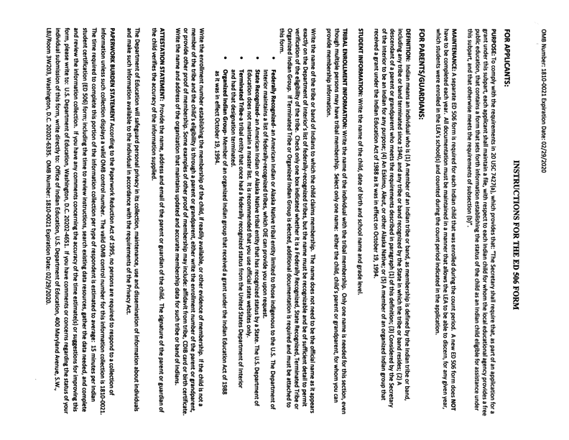

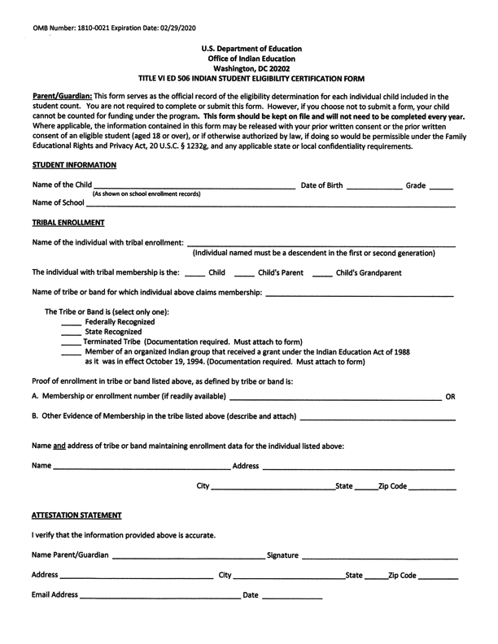

OGLALA LAKOTA COUNTY SCHOOL DISTRICT 65-1
P.O. BOX 109, BATESLAND, SD 57716

2020-21 School Year Survey Form

Dear Parents / Guardians:
The Oglala Lakota County School District 65-1 is eligible to receive Impact Aid funding (Federal funds, which are paid in lieu of taxes on trust lands). In order for the school your child is attending to receive impact aid funds we must have the following information.

- Name of Child:
First Middle Last

- Child’s Date of Birth: Female or Male

- School Teacher Grade

- Town of Residence of Child on Survey Date
City State

5. Child’s Enrollment # with the Tribe.

6. Exact Physical Location of child’s residence – housing name, house number, how many miles and direction from mailing address. (Please be as specific as you can with your directions)

7. The following land description is absolutely necessary regarding where you live. Call BIA Reality office at 867-1001

Range Unit # Township# Section# Tract#

8. Do you pay property taxes to the county for the land you live on? Yes No
Name and mailing address of Parents or Guardians on date of survey.
Name and mailing address of Parents or Guardians’ Employer on date of survey.
9.

10. Parents occupation on survey date:

Signature of Parent/Guardian
Student Social Security Number:

Date
Oglala Lakota County Virtual High School

P.O.Box 109, Batesland, SD 57716

Mission: To strengthen the Lakota identity and values of students
and to assure their overall well-being and academic success

CONSENT/RELEASE OF INFORMATION

Our school district gathers information so that the best educational program will be provided for your child. Procedures are to be followed to assure that information collected is confidential and is used only for the purpose for which it is collected. Written consent from the child’s parent or guardian is obtained before information is disclosed for any purpose.
This form requests your permission to release information concerning your child for the purpose stated below. Please sign as indicated. Your cooperation is appreciated.

Name of child:__________________________________ Date of Birth:_________ School:_Oglala Lakota County VHS

Purpose for release of information: ___X___Implement appropriate high school programming
_____Referral to outside agency ______Juvenile Court _____Juvenile Detention Center _____Other

Description of information to be released:
_X___Academic Achievement Data __X__Special Education Evaluations _X___Individual Psychological Tests
_X___Individual Education Plan __X__Cumulative School Reports _X___High School Transcript
_X___Other (Suspension/Expulsion Records)__X__Birth Certificate _X___Immunization Records

Information is to be obtained/released through the OGLALA LAKOTA COUNTY SCHOOL DISTRICT 65-1

I hereby give permission for the release of information concerning the above-named child.

__X__I give permission for my child to be photographed and/or videoed while participating in educational programming in the Oglala Lakota County School District. This information will be used for educational programming and/or assessment.
__X__I further hereby consent to have my child counseled by a Counselor of Oglala Lakota County School District and to the following Lakota cultural interventions: _____azilya (smudging) _____Inipi (sweat lodge)

PRIVACY AND CONFIDENTIALITY:
Many precautions are taken by the staff of Oglala Lakota County District Virtual High School. We will protect any
information that you may disclose. Your information is considered confidential except for certain limitations mandated by State Law. The School Counselor may be required to release information:
- To protect you or others from imminent serious harm
- To protect children from issues of Neglect and Abuse
- To parents of minors (students under age 18)
- By Court order

Please note that we utilize an electronic means of record and report and data storage. Many appropriate precautions have been taken to protect your confidential information including encryptions; however, limited access by technical system administrators may be necessary at times. Faculty or Administrators not associated with Oglala Lakota County School District Virtual High School DO NOT have access to your records without your specific permission.

______________________________________ _____________________________ __________________
Print Name of Parent/Guardian Signature of Parent/Guardian Date
OR:
______________________________________ _____________________________ __________________
Print Name of Student (over 18) Signature of Student (over 18) Date

OGLALA LAKOTA COUNTY VIRTUAL HIGH SCHOOL

PARENTAL CONSENT FORM

I/we the undersigned request that my/our child be permitted to participate in the activity named below.

STUDENT’S STUDENT’S NAME:____________________________________________________________________DOB:___________________________________

VHS Coordinators contact information:
Carolyn Tail Janet Whiting Jhoni Big Crow James Mesteth Kathy Black Crow
455-2761 455-6313 685-3787 255-5387 455-6716

DESTINATION: Day trips to supplement the students’ learning experience. Most activities are at educational facilities or programs. Students will conclude day at the usual time, with transportation by the VHS staff in school vehicles.

EDUCATIONAL PURPOSE: Lakota cultural, educational and historical exposure for 9-12th grade students. Participation requires full day, there will be no early departures from events.

DATE OF TRIP: Short day-trips limited to the Pine Ridge Reservation throughout the Fall 2016 and Spring 2017 semesters. Students may have one-day advance notice, however, some activities may be same day notice. This may include trips to other VHS sites for participation in the Exposures Photography Club, Annual Science Project, Service Learning activities or activities for career or college preparation. Students must have this Consent Form on file in order to participate during the school year 2016-17.

MEDICAL RELEASE

I understand that every effort will be made to contact me in the event of any accident or injury to my child, but in the event that I cannot be reached, I hereby authorize the school representative to consent to whatever medical or surgical treatment may be considered necessary or advisable by the physician or nurse in attendance and treating such injuries. This authorization is given pursuant to the applicable provisions of the Oglala Lakota County School District policies and procedures.

RELEASE OF CLAIMS AGAINST THE OGLALA LAKOTA COUNTY SCHOOL DISTRICT AND OGLALA LAKOTA COUNTY VIRTUAL HIGH SCHOOL

As Parent/Guardian, I have voluntarily applied, on behalf of my child, to participate in the above-identified field trips. I understand that there are risks in my child’s/ward’s presence, transportation, and participation in this school-sponsored program. I HEREBY AGREE ON BEHALF OF MY CHILD TO ASSUME ANY AND ALL RISK OF BODILY INJURY, DEATH, OR PROPERTY DAMAGE, ARISING OUT OF, OR CAUSED BY MY CHILD'S/WARD'S PRESENCE AND PARTICIPATION IN THIS FIELD TRIP I HAVE CAREFULLY READ THIS AGREEMENT AND AM AWARE THAT THIS IS A RELEASE OF LIABILITY AND A CONTRACT BETWEEN MYSELF ON BEHALF OF MY CHILD, AND THE SCHOOL AND I SIGN IT OF MY OWN FREE WILL.

BEHAVIOR EXPECTATIONS

I agree that the supervising personnel have the right at their discretion to enforce the established rules of conduct, and I agree to direct my child to cooperate and conform to directions of the supervising personnel.

SIGNATURES

Parent/Guardian Signature:__________________________________________________________Date:_________________

Please Print name:_________________________________________________________________________Phone:____________________

It is very important that the potential student answer these questions:

1. What most appeals to you about the concept of Virtual High School?

2. When was a high point in your education—a time when you built and maintained
self-discipline and good things happened for you?

3. How do you learn best—give an example of a time when you learned something very challenging.
What contributed to your success?

- What is the most significant event that has happened in your life in the last twelve months?

OGLALA LAKOTA COUNTY VIRTUAL HIGH SCHOOL
CONSENT OF PARENT OR LEGAL GUARDIAN OR OTHER PERSON WHO HAS PRIMARY
RESPONSIBILITY FOR THE CARE OF THE CHILD
FOR SCHOOL HEALTH CARE PROGRAM

Student’s Name: ______________________________ Date of Birth: ________________

The following is for routine healthcare services, provided in school facilities by school health personnel with standing orders from Public Health Service physicians.

Please check ONLY the services listed below that you DO NOT want for your child.

_____Transport children to the PHS hospital or other medical facilities for emergency treatment (ie bleeding wound) or contact appropriate authorities for transportation ACCORDINGLY (ie fracture). Parents are contacted to meet at the hospital.
_____Do routine hearing and vision screening as indicated.
_____Transport, if parental transportation is not available, identified children in need of further vision and hearing screening. An IHS permission slip must be signed.
_____Transport, if parental transportation is not available, identified children for routine dental exams and sealants. If further care is indicated, a follow-up letter is to be sent to parents/guardians who are responsible for further care and transportation.
_____Send all medications, that the child is to take, to the Nurse’s Office for dispensing. Identification of the medication, instructions for dispensing, and the dispensing physicians are to accompany the medication.
_____Administer medications approved through standing orders for: headache, fever, conjunctivitis, earache and cold symptoms.
_____Do treatments for respiratory conditions as ordered by a physician.
_____Take, as needed, vital signs: blood pressure, pulse, height, weight, temperature, etc.
_____Apply, when indicated by possible fracture or sprain, splints or elastic bandages.
_____Shower and change clothes in case of need.
_____Soak body parts that have sores on them.
_____Apply dressing or topical medications as needed for lacerations, abrasions, or other injuries, such pas burns.
_____Clean heads that are infested and/or infected.

Please list any allergies or medical conditions your child has: ________________________________________________________________________

Please list any medications being taken by your child:

Please list all emergency phone numbers where you can be reached in case of a medical emergency:

Parent/Guardian/Responsible Party_________________________
Signature
Date_____________________

PINE RIDGE IHS MOBILE CLINIC
P O BOX 1201
PINE RIDGE, SD 57770

OFFICE PHONE NUMBER: 605-687-3316
MSA PHONE NUMBER: 605-441-0869

CONSENT TO TREAT

I hereby give consent to the Pine Ridge IHS mobile clinic to treat my child for well child physicals as well as any illness related issues and to give immunizations and the seasonal flu vaccine.

Child’s Name: ______________________________________________________________

Birth Date: ________________________________________________________________

Residence: ________________________________________________________________

List allergies to any food or medication, history of patient/family heart disease. If yes, who, what problem, age of onset and/or any other medical condition your child has or if your child is on any medications:

______ I do not want my child to be given the seasonal flu vaccine

For males needing a physical, I consent for hernia check:

_____Yes _____No

Signature of Parent/Guardian or Responsible Party: _____________________________________

Date: ____________________________________________________________________

