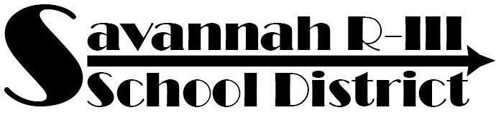
Elorie Boeh, Principal
elorie.boeh@savannahr3.com

AMAZONIA ELEMENTARY SCHOOL 845 6th STREET
A Growing District for Growing Minds AMAZONIA, MO 64421 www.savannahr3.com PH: (816) 324-3144 FAX: (816) 324-5594

Kindergarten Supply List
2 boxes, 24 count Crayola brand crayons
2 wide-ruled composition notebooks
1 pkg. washable markers
2 bottles Elmer’s washable glue
6 pack washable glue sticks - glue sticks
24 pack of pencils
2 pack pink erasers
2 three-pronged folders
1 pack colored construction paper
1 pack expo markers
1 ream white copy paper
1 box Kleenex
1 container Clorox wipes (girls)
1 bottle hand sanitizer (boys)
1 box quart Ziploc bags (girls)
1 box gallon Ziploc bags (boys)
Backpack

First Grade Supply List
2 dozen #2 pencils
1 pkg. pencil top erasers
Crayons and/or colored pencils
4 black dry erase markers
3 – plastic folders
1 ream white copy paper
Markers
Scissors
2 glue sticks
2 tissue boxes
Clorox wipes
Hand sanitizer
Headphones (NO ear buds)
Supply box (11.5”x7.5”) approx.
1 box sandwich zip bags (boys)
1 gallon slider bags (girls)

Second Grade Supply List
Crayons/markers (colored pencils optional)
Scissors/ruler/large eraser
2 glue sticks
Supply box/Clipboard/Tab Dividers
1 ream white paper
1 pkg. dry erase markers (blue/black)
1 – 3 ring binder
1 box #2 pencils
Kleenex – 2 large boxes
1 set of headphones (No ear buds)
Clorox wipes (girls)
- – 12oz bottle hand sanitizer (boys)
Sandwich zip bags (girls) Gallon zip bags (boys)

Third Grade Supply List
2 boxes of #2 pencils
2 - large erasers
Colored pencils or markers
Supply box
Scissors (Fiskars are the best)
1 spiral notebook (wide-ruled)
3 Glue sticks
2 plastic folders with prongs
3 pkgs. Dry erase markers (black)
1 – 1.5 binder (3 ring)
1 pocket folder (3 holes so it can go in binder)
1 ream white copy paper
Clorox wipes & Hand sanitizer
Earbuds/Headphones
3 boxes Kleenex

4th Grade and 5th Grade
24 - #2 pencils
2 large erasers
2 boxes of Kleenex
1 three-ring pencil pouch (needs to be able to go in binder)
1 box 24 crayons
1 box markers
1box colored pencils
2 pkgs. dry erase markers
2 glue sticks
3 red pens
1 pair of scissors
1 clipboard
1 – 1.5 inch binder (with clear cover on front)
1 pkg. wide ruled notebook paper
1 pkg. binder tabs (8 tabs)
1 ream white copy paper
Clorox wipes (boys)
Hand sanitizer (girls)
1 set of headphones/ear buds

