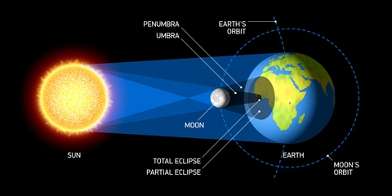
Parents Please Read!
Solar Eclipse 2017
What do I need to know?

When is the solar eclipse happening?
Monday, August 21, 2017

Where and when is totality happening?
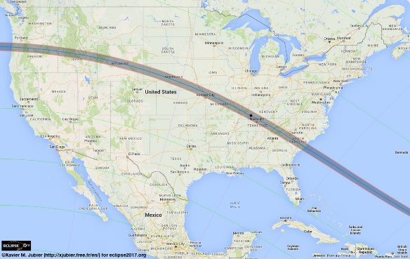

We will not experience a total eclipse here in Russellville. We will experience a partial eclipse.

Start of Partial Eclipse- 11:45 a.m.
Maximum Eclipse- 1:15 p.m.
End of Partial Eclipse- 2:44 p.m.

Do I need special glasses to view the eclipse? Looking directly at the Sun without optical aid is dangerous. Our district has purchased solar safety glasses for all students. We will reinforce the safety precautions with our students. We encourage you to do the same at home. Teachers will be constantly monitoring our students during the eclipse with zero tolerance for disregarding the directions for using solar safety glasses. Students that do not follow these guidelines will immediately be sent inside. Solar safety glasses only allow .0003 percent of the sun’s light to pass through. Regular sunglasses are not safe to use during a solar eclipse. We will be using an alternate recess plan on the day of the eclipse for student safety.
******************************************************************************************************************************************
***IF you DO NOT want your child to take part in watching the solar eclipse outside, please sign the section below and return it to your child’s teacher by Friday, August 18. Special arrangements will be made for those students to watch a live streaming of the event.

I do not want my child, _________________________________________, to take part in the watching of the solar

eclipse. My child is in ________________________________________’s class.
Parent Signature:_________________________________________________________

