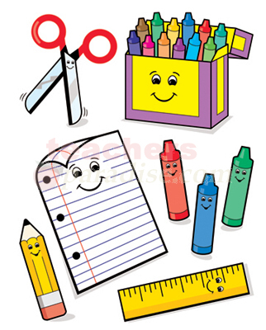
Kindergarten Supply List 2020-2021
1 - Backpack

2 - Pencil box
1 package - Pencil erasers package
1 - Big Erasers (rectangular)
1 - Scissors
2 - 24 pack of pencils #2 (presharpened)
1 - Crayons
1 - Crayola Marker Set
2 packages - Expo Dry Erase Markers
10-12 Glue Sticks
1 package - Highlighters
Index Cards
PE Shoes
Water Bottle
Personal Headphones
1 - Gallon Ziplock bags
1 - ream of copy paper
1 - ream of Astrobright cardstock

Your kindergarten student will keep their main supplies in their desk. The extra supplies will be kept in a ziplock bag and will be given to them as needed. This is very exciting for them to own their own supplies. One large pencil box or two regular pencil boxes are great for helping to keep them organized. I am so excited to start a new school year!!!

Mrs. Johnson

