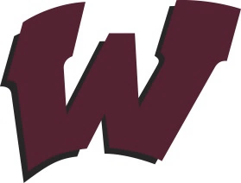
Wheaton R-III
School District Future Ready…Preparing Students for Success!
PO Box 249 – 116 McCall Ave. Wheaton, MO 64840 417.652.3914 www.wheatonschools.org 417.652.7355 fax
Dr. Trish Wilson
Superintendent
twilson@wheatonschools.org

Mr. Jody Cavness
High School Principal
jcavness@wheatonschools.org

Mr. Robert Creekmore
Director of Student Services
rcreekmore@wheatonschools.org

Mrs. Jordan McFall Elementary Principal jmcfall@wheatonschools.org

June 21, 2022

Dear Parents/Guardians,

The Seamless Summer Option for free school breakfasts and lunches has expired. This program has paid for all school meals for our students since August 2020. We know this has benefitted our families greatly, but, it has unfortunately come to an end.

Beginning in August 2022, school meal prices will go back into effect for students K-12. Student breakfasts will be $1.80 for Elementary & JH/HS. School lunches will be, Elementary $2.05 and JH/HS $2.30. Extra milk will be $0.50 and adult meals will be, breakfast $2.85 and lunch $3.40. Please be mindful of these prices as you plan ahead for the 2022-2023 school year.

Additionally, it is important to our school district for families that meet the requirements for the Free and Reduced Lunch Program to submit their application. These applications will be sent home at the beginning of the year along with other important paperwork the district will need completed. Not only is this program beneficial for families, but many federal and state programs also use school district free and reduced meal rates as a qualifying factor for grant funding.

If you have any questions, please do not hesitate to contact the Superintendent’s Office at 417-652-3914. I hope everyone has a great summer!

Sincerely,

Trish Wilson, Superintendent

J

