GradeBook- First Nine Weeks
1. Final grades must be entered in Gradebook – either through the Gradebook completing the calculations or the teacher completes a manual override through the Override Function in Teacher Gradebook. If teachers have not completed their Gradebook, then they must stop and enter only the final grade.
How to Manually Override a Final Average in PowerTeacher
Gradebook

1. Choose your first class in PowerTeacher Gradebook.
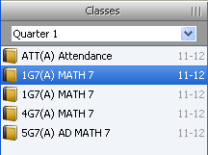

2. Right click or double click on the Final Grade column beside the student you want to manually adjust their final average
a. If you right click, click on Show Score Inspector
b. If you double click, the Final Grade box will automatically appear

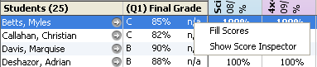

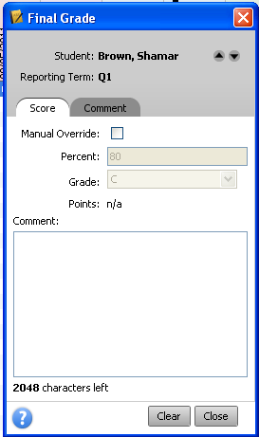
3. In the Final Grade box, make sure you are on the Score tab

85

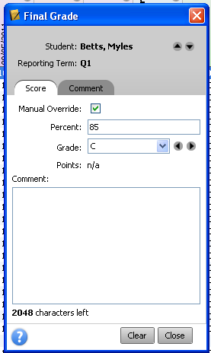

4. Put a check “” in the Manual Override box
a. Change the Percent to the corrected numerical b. Change the Grade to the correct numerical
i. Or use the arrows to toggle through for the numerical; if the grade is an “INC” or “EX”, the percent is 0.
c. Click Close.

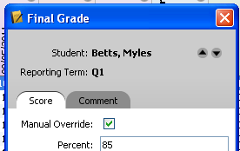
5. You can toggle between the students in this current class, to change multiple grades, by using the arrow buttons

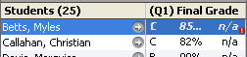
6. You will now see a red circle with a white “!” beside the student(s) Final Grade, this denotes a manual grade change has been done for that student

7. Click on your next class and repeat the above steps until you have made all the manual average adjustments needed.

8. You CAN NOT have a Final Grade over 100 for any student. If you do, you MUST go back and manually change their grade to 100 or less.

2. Once teachers have entered or calculated the final grade, they must “finalize” it in the Gradebook.
Final Grade Completion Status ****You must follow these steps for each class/course. Teachers must verify each class/course by highlighting the selected class/course under the Classes section.
Select the class/course that you want to verify.
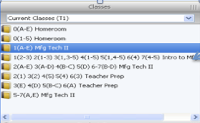

In the Scoresheet tab, click on the "Q1 in Progress" button and check the "Final Grades Complete" box.
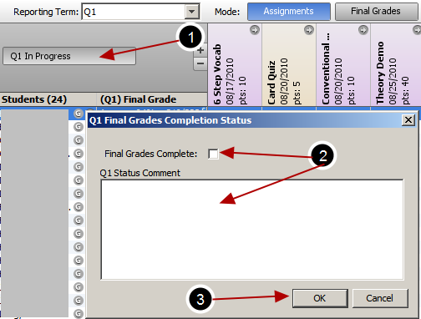
1. Click on the Q1 In Progress button and in the pop up window
2. Click in the Final Grades Complete box and type in a comment.
3. Click OK.

You are DONE! This is all you have to do to finalize your grades.

If a teacher has verified by accident, you can go back and make changes by:
- Selecting the class/course
- Clicking on the Q1 Completed tab
- Unchecking the Final Grades Complete box
- Click OK at the bottom
- Make the desired changes, and repeat the process again to verify.

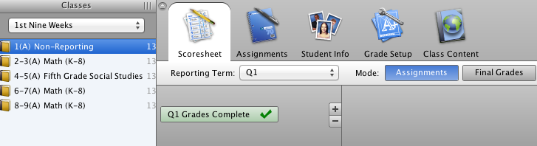

3. Data managers must print “Section Readiness Report from PowerTeacher” from the admin side. After signing and dating this report by the teacher, it is to be returned to the Data Manager immediately.
Run the Section Readiness Report
Run the Section Readiness Report at the end of a term to verify which course sections have complete or incomplete final grades.
- Navigate to Start Page> PT Administrator 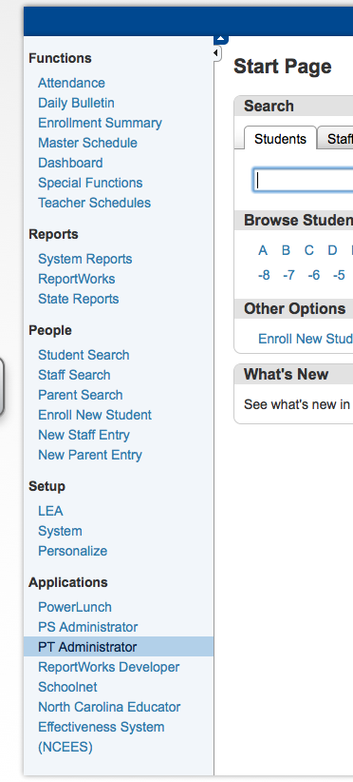
2. Hover your mouse over Reports
3. Click Section Readiness Report
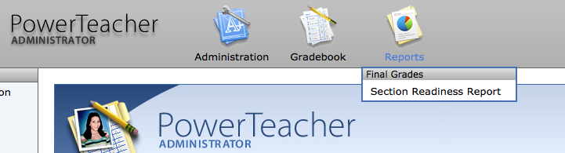

4. Make the appropriate choices on the Report Search screen:
• Select the Section Group to be included in the report
• Select how sections will be displayed on the report
• Select to include sections with complete, incomplete, or both types of final
grades on the report
• Select the School Year for which you want to verify final grades
• Select the Reporting Term for which you want to verify final grades

5. Click Run Report
6. Perform either of the following functions:
• Click Details in a section’s Show Grades/Comments column to view all the
students in the class, including the students’ grades and comments for their
calculated final scores

- After the Data Managers have collected all score sheets, they must “store” the teachers’ grades.
Store Grades
After teachers review the Grade Verification sheets and make any necessary changes to the students’ grades, you can store grades for the term. Storing grades copies each student’s final grade information and makes it a part of the student’s historical grade
record. Think of storing grades as taking a snapshot of current grades at one point in time. Graduation credit, if applicable, can also be awarded when grades are stored.

To store grades:
1. From the Start Page, navigate to System> Permanently Store Grades
2. Enter the store code that will be used to store grades
3. Enter the final grade
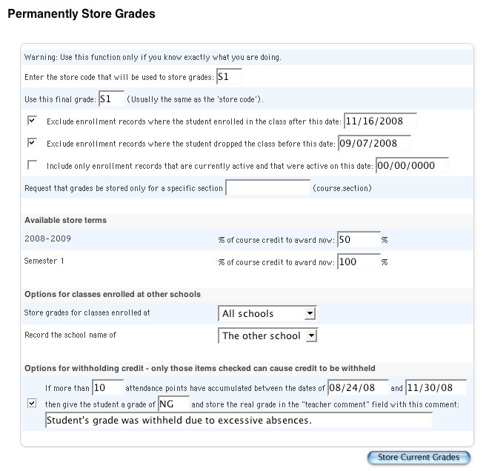
4. Select whether to exclude or include enrollment records and enter the corresponding dates
5. If storing grades for a single section only, enter the course/section number
6. Enter the amount of course credit to award for each available store term
7. If applicable, select whether to store grades for classes enrolled at All Schools or This School Only
8. If applicable, select whether to
record the school name of
This school or The other school

9. If withholding credit based on attendance points, select the Option for Withholding Credit check box, enter the number of attendance points, the date range, the alternative grade, and a comment
10. Click Store Current Grades

- Reports cards can only be printed 24 hours after the Data Managers have stored the teachers’ grades.
Print Report Cards
A report card marks a historical event in time. In the case of a report card, it marks a student’s historical grades. Once you’ve successfully stored grades, you can print report cards. Remember, if you perform this step before storing grades, you will be printing progress reports, not report cards.

To print report cards:
1. On the Start Page, select a group of students

2. Select Print Report from the Group Functions menu
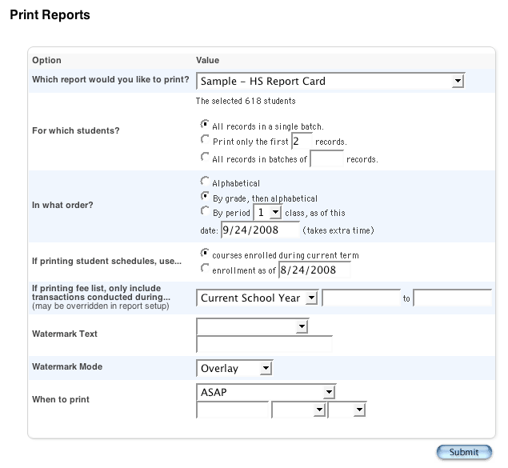
3. Select the report card to be printed

4. Select which students to print the report for

5. Select print order (applicable to student reports only)

6. If printing student schedules, select enrollments to include
(applicable to student reports only)

7. If printing a fee list, select which transactions to include

8. If using a watermark, select text and mode

9. Define when to print the report (applicable to student reports only)

10. Click Submit

