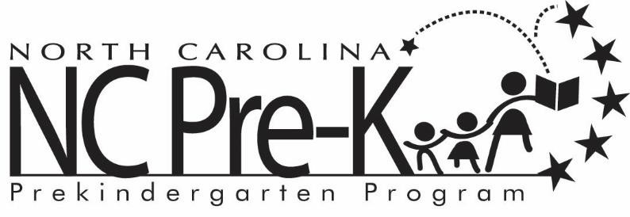

Statement of Unverifiable Income

To Whom It May Concern:

I am reporting $______________ as income to be used for my child’s Robeson County NC PreK Program application. I understand that this income will count toward eligibility for my child to receive NC Pre-K services. I am not able to provide employment documentation for the Robeson County Partnership for Children to verify this earned income.

____________________________________ ____________________________________
Parent’s Name Child’s Name

______________________________________
Signature

___________________
Date

