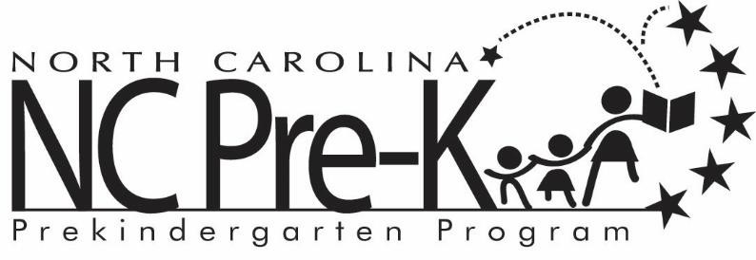

Statement of No Income

To Whom It May Concern:

I am reporting that I have no earned income, as stated on my child’s Robeson County NC Pre-K Program application.

____________________________________ ____________________________________
Parent’s Name Child’s Name

______________________________________
Signature

___________________
Date

