4th Grade Mathematics ● Unpacked Contents
For the new Standard Course of Study that will be effective in all North Carolina schools in the 2018-19 School Year.

This document is designed to help North Carolina educators teach the 4th Grade Mathematics Standard Course of Study. NCDPI staff are continually updating and improving these tools to better serve teachers and districts.

What is the purpose of this document?
The purpose of this document is to increase student achievement by ensuring educators understand the expectations of the new standards. This document may also be used to facilitate discussion among teachers and curriculum staff and to encourage coherence in the sequence, pacing, and units of study for grade-level curricula. This document, along with on-going professional development, is one of many resources used to understand and teach the NC SCOS.

What is in the document?
This document includes a detailed clarification of each standard in the grade level along with a sample of questions or directions that may be used during the instructional sequence to determine whether students are meeting the learning objective outlined by the standard. These items are included to support classroom instruction and are not intended to reflect summative assessment items. The examples included may not fully address the scope of the standard. The document also includes a table of contents of the standards organized by domain with hyperlinks to assist in navigating the electronic version of this instructional support tool.

How do I send Feedback?
Please send feedback to us at feedback@dpi.state.nc.us and we will use your input to refine our unpacking of the standards. Thank You!

Just want the standards alone?
You can find the standards alone at http://www.ncpublicschools.org/curriculum/mathematics/scos/.

North Carolina Course of Study – 4th Grade Standards
Standards for Mathematical Practice
Operations & Algebraic Thinking | Number & Operations in Base Ten | Number & Operations-Fraction | Measurement & Data | Geometry
Represent and solve problems involving multiplication and division.  NC.4.OA.1  Use the four operations with whole numbers to solve problems.  NC.4.OA.3  Gain familiarity with factors and multiples.  NC.4.OA.4  Generate and analyze patterns.  NC.4.OA.5 | Generalize place value understanding for multi-digit whole numbers.  NC.4.NBT.1  NC.4.NBT.2  NC.4.NBT.7  Use place value understanding and properties of operations to perform multi-digit arithmetic.  NC.4.NBT.4  NC.4.NBT.5  NC.4.NBT.6 | Extend understanding of fractions.  NC.4.NF.1  NC.4.NF.2  Build fractions from unit fractions by applying and extending previous understandings of operations on whole numbers.  NC.4.NF.3  Use unit fractions to understand operations of fractions.  NC.4.NF.4  Understand decimal notation for fractions, and compare decimal fractions.  NC.4.NF.6  NC.4.NF.7 | Solve problems involving measurement.  NC.4.MD.1  NC.4.MD.2  NC.4.MD.8  Solve problems involving area and perimeter.  NC.4.MD.3  Represent and interpret data.  NC.4.MD.4  Understand concepts of angle and measure angles.  NC.4.MD.6 | Classify shapes based on lines and angles in two-dimensional figures.  NC.4.G.1  NC.4.G.2  NC.4.G.3
Standards for Mathematical Practice

Practice | Explanation and Example
- Make sense of problems and persevere in solving them. | Mathematically proficient students in grade 4 know that doing mathematics involves solving problems and discussing how they solved them. Students explain to themselves the meaning of a problem and look for ways to solve it. Fourth graders may use concrete objects or pictures to help them conceptualize and solve problems. They may check their thinking by asking themselves, “Does this make sense?” They listen to the strategies of others and will try different approaches. They often will use another method to check their answers.
- Reason abstractly and quantitatively. | Mathematically proficient fourth grade students should recognize that a number represents a specific quantity. They connect the quantity to written symbols and create a logical representation of the problem at hand, considering both the appropriate units involved and the meaning of quantities. They extend this understanding from whole numbers to their work with fractions and decimals. Students write simple expressions, record calculations with numbers, and represent or round numbers using place value concepts.
- Construct viable arguments and critique the reasoning of others. | In fourth grade mathematically proficient students may construct arguments using concrete referents, such as objects, pictures, and drawings. They explain their thinking and make connections between models and equations. They refine their mathematical communication skills as they participate in mathematical discussions involving questions like “How did you get that?” and “Why is that true?” They explain their thinking to others and respond to others’ thinking.
- Model with mathematics. | Mathematically proficient fourth grade students experiment with representing problem situations in multiple ways including numbers, words (mathematical language), drawing pictures, using objects, making a chart, list, or graph, creating equations, etc. Students need opportunities to connect the different representations and explain the connections. They should be able to use all of these representations as needed. Fourth graders should evaluate their results in the context of the situation and reflect on whether the results make sense.
- Use appropriate tools strategically. | Mathematically proficient fourth grader students consider the available tools (including estimation) when solving a mathematical problem and decide when certain tools might be helpful. For instance, they may use graph paper or a number line to represent and compare decimals and protractors to measure angles. They use other measurement tools to understand the relative size of units within a system and express measurements given in larger units in terms of smaller units.
- Attend to precision. | As fourth grader students develop their mathematical communication skills, they try to use clear and precise language in their discussions with others and in their own reasoning. They are careful about specifying units of measure and state the meaning of the symbols they choose. For instance, they use appropriate labels when creating a line plot.
- Look for and make use of structure. | In fourth grade mathematically proficient students look closely to discover a pattern or structure. For instance, students use properties of operations to explain calculations (partial products model). They relate representations of counting problems such as tree diagrams and arrays to the multiplication principal of counting. They generate number or shape patterns that follow a given rule.
- Look for and express regularity in repeated reasoning. | Students in fourth grade should notice repetitive actions in computation to make generalizations Students use models to explain calculations and understand how algorithms work. They also use models to examine patterns and generate their own algorithms. For example, students use visual fraction models to write equivalent fractions.
Return to Standards

Operations and Algebraic Thinking

Represent and solve problems involving multiplication and division.
NC.4.OA.1 Interpret a multiplication equation as a comparison. Multiply or divide to solve word problems involving multiplicative comparisons using models and equations with a symbol for the unknown number. Distinguish multiplicative comparison from additive comparison.
Clarification | Checking for Understanding
A multiplicative comparison is a situation in which one quantity is multiplied by a specified number to get another quantity (e.g., “a is n times as much as b”). In a multiplicative comparison, the underlying question is what factor would multiply one quantity in order to result in the other. Students should be able to identify and verbalize which quantity is being multiplied and which number tells how many times.  Students should be able to translate comparative situations into equations with an unknown and solve. Many opportunities to solve contextual problems and write and identify equations and statements for multiplicative comparison should be provided. | Sally is five years old. Her mom is eight times older. How old is Sally’s Mom?  Possible response:  5 x 8 = 40.  5  5  5  5  5  5  5  5  40  A book costs $18. That is 3 times more than a DVD. How much does a DVD cost?  Possible response:  18 ÷ p = 3  or 3 x p = 18  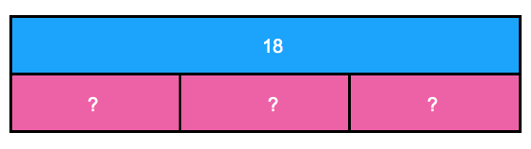
Return to Standards

Use the four operations with whole numbers to solve problems.
NC.4.OA.3 Solve two-step word problems involving the four operations with whole numbers.
- Use estimation strategies to assess reasonableness of answers.
- Interpret remainders in word problems.
- Represent problems using equations with a letter standing for the unknown quantity.
Clarification | Checking for Understanding
The focus in this standard is to have students use and discuss various strategies for solving word problems using all four operations. Students should build on the problem solving strategies they developed in earlier grades and apply those strategies to multi-step problems.  Students should be introduced to a variety of estimation strategies. Estimation strategies include identifying when estimation is appropriate, determining the level of accuracy needed, selecting the appropriate method of estimation, and verifying solutions or determining the reasonableness of situations using various estimation strategies. Estimation strategies include, but are not limited to:  - front-end estimation with adjusting (using the highest place value and estimating from the front end, making adjustments to the estimate by taking into account the remaining amounts),  - clustering around an average (when the values are close together an average value is selected and multiplied by the number of values to determine an estimate),  - rounding and adjusting (students round down or round up and then adjust their estimate depending on how much the rounding affected the original values),  - using friendly or compatible numbers such as factors (students seek to fit numbers together - e.g., rounding to factors and grouping numbers together that have round sums like 100 or 1000),  - using benchmark numbers that are easy to compute (students select close whole numbers for fractions or decimals to determine an estimate).  Problems should be structured so that all acceptable estimation strategies will arrive at a reasonable answer. The assessment of estimation strategies should only have one reasonable answer (500 or 530), or a range (between 500 and 550).  This standard also references interpreting remainders. Remainders should be put into context for interpretation. Ways to address remainders:  - Remain as a left over  - Partitioned into fractions or decimals  - Discarded leaving only the whole number answer  - Increase the whole number answer up one  - Round to the nearest whole number for an approximate result | On a vacation, your family travels 267 miles on the first day, 194 miles on the second day and 34 miles on the third day. How many miles did they travel total? How do you know your answer is reasonable?  Possible responses:  Student 1 I first thought about 267 and 34. I noticed that their sum is about 300. Then I knew that 194 is close to 200. When I put 300 and 200 together, I get 500. Student 2 I first thought about 194. It is really close to 200. I also have 2 hundreds in 267. That gives me a total of 4 hundreds. Then I have 67 in 267 and the 34. When I put 67 and 34 together that is really close to 100. When I add that hundred to the 4 hundreds that I already had, I end up with 500. Student 3 I rounded 267 to 300. I rounded 194 to 200. I rounded 34 to 30. When I added 300, 200 and 30, I know my answer will be about 530.  Your class is collecting bottled water for a service project. The goal is to collect 300 bottles of water. On the first day, Max brings in 6 packs with 6 bottles in each container. About how many bottles of water still need to be collected?  Possible responses:  Student 1 First, I multiplied 6 and 6 which equals 36. I’m trying to get to 300. 36 is close to 40, and 40 plus 60 is 100. Then I need 2 more hundreds. So, we still need about 260 bottles. Student 2 First, I multiplied 6 and 6 which equals 36. I know 36 is about 40 and 300-40 = 260, so we need about 260 more bottles.  Write different word problems involving 44 ÷ 6 = ? where the answers are best represented as:  Problem A: 7  Problem B: 7 r 2  Problem C: 8  Problem D: 7 or 8  Problem E: 7  Possible responses:  Problem A: 7. Mary had 44 pencils. Six pencils fit into each of her pencil pouches. How many pouches did she fill? 44 ÷ 6 = p; p = 7 r 2. Mary can fill 7 pouches completely.  Problem B: 7 r 2. Mary had 44 pencils. Six pencils fit into each of her pencil pouches. How many pouches could she fill and how many pencils would she have left? 44 ÷ 6 = p; p = 7 r 2; Mary can fill 7 pouches and have 2 left over.  Problem C: 8. Mary had 44 pencils. Six pencils fit into each of her pencil pouches. What would the fewest number of pouches she would need in order to hold all of her pencils? 44 ÷ 6 = p; p = 7 r 2; Mary needs 8 pouches to hold all of the pencils.  Problem D: 7 or 8. Mary had 44 pencils. She divided them equally among her friends before giving one of the leftovers to each of her friends. How many pencils could her friends have received? 44 ÷ 6 = p; p = 7 r 2; Some of her friends received 7 pencils. Two friends received 8 pencils.  Problem E: 7 . Mary had 44 pencils and put six pencils in each pouch. What fraction represents the number of pouches that Mary filled? 44 ÷ 6 = p; p = 7  There are 1,128 students going on a field trip. If each bus held 30 students, how many buses are needed?  1,128 ÷ 30 = b; b = 37 R 6; They will need 38 buses because 37 buses would not hold all of the students.
Return to Standards

Gain familiarity with factors and multiples.
NC.4.OA.4 Find all factor pairs for whole numbers up to and including 50 to:
- Recognize that a whole number is a multiple of each of its factors.
- Determine whether a given whole number is a multiple of a given one-digit number.
- Determine if the number is prime or composite.
Clarification | Checking for Understanding
This standard requires students to demonstrate understanding of factors and multiples of whole numbers up to and including 50. Factor pairs include two numbers that when multiplied result in a particular product. Students should be given opportunities to explore factor pairs with concrete objects and drawings to represent arrays.  Multiples are the result of multiplying two whole numbers. Multiples can be related to factors, and this relationship can be discovered through exploration with arrays. Students can build on their understanding of skip counting by a given number to determine the multiples of the given number.  As students explore and discover patterns, they build a conceptual understanding of prime and composite numbers. Prime numbers have exactly two factors, the number one and their own number. For example, the number 17 has the factors of 1 and 17. Composite numbers have more than two factors. For example, 8 has the factors 1, 2, 4, and 8. A common misconception is that the number 1 is prime, when it is neither prime nor composite. Another common misconception is that all prime numbers are odd numbers. This is not true, since the number 2 has only 2 factors, 1 and 2, and is also an even number. | There are 24 chairs in the art room. What are the different ways that the chairs can be arranged into equal groups if you want at least 2 groups and want at least 2 chairs in each group?  - How do you know that you have found every arrangement? Write division equations to show your answers.  There are 48 chairs in the multi-purpose room. What are the different ways that the chairs can be arranged into equal groups if you want at least 2 groups and want at least 2 chairs in each group?  - How do you know that you have found every arrangement? Write division equations to show your answers.  - What relationship do you notice about the size of the groups if the chairs were arranged in 4 groups in both Part 1 and Part 2?  - What about if the chairs were arranged in 8 groups? Explain why you think this relationship exists.  A landscaping company visits the school to talk about the possible ways to tile a patio and picnic area near the playground. The school can afford between 24 and 30 square tiles.  - For each of the proposed number of tiles (24-30), determine all of the possible dimensions of rectangles you could make.  - The space for the patio is configured so that there cannot be any more than 10 tiles in a row. For the proposed number of tiles (24-30), determine which numbers would work as the total number of tiles.  - Which number of tiles provides the most flexibility in terms of the possible ways that the tiles could be arranged? Explain your reasoning.
Return to Standards

Generate and analyze patterns.
NC.4.OA.5 Generate and analyze a number or shape pattern that follows a given rule.
Clarification | Checking for Understanding
The ability to recognize and explain patterns in mathematics leads students to developing the ability to make generalizations, a foundational concept in algebraic thinking. Students need multiple opportunities creating and extending number and shape patterns. This standard does not require students to infer or guess the underlying rule for a pattern, but rather asks them to generate a pattern from a given rule and identify features of the given pattern.  Patterns and rules are related. A pattern is a sequence that repeats the same process over and over. A rule dictates what that process will look like. Students investigate different patterns to find rules, identify features in the patterns, and justify the reason for those features.  This standard begins with a small focus on reasoning about a number or shape pattern, connecting a rule for a given pattern with its sequence of numbers or shapes. Patterns that consist of repeated sequences of shapes or growing sequences of designs would be appropriate for fourth grade. | Ted and Nancy both mow lawns during the summer to earn money.  Ted charges $10 per lawn and $2 per hour.  Nancy charges $4 per lawn and $4 per hour.  Complete the table to show how much Ted and Nancy would each earn based on the amount of time that it took to mow a lawn.  Ted Nancy  ½ hour  1 hour  1 and ½ hours  2 hours  2 and ½ hours  3 hours  3 and ½ hours  4 hours  There are 4 beans in the jar. Each day 3 beans are added. How many beans are in the jar for each of the first 5 days?  Day Operation Beans  0 3 x 0 + 4 4  1 3 x 1 + 4 7  2 3 x 2 + 4 10  3 3 x 3 + 4 13  4 3 x 4 + 4 16  5 3 x 5 + 4 19
Return to Standards

Number and Operations in Base Ten

Generalize place value understanding for multi-digit whole numbers.
NC.4.NBT.1 Explain that in a multi-digit whole number, a digit in one place represents 10 times as much as it represents in the place to its right, up to 100,000.
Clarification | Checking for Understanding
This standard calls for students to extend their understanding of place value related to multiplying and dividing by multiples of 10. In this standard, students should reason about the magnitude of digits in a number. In the base-ten system, the value of each place is 10 times the value of the place to the immediate right. Students should reason and analyze the relationships of numbers that they are working with. | Part 1:  Gina said, “In my pocket I have 25 of the same amount of dollar bills. What is the value of Gina’s money if she has:  - 25 one dollar bills  - 25 ten dollar bills  - 25 hundred dollar bills  Part 2:  Gina reasoned, “The value of the 2 when I have ten dollar bills is 200, but the value of the 2 when I have one dollar bills is only 20.” Is Gina correct? Why or why not?  Part 3:  If you had 260 of each of the kinds of dollar bills in parts a, b, and c above; what would the value of each kind of bill be? Explain how you found your answer.

Generalize place value understanding for multi-digit whole numbers.
NC.4.NBT.2 Read and write multi-digit whole numbers up to and including 100,000 using numerals, number names, and expanded form.
Clarification | Checking for Understanding
This standard asks for students to write numbers in various forms. Students should have flexibility with the different forms of a number.  Written form or number name is to write out a number in words like “two hundred eighty-five.” Traditional expanded form is 285 = 200 + 80 + 5. However, students should have opportunities to explore the idea that 285 could also be 28 tens plus 5 ones or 1 hundred, 18 tens, and 5 ones. They should also be comfortable with expanding a number by place value such as (2 x 100) + (8 x 10) + (5 x 1).  To read numerals between 1,000 and 100,000, students need to understand the role of commas. Each section between commas is read a hundreds, tens, and ones followed by the appropriate unit (thousands). 97,345 would be read ninety-seven thousand, three hundred forty-five. | Juice pouches are packaged in different ways. A box holds 10 pouches. A case holds 10 boxes. A crate holds 10 cases.  Some students bring in juice boxes for Field Day. The information is below.  Miguel- 1 crate, 12 cases, 3 boxes and 6 pouches.  Aaron- 1 crate, 13 cases, 17 boxes, and 2 pouches.  Sarah- 1 crate, 12 cases, 2 boxes and 17 pouches.  Vicky- 1 crate, 14 cases, 6 boxes, and 9 pouches.  - If each person were going to reorganize their drink pouches to use as many of the larger containers as possible, how many of each container would each of them need?  - How many total drink pouches does each student have?
Return to Standards

Generalize place value understanding for multi-digit whole numbers.
NC.4.NBT.7 Compare two multi-digit numbers up to and including 100,000 based on the values of the digits in each place, using >, =, and < symbols to record the results of comparisons.
Clarification | Checking for Understanding
In this standard, students use their understanding of groups and value of digits to compare two numbers by examining the value of the digits. Students are expected to be able to compare numbers presented in various forms.  Students should have ample experiences communicating their comparisons in words before using symbols. Students were introduced to the symbols greater than (>), less than (<) and equal to (=) in First Grade and continue to use them.  While students may have the skills to order more than 2 numbers, this standard focuses on comparing two numbers and using reasoning about place value to support the use of the various symbols. | Compare these two numbers. 75,452 __ 75,455  Possible responses:  Student A Place Value 75,452 has 75 thousands, 4 hundreds, 5 tens, and 2 ones. 75,455 has 75 thousands, 4 hundreds, 5 tens, and 5 ones. They have the same number of thousands, hundreds and the same number of tens, but 455 has 5 ones and 75,452 only has 2 ones. 75,452 is less than 455. 75,452 < 75,455 Student B Counting 75,452 is less than 75,455. I know this because they have the same thousands. So, I’m going to compare 452 and 455. When I count up I say 452 before I say 455. 75,452 is less than 75,455. 75,452 < 75,455 .
Return to Standards

Use place value understanding and properties of operations to perform multi-digit arithmetic.
NC.4.NBT.4 Add and subtract multi-digit whole numbers up to and including 100,000 using the standard algorithm with place value understanding.
Clarification | Checking for Understanding
In this standard, students build on their conceptual understanding of addition and subtraction, their use of place value and their flexibility with multiple strategies to make sense of the standard algorithm. They continue to use place value in describing and justifying the processes they use to add and subtract. Students are expected to explain their thinking to show understanding of the algorithm.  This is the first grade level in which students are expected to be proficient at using the standard algorithm to add and subtract. However, other previously learned strategies are still appropriate for students to use.  In mathematics, an algorithm is defined by its steps and not by the way those steps are recorded in writing. With this in mind, minor variations in methods of recording standard algorithms are acceptable.  Students may ask if it is possible to subtract a larger number from a smaller number. While it is not the focus or expectation of this standard in this grade, students should know that it is mathematically possible, and they will be learning more about that concept in later grades. If the misconception that larger numbers cannot be subtracted from smaller numbers is confirmed or reinforced, students may struggle to make the transition to negative numbers in later grades. | The following amounts of juice were in separate containers after the school’s parent breakfast.  - Container 1: 750 mL  - Container 2: 1,450 mL  - Container 3: 2,087 mL  - Container 4: 299 mL  - Container 5: 476 mL  If all of the liquid was put into one large container how much liquid would be in the large container?  On a field trip, three different schools send their fourth graders across town to the high school for a math competition. Each school sends between 120 and 170 students each. There are 417 students total.  - How many students could have come from each school? Show your thinking.  - Find another possible solution to this task. Show your thinking.  - If the number of students from each school was the same, how many students came from each school? Explain how you found your solution.
Return to Standards

Use place value understanding and properties of operations to perform multi-digit arithmetic.
NC.4.NBT.5 Multiply a whole number of up to three digits by a one-digit whole number, and multiply up to two two-digit numbers with place value understanding using area models, partial products, and the properties of operations. Use models to make connections and develop the algorithm.
Clarification | Checking for Understanding
In this standard, students extend their understanding of multiplying a single-digit factor times a multiple of ten to multiplying a single-digit factor times multi-digit factors. Students will also begin their exploration of multiplying two two-digit factors. Students should be able to apply their understanding of place value and various forms of a number to compute products. Students will also use area models, partial products and properties of operations to solve multiplication problems  Connections should be made between models and written equations, but it is not necessary for fourth grade students to use the standard algorithm. The standard algorithm for multiplication is not an expectation until fifth grade. | There are 25 dozen cookies in the bakery. What is the total number of cookies at the bakery?  Possible responses:  Student A 25 x12 I broke 12 up into 10 + 2 25 x 10 = 250 25 x 2 = 50 250 + 50 = 300 Student B 25 x 12 I broke 25 up into 5 groups of 5 5 x 12 = 60 There are 5 groups of 5 in 25 60 x 5 = 300 Student C 25 x 12 I doubled 25 and cut 12 in half to get 50 x 6 50 x 6 = 300  In the cafeteria, there are 14 long tables. Each table seats 16 students. How many students can eat in the cafeteria at one time?  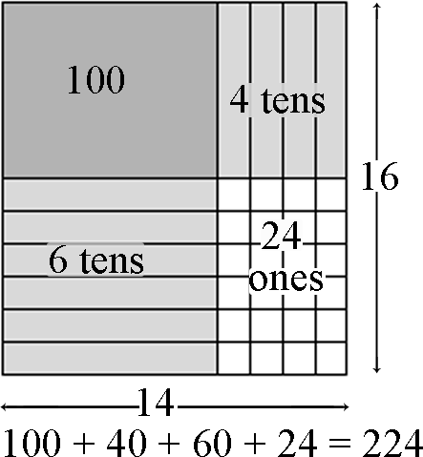  Using base ten blocks to model this problem, this student sees:  (10 + 4) x (10 + 6) =  1 hundred 4 tens 6 tens 24 ones 10 x 10 4 x 10 6 x 10 6 x 4 100 40 60 24  14 x 16 = 224  There are 38 buses in the parking lot, and each bus holds 74 people. How many people are able to ride the buses?  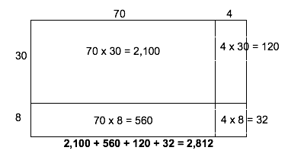  This student draws an area model. The student uses the model and understanding of partial products to solve the multiplication problem.
Return to Standards

Use place value understanding and properties of operations to perform multi-digit arithmetic.
NC.4.NBT.6 Find whole-number quotients and remainders with up to three-digit dividends and one-digit divisors with place value understanding using rectangular arrays, area models, repeated subtraction, partial quotients, properties of operations, and/or the relationship between multiplication and division.
Clarification | Checking for Understanding
In this standard, students build on their understanding of the meaning of division and the relationship to multiplication by modeling, writing, and explaining division by a one-digit divisor. This standard calls for students to explore division through various strategies. Students should be able to apply their understanding of place value and various forms of a number to compute quotients. Students will also use arrays and area models, repeated subtraction, partial quotients and properties of operations to solve division problems  This standard also references interpreting remainders. Remainders should be put into context for interpretation. Ways to address remainders:  - Remain as a left over  - Partitioned into fractions or decimals  - Discarded leaving only the whole number answer  - Increase the whole number answer up one  - Round to the nearest whole number for an approximate result  The focus of this standard is to build conceptual understanding of division. Students are expected to use various strategies and explain their thinking. Students are not expected to master the traditional algorithm until middle school. | A 4th grade teacher bought 4 new pencil boxes. She has 260 pencils. She wants to put the pencils in the boxes so that each box has the same number of pencils. How many pencils will there be in each box?  Possible responses:  - Using Base 10 Blocks: Students build 260 with base 10 blocks and distribute them into 4 equal groups. Some students may need to trade the 2 hundreds for tens but others may easily recognize that 200 divided by 4 is 50.  - Using Place Value: 260 ÷ 4 = (200 ÷ 4) + (60 ÷ 4)  - Using Multiplication: 4 x 50 = 200, 4 x 10 = 40, 4 x 5 = 20; 50 + 10 + 5 = 65; so, 260 ÷ 4 = 65  There are 592 students participating in Field Day. They are put into teams of 8 for the competition. How many teams get created?  Student 1 592 divided by 8 There are 70 8’s in 560 592 - 560 = 32 There are 4 8’s in 32 70 + 4 = 74 Student 2 592 divided by 8 I know that 10 8’s is 80 If I take out 50 8’s that is 400 592 - 400 = 192 I can take out 20 more 8’s which is 160 192 - 160 = 32 4 groups of 8 is 32 I have none left I took out 50, then 20 more, then 4 more. That’s 74 Student 3 I want to get to 592 8 x 25 = 200 8 x 25 = 200 8 x 25 = 200 200 + 200 + 200 = 600 600 - 8 = 592 I had 75 groups of 8 and took one away, so there are 74 teams  Using an Open Array or Area Model  Example: 150 ÷ 6  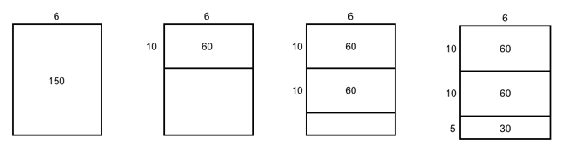  Students make a rectangle and write 6 on one of its sides. They express their understanding that they need to think of the rectangle as representing a total of 150.  - What number is a number close to 150? Students recognize that 6 x 10 is 60 so they record 10 as a factor and partition the rectangle into 2 rectangles and label the area aligned to the factor of 10 with 60. They express that they have only used 60 of the 150 so they have 90 left.  - Recognizing that there is another 60 in what is left they repeat the process above. They express that they have used 120 of the 150 so they have 30 left.  - Knowing that 6 x 5 is 30. They write 30 in the bottom area of the rectangle and record 5 as a factor.  - Students express their calculations in various ways:  - 150 150 ÷ 6 = 10 + 10 + 5 = 25  - 60 (6 x 10)  90  - 60 (6 x 10)  30  - 30 (6 x 5)  0  - 150 ÷ 6 = (60 ÷ 6) + (60 ÷ 6) + (30 ÷ 6) = 10 + 10 + 5 = 25
Return to Standards

Number and Operations—Fractions

Extend understanding of fractions.
NC.4.NF.1 Explain why a fraction is equivalent to another fraction by using area and length fraction models, with attention to how the number and size of the parts differ even though the two fractions themselves are the same size.
Clarification | Checking for Understanding
While working on NC.4.NF.1 students always use area and length fraction models to explain how fractions are equivalent to each other. Area models include circles and rectangles while length models typically focus on number lines. Students should not do any work on this standard without the use of a model. Students only work with the denominators 2, 3, 4, 5, 6, 8, 10, 12, and 100 in this Standard. | Kennedy rode her bike down a straight road and stopped at the halfway point for water. Courtney also biked the same distance but broke her bike ride into 4 equal parts to get water. Did Courtney and Kennedy ever stop at the same place to get water? How do you know? Draw and label a number line to support your conclusions.  Possible student response:  Courtney broke her ride into fourths since she had 4 equal parts. Kennedy stopped at the halfway point. Based on the number line Courtney stopped 2/4 of the way down the road which is the same point as one half.  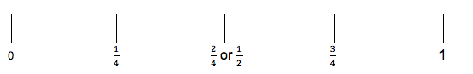  Mr. Gomez and Mr. Lopez each have vegetable gardens that are the same size. Mr. Gomez plants carrots in 6/8 of his garden. If Mr. Lopez has 4 regions and wants to plant carrots in the same sized space as Mr. Gomez how many of the regions will he plant carrots in? Draw a picture and write a sentence to explain your answer.  Possible response:  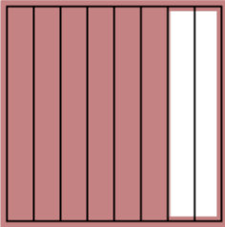 Mr. Gomez: 6/8  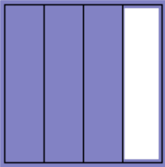 Mr. Lopez: I know that 2/8 = ¼ and 6/8 is 2/8 + 2/8 + 2/8. That means that Mr. Lopez’s garden is ¼ + ¼ + ¼ = ¾.
Return to Standards

Extend understanding of fractions.
NC.4.NF.2 Compare two fractions with different numerators and different denominators, using the denominators 2, 3, 4, 5, 6, 8, 10, 12, and 100. Recognize that comparisons are valid only when the two fractions refer to the same whole. Record the results of comparisons with symbols >, =, or <, and justify the conclusions by:
- Reasoning about their size and using area and length models.
- Using benchmark fractions 0, ½, and a whole.
- Comparing common numerator or common denominators.
Clarification | Checking for Understanding
In NC.4.NF.2 students compare two fractions with the denominators 2, 3, 4, 5, 6, 8, 10, 12, and 100. They are expected to reason about their size and justify their comparison using area and length models, including circles, rectangles, and number lines. Students are also expected to use the benchmark fractions 0, ½ and 1 whole to compare fractions. It’s important to note that this standard does not address the use of an algorithm such as cross multiplication, for comparing fractions. A student’s justification that relies solely on explaining the steps of an algorithm would not demonstrate mastery of this standard. | Crystal and Katie are each running a mile. Crystal ran ¾ of a mile before stopping for water, while Katie ran 2/3 of a mile before stopping. Who ran the farthest before stopping? Draw a picture or write a sentence to support your answer.  Possible responses:  Student 1: Crystal ran more since ¾ is farther from 0 than 2/3.  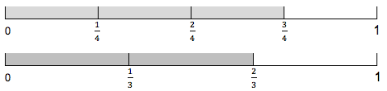  Student 2:  I noticed that Crystal ran ¼ less than a whole and Katie ran 1/3 less than a whole. Since ¼ is smaller than 1/3 I know Crystal ran the farthest. I then drew a number line to check my work.
Return to Standards

Build fractions from unit fractions by applying and extending previous understandings of operations on whole numbers.
NC.4.NF.3 Understand and justify decompositions of fractions with denominators of 2, 3, 4, 5, 6, 8, 10, 12, and 100.
- Understand addition and subtraction of fractions as joining and separating parts referring to the same whole.
- Decompose a fraction into a sum of unit fractions and a sum of fractions with the same denominator in more than one way using area models, length models, and equations.
- Add and subtract fractions, including mixed numbers with like denominators, by replacing each mixed number with an equivalent fraction, and/or by using properties of operations and the relationship between addition and subtraction.
- Solve word problems involving addition and subtraction of fractions, including mixed numbers by writing equations from a visual representation of the problem.
Clarification | Checking for Understanding
NC.4.NF.3 calls for students to solve addition and subtraction problems with like denominators of 2, 3, 4, 5, 6, 8, 10, 12, and 100. A unit fraction is a term that identifies the size of 1 fractional piece in a whole. For example, 1/3 is the unit fraction that identifies a whole being divided into 3 equal pieces. Just as there are 3, one inch units in the length of 3 inches, there are 2, 1/3 units in the fraction 2/3.  The first two bullets focus on the conceptual development of what addition and subtraction of fractions looks like with area and length models. These models should also be used to support students’ work when they add and subtract fractions in the latter two bullets of this standard. When students are able to fluently decompose fractions, including mixed numbers, it supports their work when adding and subtracting fractions. | After a pizza party there is 7/8 of a pizza left. Some pieces of the pizza are cheese, some are pepperoni, and some are vegetable. What fraction of a pizza could be cheese, pepperoni, and vegetable? Draw a picture and write an equation to represent the amounts of each type of pizza that are remaining. Find at least two combinations.  Possible student response:  4/8 + 2/8 + 1/8 = 7/8 2/8 + 3/8 + 2/8 = 7/8  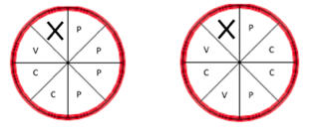  There is some firewood on the pile. Mr. Mickelson adds 7/8 pounds of firewood. If there is now 2 and 1/8 of firewood on the pile how much firewood was first there?  Possible student responses:  Student 1 I wrote the equation 2 1/8 – 7/8 to find out how much firewood was first there. I then drew a picture of 2 and 1/8 and crossed out 7/8. I had 1 and 2/8 or 1 and 1/4 left. Student 2 I drew 7/8 and then added on until I reached 2 and 1/8. I then went back and counted. I added 1/8 + 1 + 1/8 which is 1 and 2/8 or 1 and ¼ pounds.  Student 3  I renamed 2 and 1/8 into an equivalent fraction 17/8. I then took 7/8 away from 17/8 which got me an answer of 10/8. When I drew the picture, I realized 10/8 is 1 whole and 2/8, which is 1 and 2/8 pounds.  Brielle ran 1 and 2/3 miles less than Kim. Brielle ran 2 and 2/3 miles. How far did Kim run? Draw a number line and an equation to support your answer.  Possible student responses:  Student 1:  I started at 2 and 2/3 since that was how far Brielle ran. Since Brielle ran less than Kim I knew I had to add 1 and 2/3. I broke the 2/3 up into 2 jumps of a 1/3 so I could land on 3, then jump to 4, then landed on 4 and 1/3. An equation is 2 2/3 + 1 2/3 = 4 1/3.  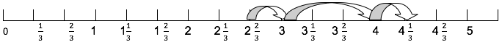  Student 2:  I started at 2 and 2/3 since that was how far Brielle ran. Since Brielle ran less than Kim I knew I had to add 1 and 2/3. I jumped 1 to land on 3 and 2/3. I then made 2 jumps of 1/3 and landed on 4 and 1/3. An equation is 2 2/3 + 1 2/3 = 4 1/3.  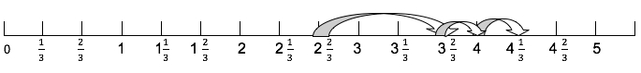
Return to Standards

Use unit fractions to understand operations of fractions.
NC.4.NF.4 Apply and extend previous understandings of multiplication to:
- Model and explain how fractions can be represented by multiplying a whole number by a unit fraction, using this understanding to multiply a whole number by any fraction less than one.
- Solve word problems involving multiplication of a fraction by a whole number.
Clarification | Checking for Understanding
This standard calls for students to understand a fraction as a whole number of groups of a unit fraction. A unit fraction is a term that identifies the size of 1 fractional piece in a whole. For example, 1/3 is the unit fraction that identifies a whole being divided into 3 equal pieces. Just as there are 3, one inch units in the length of 3 inches, there are 2, 1/3 units in the fraction 2/3.  They use a unit fraction as well as repeated addition to establish a foundation for the process of multiplying a whole number by a fraction (4 x 2/3 = 2/3 + 2/3 + 2/3 + 2/3 = (4x2)/3. Students use both area and length models to explore and solve word problems. All fractions are limited to the denominators of 2, 3, 4, 5, 6, 8, 10, 12. | Express the fraction 3/6 as the product of a whole number and a unit fraction. Draw a model which supports your answer.  Possible student response:  3/6 = 3 * 1/6.  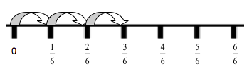  Tomas and Hector are running at P.E. Tomas runs 3/4 of a mile. Hector runs 3 times as far as Tomas. How far did Hector run?  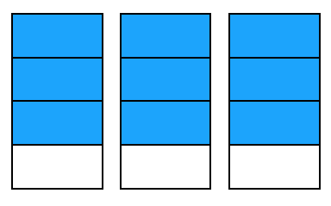  Hector ran ¾ times 3 = 9/4 miles.
Return to Standards

Understand decimal notation for fractions and compare decimal fractions.
NC.4.NF.6 Use decimal notation to represent fractions.
- Express, model and explain the equivalence between fractions with denominators of 10 and 100.
- Use equivalent fractions to add two fractions with denominators of 10 or 100.
- Represent tenths and hundredths with models, making connections between fractions and decimals.
Clarification | Checking for Understanding
Students work with decimals for the first time in fourth grade. Students should have ample opportunities to explore and reason about the idea that a number can be represented as both a fraction and a decimal. This standard establishes the connection that a fraction that has been equally partitioned into 10 or 100 equal parts (10th and 100ths) can also be written as a decimal.  Students make connections between fractions with denominators of 10 and 100 and the place value chart.  By reading fraction names, students say 32/100 as thirty-two hundredths and rewrite this as 0.32 or represent it on a place value model as shown below.  Hundreds Tens Ones • Tenths Hundredths  • 3 2 | Rosita has 8/10 of a meter of ribbon. However, the directions for her craft product have directions written about hundredths of a meter. What is an equivalent decimal to 8/10 to the hundredths place?  Possible response:  I shaded in 8 columns on the decimal grid. That is the same as 80/100 which can also be written as 0.8 or 0.80.  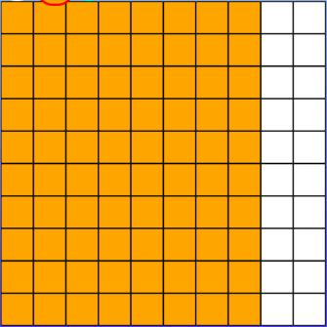  Mitch swam 5/10 of a mile on Saturday and 39/100 a mile on Sunday. How much did Mitch swim on the two days? Use a decimal grid to show your answer and write your answer as a decimal.  Possible response:  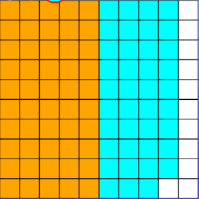  89 of the one hundred squares are shaded so Mitch swam 89/100 of a mile. I can also write 89/100 as 0.89.

Understand decimal notation for fractions and compare decimal fractions.
NC.4.NF.7 Compare two decimals to hundredths by reasoning about their size using area and length models, and recording the results of comparisons with the symbols >, =, or <. Recognize that comparisons are valid only when the two decimals refer to the same whole.
Clarification | Checking for Understanding
Students should reason that comparisons are only valid when they refer to the same whole. Comparisons should only be done in Grade 4 with area and length models, which include decimal grids, decimal circles, number lines, and meter sticks. | Sarah drinks 0.37 Liters of juice. Rochelle drinks 0.4 Liters of juice. Who drank more juice? Draw a picture and explain your reasoning.  Possible response:  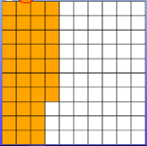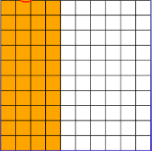  Sarah Rochelle  Sarah drank 37 hundredths of a Liter, while Rochelle drank 4 tenths or 40 hundredths of a Liter. Rochelle drank more.  Denard lives 0.67 km from school and Calvin lives 0.76 km from school. Draw a number line to show who lives the farthest from school.  Possible student response:  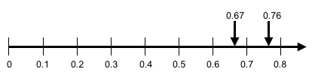  Denard lives 67 hundredths of a kilometer away which is less than 7 tenths of a kilometer. Calvin lives 76 hundredths of a kilometer away which is greater than 7 tenths. Calvin lives farther from school than Denard.
Return to Standards

Measurement and Data

Solve problems involving measurement.
NC.4.MD.1 Know relative sizes of measurement units. Solve problems involving metric measurement.
- Measure to solve problems involving metric units: centimeter, meter, gram, kilogram, Liter, milliliter.
- Add, subtract, multiply, and divide to solve one-step word problems involving whole-number measurements of length, mass, and capacity that are given in metric units.
Clarification | Checking for Understanding
In this standard, students reason about the units of length, capacity and weight using metric units. Students need to develop a basic understanding of the size and weight of metric units and apply this understanding when estimating and measuring. Students should understand how to express larger measurements in smaller units within the metric system to reinforce notions of place value.  Word problems should only be one-step and include the same units. Students are not expected to do conversions between units before solving problems. | One can of soda holds 355 mL. A large container holds 5 times more punch than the can of soda. How much soda does the large container hold?  I have 4,325 L of punch. I want to divide the punch equally into 5 containers. How much punch will be in each container?

Solve problems involving measurement.
NC.4.MD.2 Use multiplicative reasoning to convert metric measurements from a larger unit to a smaller unit using place value understanding, two-column tables, and length models.
Clarification | Checking for Understanding
In this standard, students should understand how to express larger measurements in smaller units within the metric system to reinforce notions of place value. Students will make metric conversions from larger units to smaller units exploring the relationship between the units. Students may use a two-column chart to convert from larger to smaller units and record equivalent measurements.  Through exploration with place value and conversions, students may explore with various metric prefixes. However, students are only responsible for knowing conversions between centimeter/meter, gram/kilogram, and Liter/milliliter.  Students are able to use their place value understanding to make statements such as, if 1 meter is 100 centimeters, then 3 meters is 300 centimeters because 3 hundreds is 300. | Crystal has 8 Liters of soda. How many milliliters does she have?  Complete the table below:  Meters Centimeters  3  4  4.5  12  120
Return to Standards

Solve problems involving measurement.
NC.4.MD.8 Solve word problems involving addition and subtraction of time intervals that cross the hour.
Clarification | Checking for Understanding
In this standard, students apply addition and subtraction strategies to find an end time, amount of time passed, or a start time. In third grade, students determined elapsed time within an hour. This standard calls for students to be able to cross over the hour. Students should use tools such as clocks, time lines, and tables to solve problems. | The movie started at 2:30 pm and lasted for 1 hour and 35 minutes. What time did the movie end?  Possible response:  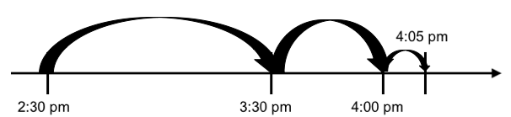
Return to Standards

Solve problems involving area and perimeter.
NC.4.MD.3 Solve problems with area and perimeter.
- Find areas of rectilinear figures with known side lengths.
- Solve problems involving a fixed area and varying perimeters and a fixed perimeter and varying areas.
- Apply the area and perimeter formulas for rectangles in real world and mathematical problems.
Clarification | Checking for Understanding
In this standard, students will apply their previous understanding of perimeter and area to problem situations.  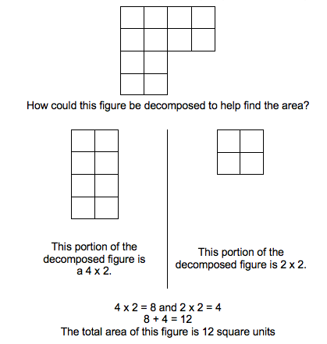  Students will be able to determine the area of a rectilinear figure. A rectilinear figure is a polygon that has all right angles. Recognizing that area is additive, students will be able to decompose the rectilinear figure into rectangles, determine the area of the rectangles, and use the areas of the rectangles to determine the area of the rectilinear figure.  Students will solve problems that involve exploration of the relationship between perimeter and area in a rectangle. When given a fixed area, students will be able to determine all of the possible dimensions of the rectangle. When given a fixed perimeter, students will be able to determine all possible areas.  Students learn to apply these understandings and formulas to the solution of real-world and mathematical problems. Note that “apply the formula” does not mean write down a memorized formula and put in known values. In fourth grade, working with perimeter and area of rectangles is still based in models and strategies. | A plan for a house includes a rectangular room with an area of 60 square meters and a perimeter of 32 meters. What are the length and the width of the room?  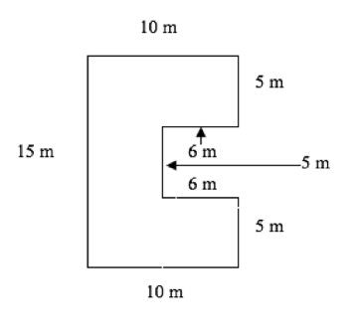  A storage shed is pictured to the right. What is the total area?  How could the figure be decomposed to help find the area?  Mr. Rutherford is covering the miniature golf course with an artificial grass. How many 1-foot squares of carpet will he need to cover the entire course?  You want to build a region that has an area of 12 square meters. What are the possible dimensions? Which dimensions require the least amount of fencing?  Possible solution:  Area Length Width Perimeter  12 sq. m 1 m 12 m 26 m  12 sq. m. 2 m 6 m 16 m  12 sq. m 3 m 4 m 14 m  12 sq. m 4 m 3 m 14 m  12 sq. m 6 m 2 m. 16 m  12 sq. m 12 m 1 m 26 m
Return to Standards

Represent and interpret data.
NC.4.MD.4 Represent and interpret data using whole numbers.
- Collect data by asking a question that yields numerical data.
- Make a representation of data and interpret data in a frequency table, scaled bar graph, and/or line plot.
- Determine whether a survey question will yield categorical or numerical data.
Clarification | Checking for Understanding
In this standard, students will interact with data through data collection, creation of a scaled bar graph or a line plot, and interpretation of data. In third grade, students collected data by asking a question that yielded categorical data, which is data that can be grouped into categories. Students in fourth grade will build on that concept and begin to also ask questions that provide numerical data, which is data that is measurable such as time, height, weight, temperature, etc.  Once data is collected, students should be able to choose an appropriate representation of categorical or numerical data and create the representation. Students will create frequency tables, scaled bar graphs or line plots based on the data collected. Graphs should include a title, categories, category label, key, and data. Once graphs are created, students should be able to solve simple one and two-step problems using the information in the graphs.  Scaled bar graphs have a scale on the y-axis in which the labels do not include every number. | Mrs. Smith’s class tracked the daily high temperatures for 20 days in July. The chart below shows the data that the class collected.  90 92 93 92 89  93 91 95 88 90  95 94 97 97 94  94 91 90 89 94  - Create a line plot that shows the frequency of the July high temperatures. Make sure you label the scale.  - If the normal daily high temperature for July is 90°, how many days was the high temperature less than normal?  - What was the most frequent daily high temperature recorded during the 20 days?
Return to Standards

Understand concepts of angles and measure angles.
NC.4.MD.6 Develop an understanding of angles and angle measurement.
- Understand angles as geometric shapes that are formed wherever two rays share a common endpoint and are measured in degrees.
- Measure and sketch angles in whole-number degrees using a protractor.
- Solve addition and subtraction problems to find unknown angles on a diagram in real-world and mathematical problems.
Clarification | Checking for Understanding
In this standard, students explore angles and their properties. An angle is formed by two rays that share an endpoint and is measured with reference to the degrees of a circle.  For example: If the common endpoint of two rays is the center of a circle, the angle can be measured by considering the fraction of the circular arc between the points where the rays intersect the circle.  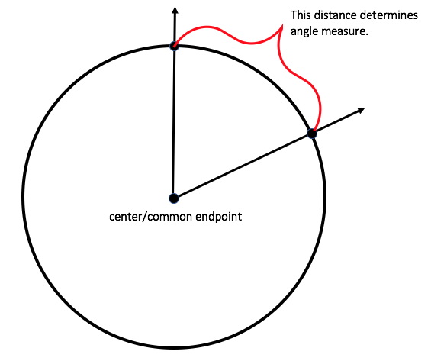  An angle that turns $\frac{1}{360}$ of a circle is a “one-degree angle”.  Students will be able to identify three types of angles: right angle, acute angle, and obtuse angle  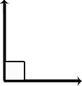 right angle: An angle that equals one quarter of a full rotation of a circle, or 90º  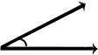 acute angle: An angle that is less than a right angle, or less than 90º  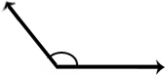 obtuse angle: An angle that is more than a right angle, or more than 90º.  Straight angle:  An angle that is 180º  Students will learn to measure and sketch angles using a protractor. Students should also have an understanding of benchmark angles such as 45º, 90º and 180º.  For example:  When measuring angles with a protractor, students will first identify if the angle is acute or obtuse to determine which numbers to use. Acute angles would measure 0º to 89º, and obtuse angles would measure 91º to 179º. In this example, the angle is obtuse, so it would be read as 120º. In the following example, the angle measured is obtuse, but facing the opposite direction of the angle pictured to the left. Students who understand that obtuse angles measure 91º to 179º would know that this angle measures 135º rather than 45º. 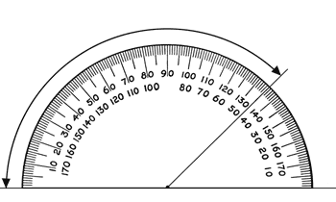  Students will understand that angle measure is additive. When an angle is decomposed into non-overlapping parts, the angle measure of the whole is the sum of the angle measures of the parts. Two angles are called complementary if their measurements have the sum of 90º. Two angles are called supplementary if their measurements have the sum of 180º. Two angles with the same vertex that share a side are called adjacent angles. These terms may come up in classroom discussion, but students are not responsible for knowing these terms by the end of the year. This concept is developed thoroughly in middle school (7th grade). | If the two rays are perpendicular, what is the value of m?  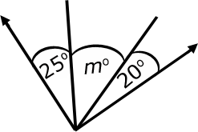  A lawn water sprinkler rotates 65 degress and then pauses. It then rotates an additional 25 degrees. What is the total degree of the water sprinkler rotation?  To cover a full 360 degrees how many times will the water sprinkler need to be moved?  If the water sprinkler rotates a total of 25 degrees then pauses. How many 25 degree cycles will it go through for the rotation to reach at least 90 degrees?  Joey knows that when a clock’s hands are exactly on 12 and 1, the angle formed by the clock’s hands measures 30º. What is the measure of the angle formed when a clock’s hands are exactly on the 12 and 4?
Return to Standards

Geometry

Classify shapes based on lines and angles in two-dimensional figures.
NC.4.G.1 Draw and identify points, lines, line segments, rays, angles, and perpendicular and parallel lines.
Clarification | Checking for Understanding
This standard asks students to draw two-dimensional geometric objects and to also identify them in two-dimensional figures.  Students should be able to draw and identify the following figures:  point angle  line segment right angle  line acute angle  ray obtuse angle  parallel lines straight angle  perpendicular lines  Students should understand the concept of parallel and perpendicular lines. Two lines are parallel if they never intersect and are always equidistant. Two lines are perpendicular if they intersect in right angles (90º).  Lines AB and CD are parallel. Line FG is perpendicular to lines AB and CD forming right angles.  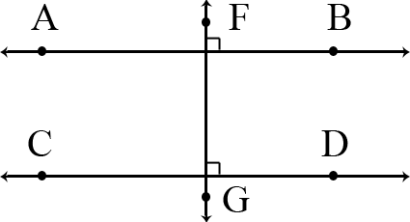 | Draw two different types of quadrilaterals that have two pairs of parallel sides?  Is it possible to have an acute right triangle? Justify your reasoning using pictures and words.  Draw and list the properties of a parallelogram. Draw and list the properties of a rectangle. How are your drawings and lists alike? How are they different? Be ready to share your thinking with the class.  How many acute, obtuse and right angles are in this shape? Explain how you know.
Return to Standards

Classify shapes based on lines and angles in two-dimensional figures.
NC.4.G.2 Classify quadrilaterals and triangles based on angle measure, side lengths, and the presence or absence of parallel or perpendicular lines.
Clarification | Checking for Understanding
This standard calls for students to sort quadrilaterals and triangles based on parallelism, perpendicularity, side lengths, and angle types.  Students should be able to use side length to classify triangles as equilateral, isosceles, or scalene; and can use angle size to classify them as acute, right, or obtuse. They then learn to cross-classify, for example, naming a shape as a right isosceles triangle.  Students should be able to use the relationship between sides and side lengths to classify quadrilaterals. Students’ experiences with drawing and identifying right, acute, and obtuse angles support them in classifying two-dimensional figures based on specified angle measurements. They use the benchmark angles of 90°, 180°, and 360° to approximate the measurement of angles.  For example: The square has perpendicular lines because the sides meet at a corner, forming right angles. It also has parallel sides that are opposite from each other. I know this because if I changed the sides to lines that never end, the lines would never intersect and be the same distance apart. Segments are just parts of lines. All of the line segments are equal.  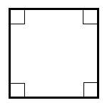  The notion of congruence (“same size and same shape”) may be part of classroom conversation but the concepts of congruence and similarity do not appear until middle school.  Note: North Carolina has adopted the exclusive definition for a trapezoid. A trapezoid is a quadrilateral with exactly one pair of parallel sides. | Which figure in the Venn diagram below is in the wrong place, explain how you know?  Do you agree with the label on each of the circles in the Venn diagram above? Describe why some shapes fall in the overlapping sections of the circles.  For each of the following, sketch an example if it is possible. If it is impossible, say so, and explain why or show a counter example.  - A parallelogram with exactly one right angle.  - An isosceles right triangle.  - A rectangle that is not a parallelogram. (impossible)  - Every square is a quadrilateral.  - Every trapezoid is a parallelogram.  Identify which of these shapes have perpendicular or parallel sides and justify your selection.
Return to Standards

Classify shapes based on lines and angles in two-dimensional figures.
NC.4.G.3 Recognize symmetry in a two-dimensional figure, and identify and draw lines of symmetry.
Clarification | Checking for Understanding
In this standard, students determine if figures are symmetrical. Students should understand that if a figure can be folded or divided in half so the two halves mirror each other, the figure has line symmetry and the line of symmetry is the line that divides the figure. Students should be able to identify lines of symmetry in regular and non-regular polygons and understand that some figures may have more than one line of symmetry. This standard only includes line symmetry not rotational symmetry.  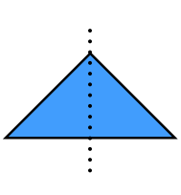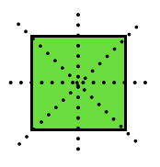  The triangle has one line of symmetry, and the square has four lines of symmetry. | For each figure, draw all of the lines of symmetry. What pattern do you notice?  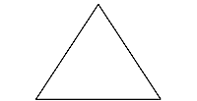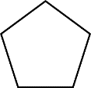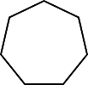  How many lines of symmetry do you think there would be for regular polygons with 9 and 11 sides. Sketch each figure and check your predictions.  Polygons with an odd number of sides have lines of symmetry that go from a midpoint of a side through a vertex.
Return to Standards

