[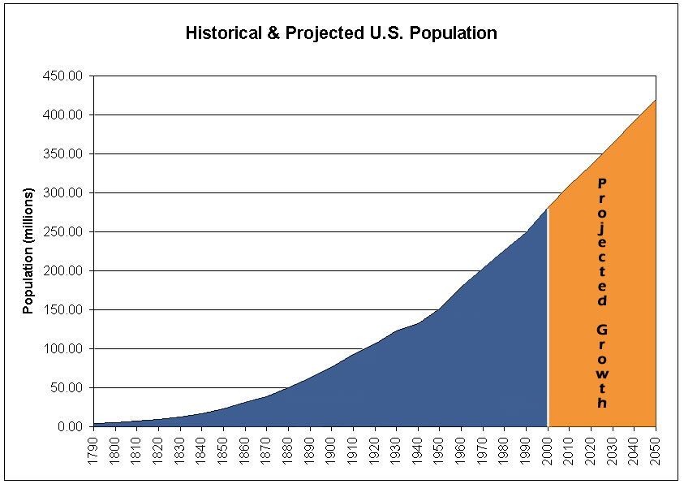](http://www.google.com/url?sa=i&rct=j&q=population+growth+in+the+US&source=images&cd=&cad=rja&docid=rmZVFleP9D9ZwM&tbnid=ie7G1l3WQ9JQPM:&ved=0CAUQjRw&url=http://www.npg.org/popfacts.htm&ei=qI_LUfzDG4rs8wTD94DgBA&bvm=bv.48340889,d.eWU&psig=AFQjCNEL2As9yNs3a5msHpDXniQCnJ5bpQ&ust=1372381477869085)

[](http://www.google.com/url?sa=i&rct=j&q=population+growth+in+the+US&source=images&cd=&cad=rja&docid=xqFg4MzFk5L4FM&tbnid=MyYbxqAC7upnCM:&ved=0CAUQjRw&url=http://beta.fool.com/makinmoney2424/2013/01/02/does-company-have-prescription-investors-portfolio/20006/&ei=8I_LUZ_WMo3O9gTtuYDQDg&bvm=bv.48340889,d.eWU&psig=AFQjCNEL2As9yNs3a5msHpDXniQCnJ5bpQ&ust=1372381477869085)