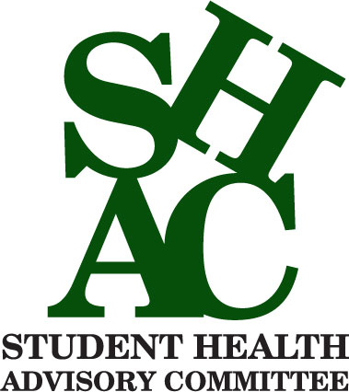
The Chireno ISD School Health Advisory Council is Seeking New Members!
The School Health Advisory Council (SHAC) assists the district in ensuring that local community values are reflected in the school district. The SHAC will address the continued implementation of coordinated health services, nutrition services, counseling, healthy school environment, staff health promotion and family/community involvement.
SHAC Meetings 2019-2020
Nurse’s Office @ 8:30 a.m.
Sept. 25, Nov. 21, Feb. 27, April 23
We would love to see you there!!!

