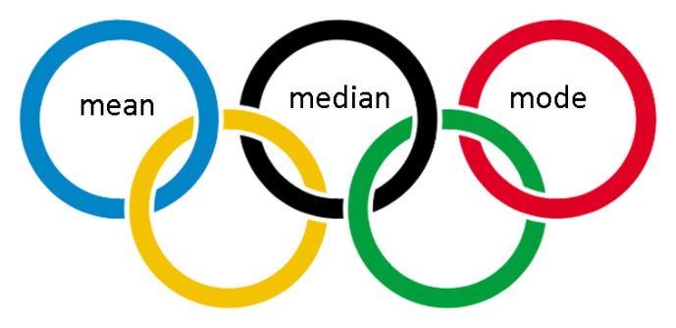

Name: ______________________________

3 M Olympics

List team names below: | Laps | Jump Rope | Push Ups | Sit Ups | Ball Throw
1.
2.
3.
4.
5.
6.
mean
median
mode

