Camping Equipment
These are the items available for you to use in your campsite. You must have enough sleeping space and seating for at least 3 people. Additionally you must have at least one fire pit and at least one cooler.
Equipment | Dimensions | Area
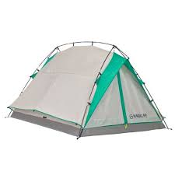  1 person tent | 5 ft. x 2 ft.
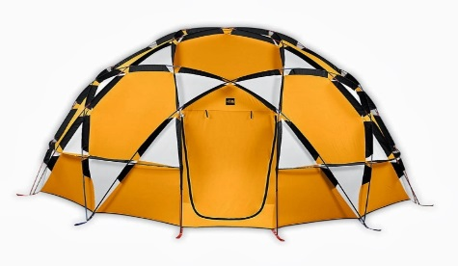  2 person tent | 5 ft. x 3 ft.
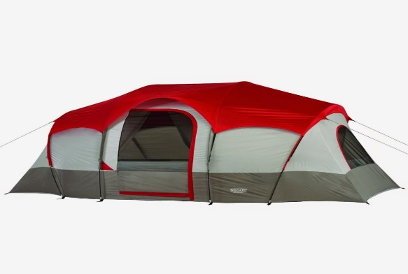  4 person tent | 6 ft. x 5 ft.
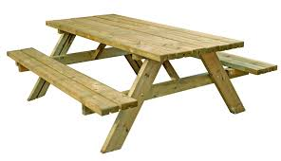  Picnic table | 2 ft. x 3 ft.
1 person chair | 1 ft. x 1 ft.
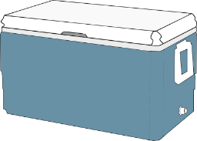  Cooler | 1 ft. x 2 ft.
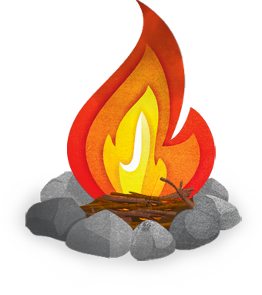  Fire pit | 2 ft. x 2 ft.

