Farmer’s Market Challenge
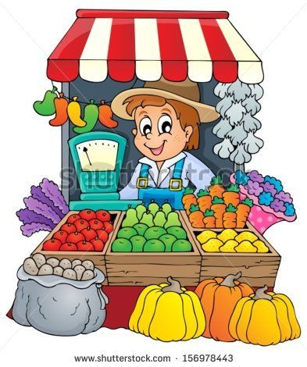
You are a vendor at the local Sunnyside Farmer’s Market. You have 3 display carts in which to lay out the fruits and vegetables you are selling. Each display car has 3 shelves.
Fruits and vegetables take up different amounts of space based on their size. For example, a watermelon is going to take up more space than a small basket of strawberries. You must display at least one shelf of each different fruit and vegetable in order to give your customers the greatest selection. The fairgrounds where the farmer’s market meets requires each vendor to pay a $55 membership fee. So be sure to pay this fee from your earnings!
Organize your carts to maximize your profits (amount of money you earn). Show two possible display cart combinations then chose the most profitable one as your solution.

