George Washington School
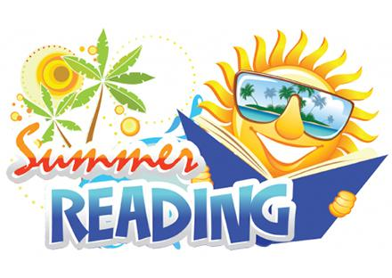
2020 Summer Reading List for Students Entering Kindergarten
Pete The Cat by James Dean
Do You Want to Be My Friend? by Eric Carle
Don’t Let the Pigeon Drive the Bus by Mo Willems
The Day You Begin by Jacqueline Woodson
Good News Bad News by Jeff Mack
Interrupting Chicken by David Gzra Stein
Jumbari Jumps by Gaia Cornwall
The Tiny Seed by Eric Carle
The Name Jar by Yangsook Choi
Click Clack Moo: Cows that Type by Doreen Cronin
Last Stop on Market Street by Matt de la Peña
Shoo Fly Guy by Tedd Arnold
Snowy Day by Ezra Jack Keats
Make Way for Duckling by Robert McCloskey
Happy in Our Skin by Fran Manushkin
Harold and the Purple Crayon by Crockett Johnson
Dreamers by Yuyi Morales

Fun Activities to Share Your Books!
After reading your book, select one of the projects below to submit when you return to school. Please bring it in on the first day of school. Don´t forget to write your childś name on the back of the project.
- Write the title and author of the book. Then draw your favorite part of the story.
- Make a paper bag puppet of a character in the book you read. Be creative when using supplies and have fun with your family.
- Draw and write a different ending to the story you read.
- Retell and draw the beginning, middle, and end of your story. Explain why you chose that book.
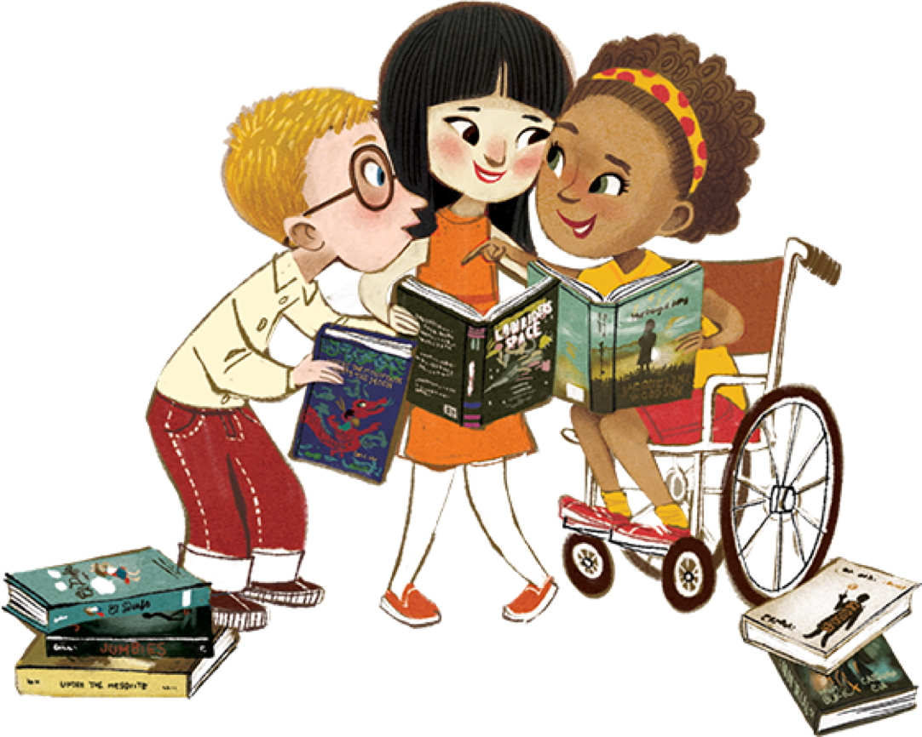

Be as creative as you wish. Please note that your child's work will be proudly displayed in their classroom.

