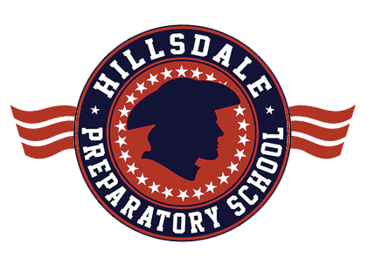
Hillsdale Preparatory School
160 W. Mechanic Road
Hillsdale, MI 49242
(517) 437-4235
Dear Hillsdale Prep Parents,
As we conclude what has been a rewarding, yet unprecedented school year, I want to thank you for your partnership in the journey we have gone through together! In my fifteen years in education I cannot remember a time where parents had to juggle so many responsibilities with their families, including taking on an educational role at times! Thank you for all that you have done and thank you for your patience as we navigated the waters of remote learning.
So where do we go from here? We obviously don’t know the scenario we will be faced with in the Fall of 2020, but please know this: we will provide a quality education for your child no matter what your preference, no matter what the guidelines, no matter the situation! While we prefer to begin the school year 100% in person, we know that we must have a robust customized remote learning plan should the circumstances require it.
A plan that resembles what we teach in person and when we teach it so that kids have a similar experience in either delivery model. One that provides a great deal of student-teacher interaction and support. One that will look more like the in school experience than the model we are finishing up right now. One that allows the parent to return to being the parent and the school re-assuming the major role of educating every student.
We have teams working on our in person re-entry to school and remote learning instruction. In addition, we are preparing for facilities that are safer than at any previous time. We will be ready to begin next August 19!
A survey will be sent out following this letter that will provide Hillsdale Preparatory School and all of Hillsdale county with some very important information regarding both the experience your student(s) have just completed and what you are thinking at this point in time in regards to the Fall of 2020 learning preferences for your child. Please know this survey is confidential. The data will provide good information as we plan to meet your needs for next school year. Please take time to complete the survey so that we have a true and accurate depiction of the needs of our students and their families.
Things appear to be changing rapidly with each week that passes. I assure you that we will be ready to provide the top-notch education you have come to expect from Hillsdale Preparatory School. If you have any questions, please contact me at Annie.Fowler@hillsdaleprep.org.
Again, thank you for your continued partnership. We look forward to an exceptional 2020-2021 school year!
Educationally,
Annie Fowler

