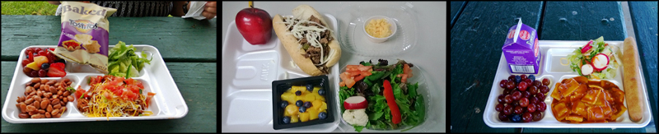

Feeding Children is our Business
School lunches are planned to provide 1/3 of the recommended dietary allowances for school-age children. All Harrison County students are encouraged to select a complete lunch; however, under the “offer vs. serve” regulation they are allowed to select three, four or five items. Menus are planned to include a variety of choices, and changes have been made in food specifications and preparation to lower sodium, fat and sugar in school meals.

School Breakfast...The first Step to Learning
Children who are hungry find it hard to stay alert and participate in their classroom experiences. The Harrison County Schools Breakfast Program helps close the “readiness gap” with nutritious food in a cost-effective manner before classes begin. Breakfast is offered in all Harrison County Schools; check with your school's cafeteria manager for information needed.

Offer vs. Serve is implemented in all schools:
What is offer vs. serve? This is a serving style that allows students to choose from a selection of foods offered by their schools cafeteria rather than being forced to take all items. The goal of offer vs. serve is to offer students a choice in what they eat, and to reduce waste. Students are required to select at least three components to make a creditable meal, and at least 1 of those components must be a fruit or vegetable. Students are given at least 2 options for each component every day, barring any unexpected shortages or demands for a certain item.
Meal Components Include: Meat/Meat Alternates, Grains, Vegetable, Fruit, and Milk.

Free or Reduced Priced Meal Benefits
To apply for free or reduced priced meal benefits, complete a family application, which is available in your school's office. If your student qualifies for free or reduced price lunch, they also qualify for free or reduced price breakfast. For additional information contact Austin Dacci, Director of Food Service, 234-7110.

Harrison County Now Offers On Line Payment Process for Meals
Introducing MySchoolBucks, the most convenient way for parents to make online meal payments, check lunch account balances, and monitor cafeteria purchases. Click here for more information.
Pre-payment is strongly encouraged.

Harrison Co. Is Dedicated to Wellness
Interested in how we approach your student's health? Click here to review our Wellness Policy.

