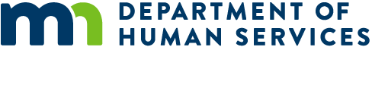

# Need assistance purchasing groceries?

If your child is between the ages of 5 and 18 and was eligible for free or reduced-price meals during the 2019-2020 school year, you could receive $325 per child in Pandemic EBT (P-EBT) benefits. These benefits can help your family purchase groceries and are available even if your child continued to receive a school meals while schools were closed. This program is a benefit for your child, and applying for P-EBT does not affect enrollment in any other program.

If you are already enrolled in the Supplemental Nutrition Assistance Program (SNAP) or Minnesota Family Investment Program (MFIP) – and your case was open as of March 18, 2020 – your benefits will be automatic. If you are not enrolled in these programs, but your child was receiving free or reduced-price school meals this year – or your family accesses food through the Food Distribution Program on Indian Reservations (FDPIR) – you will need to apply for these benefits.

### Families receiving SNAP or MFIP when schools closed on March 18, 2020

* Benefits will be loaded automatically to your EBT card.
* You **do not** need to apply or to take any additional steps.

### Families getting free/reduced-price meals or FDPIR, but *not* SNAP/MFIP when schools closed

* You will need to complete an application between June 8, 2020, and June 30, 2020.
* Apply at **http://www.mn.p-ebt.org/**
* A card will be mailed to you if you are found eligible. You can use it to buy groceries at most local grocery stores.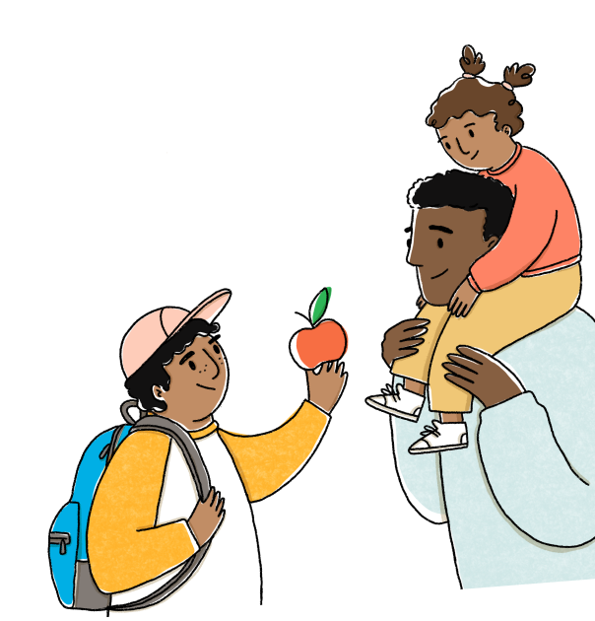

## Need assistance?

If you have questions, or need help applying for or using your P-EBT benefits, please contact the P-EBT Hotline at 800-657-3698.

If your family is having trouble purchasing healthy food, please contact your local county or tribal human services agency or the Minnesota Food HelpLine at hungersolutions.org or 651-486-9860.