Parents/Guardians:
Can you believe how fast our school year is going? We are already in full swing for Semester 2 here at the high school. Hopefully your sons/daughters were successful in semester 1 and will continue to be successful in semester 2. If they are a 9th, 10th, or 11th grader, we don’t want them to fall behind on credits. If they are a senior, we certainly don’t want them to be short credits for graduation.
We are starting the registration process for our 9th-11th graders very soon. Our counseling staff will be in classrooms to talk with all the students about class options for next year. Please make sure you are talking with your child as well to help guide them. Since we will be in year 4 of our academy model, we want all of our students to be deliberate about what classes they are taking. All of these classes are laid out in our registration packet, but they still need guidance from you!
We will be giving the Pre-ACT to our 10th graders and offering the ACT to our 11th graders later in March. Please check your emails for more information on that.
This newsletter is filled with lots of other information on things happening here at the high school. Please take some time to read it so you stay informed. If you have any questions on any of the information in this newsletter, don’t hesitate to call and ask. If I can’t answer your questions, I will be sure to direct you to someone who can.

Sincerely,
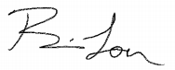
Principal Brian Loer

Dates to remember:
Social Media Links:
Website: www.egf.k12.mn.us
Facebook: @EGFSH595
Twitter: @Egfisd (school) & @egfactivities1 (activities/sports)
Register for sports/activities: https://1967a.cf.wordwareinc.com/
SchoolPay: www.schoolpay.com
Online Calendar: https://region8mn.org/public/genie/58/school/1904/
ParentVue/StudentVue Login: https://rt2.region1.k12.mn.us/rt0595/PXP2_Login.aspx
The Wave Shop: https://egf-waveshop.square.site/

1/25 Early Out day
1/27-One Act Play Performance-PAC 7pm
1/31-Myra Jazz Band Festival 8:30-1:00 GFCHS
2/1-Myra Jazz Band Festival 11:00-3:00pm GFCHS
2/4-Snoball Dance 8:00-11:00pm SH Cafeteria
2/8-Vocal Solo/Ensemble Contests Noon-5pm EGFSH
2/8-Conferences 3:30-6:30
2/15-Conferences 3:30-6:30
2/17-NO SCHOOL
2/20-NO SCHOOL
2/22-Early Out Day
2/27-3/10-ACCESS Testing
3/1-Instrumental Solo/Ensemble contest 9:00am EGFSH
3/6-Music Boosters SPUD-TACULAR
3/15-Early Out Day
3/24-End of Q3
3/27-No School—Curriculum Day

About Us:
Principal-Brian Loer (bloer@egf.k12.mn.us)
Assistant Principal-Bruce Nelson (bnelson@egf.k12.mn.us)
Activities Director-Scott Koberinski (skoberinski@egf.k12.mn.us)
Counselor (A-K)-Andrew Glaser (aglaser@egf.k12.mn.us)
Counselor (L-Z)-Erin Terpstra (eterpstra@egf.k12.mn.us)
Phone: 218-773-2405 Fax: 218-773-3070

Attendance Information
Attendance is crucial to your students’ success at the EGF Senior High School. “Attend Today and Achieve Tomorrow!”

If your student must miss school, you need to make sure you contact the school to let them know. You can either call (218-773-2405) or sign in to your ParentVue and enter attendance there. Please do this as early as possible in the day to ensure we have accurate attendance. Also remember when entering partial day absences on ParentVue to be as specific as possible in the “Note” box. Include time dismissed and estimated return time.

Graduation Information

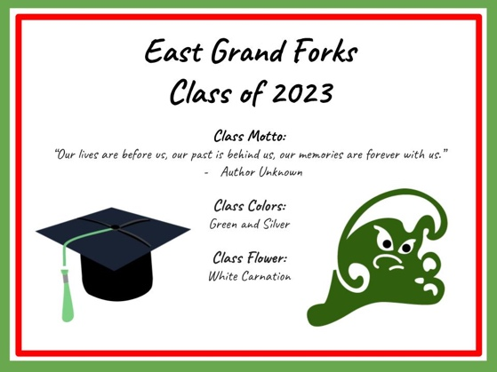
Seniors & Parents: You should have ordered their cap & gown already. If you have NOT, please go to this link: www.jostens.com. Look for an announcement regarding cap & gown distribution in the near future! If your student has unpaid fees, they will not receive their cap/gown that day. A separate letter with outstanding fees will be sent to parents soon.

The next step in preparing for Graduation is ordering diplomas in February. Seniors have received an email in January asking for the complete spelling of their legal name. This ensures that a diploma can be used as a legal document in the future.

One-Act Plays - Public Performance Friday, Jan. 27th at 7:00 p.m. in the PAC
This year's one-act plays are well underway and quickly approaching their show dates! The show chosen for the MSHSL One-Act Play Contest is The Real Inspector Hound by Tom Stoppard. In this play, feuding theatre critics Moon and Birdboot are swept into the Agatha Christie-style whodunit they are watching. You will certainly be entertained as you try to keep up with all the plot twists in this clever spoof!
The non-competitive show, Check Please by Jonathan Rand, has been the most-produced short play by high schools for the last eighteen years straight. The action of the play follows a series of blind dinner dates that couldn't get any worse...until they do. Both comedies will be presented on Friday, January 27th at 7:00 p.m. in the PAC with a short intermission between them. Admission is free; donations will be accepted to put toward upgrading the theatre lighting in the PAC.
Music Department
Jazz Band students are busy preparing for their annual performance at the Myra Jazz Festival on Wednesday, February 1st at Red River High School in Grand Forks.
Members of the Concert Choir and Pop Singers are getting ready for the MSHSL Vocal Solo/Ensemble Contest on Wednesday, February 8th at EGF Senior High. Beginning at noon, students from several area schools will perform selections in front of peers and professional adjudicators for feedback and ratings. Schedules will be finalized as the event approaches; performances are open to the public if you would like to watch your child!
Congratulations to the Band Seniors for collecting 130 pounds of food for the EGF Food Shelf at their concert on Dec. 5th, 2022!
It’s not too early to be thinking about East Side Idol! Idol will be held in the PAC on Monday, March 20th at 7pm See Mrs. Bach for details.
Music students district-wide are in the midst of preparations for this year's Music Boosters Spud-tacular (formerly known as the "Potato Feed"), scheduled for Monday, March 6th. The baked potato meal will be served from 4:30-7:00 p.m. in the Senior High cafeteria with performances throughout the night in the old gym. The event will also include raffle prize giveaways to help raise funds for the EGF Music Boosters to continue the excellent work they do supporting our young musicians! If you would like to donate money or a raffle prize, become a member of the Music Boosters, or volunteer to help with the running of the event, please email dhanson@egf.k12.mn.us or sbach@egf.k12.mn.us. You can also become a member of the Music Boosters by scanning the QR code below!
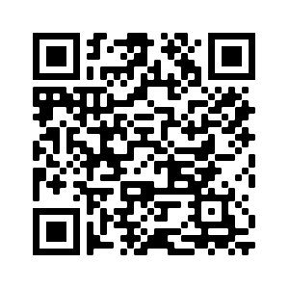

Snoball Dance Information
The 2023 Snowball Dance will be on Saturday, Feb. 4th from 8:00 PM to 10:30 PM. This year, tickets will be sold at the door for $10.00 per person. Caulfield's will once again be taking pictures starting at 8:00 PM. Picture packets will be available in the Counseling Office the week of the dance.
This is a semi-formal dance open to all 9th – 12th graders. If your student is bringing an out-of-school guest, they must be signed up in the main office by 3pm Thursday, Feb. 2nd
We are in need of volunteers to chaperone the dance. If you are willing, please email Tracey Heisler (theisler@egf.k12.mn.us) or Meradith Vanyo (mvanyo@egf.k12.mn.us).
Yearbooks 2022-23
Yearbooks are currently $55 plus tax. If you’re not sure you ordered one, check your ParentVue under student fee to see if you’ve paid for one yet.

Wave Academy
Wave Academy is in its third year at EGF Senior High School. We initiated this program 3 years ago as a better way for our students to be career and college ready by the time they graduate. With many of our graduates choosing to stay in this region, it is our way to ensure our students have exposure to the careers available in our area and know what they need to do to be prepared and have the skills necessary to be successful when they graduate.

Our 9th graders take Freshman Seminar for the full year. This class helps to ease the transition from middle school to high school and as Mr. Kjono states, “this class is adulting 101.” He explores the world of work and helps students begin to answer the “Who am I?”, “Why do I have to learn this?” and “What do I want to do with my life during and after high school?” Sophomore students narrow their career focus to a pathway course that begins a deep dive into careers in one of 3 pathway academies: Business, Entrepreneurship, and Communications (BEC), Health and Human Services (HHS), and Science, Technology, Engineering, Arts and Science (STEAM). Students in these pathways are exposed to careers in our region through class fieldtrips and classroom speakers. In the junior year, students take a course in their chosen pathway each semester and identify 1-2 areas in which they would like to job shadow. As we grow our program to the senior year, we are working to establish a 21st Century Skills course, find internship opportunities, and offer college credits and other industry-recognized credentials.

We are offering a new Certified Nursing Assistant course this semester. Mary Barrett, our community expert, is working with a group of 10 seniors that will complete their training and take the certification exam in the spring. Ryan Kasowski had 60+ students earn their certifications in CPR, AED and choking. So many fun, cool, and interesting things happening!

We ask for your involvement in Wave Academy. Do you have a career that you would like to share with our students? Do you work in an industry that would welcome a student tour? Do you have a need for student interns? It really does take a village, and we welcome your involvement and interest in Wave Academy. Please reach out to Stephanie Larson, Wave Academy Coordinator at slarson@egf.k12.mn.us to offer your expertise and to learn more about the opportunities in which to be involved.

Counseling Department News
-Here are Registration Dates for 8th-11th graders

11th Grade: Registration Information Feb. 3rd, Online registration Feb. 10th in Science classes

10th Grade: Registration Information Feb. 6th, Online registration Feb. 13th in Science classes

9th Grade: Registration Information Feb. 24th, Online registration March 3rd in Freshman Seminar

8th Grade: Registration Information and online registration will be in Early March, dates TBD

-PSEO Information Night in the Senior High PAC during PT conferences Feb. 8th and 15th from 5:30-6:30 both nights

-Blood Drive at East Grand Forks Senior High in February. Be on the lookout for more information soon!!

