Understanding District 101 Enrichment and Intervention Services
Because every child is unique, Western Springs School District 101 offers comprehensive and systematic supports within the general education realm to meet the varying needs of students. These services are offered through a “Response to Intervention” (RtI) problem solving approach and are appropriate for students who require either intervention, to close a grade level learning gap, or enrichment, to ensure appropriate challenge, and thus, consistent learning gains beyond already secured grade level outcomes.

It is important to note that our rigorous, core curricula have been developed with consideration to our local students’ needs, and as a result, our definition of “grade level secure” is also a local understanding, not a nationally-normed understanding. In other words, District intervention and enrichment services are tailored to ensure academic/behavioral success for students who attend Western Springs schools. These services, in an effective model, are appropriate for and should impact approximately 5-15% of the student population within the District. The remaining 85-95% of students should experience success, appropriate challenge, and consistent growth through engaging in the delivery of core classroom curricula alone.

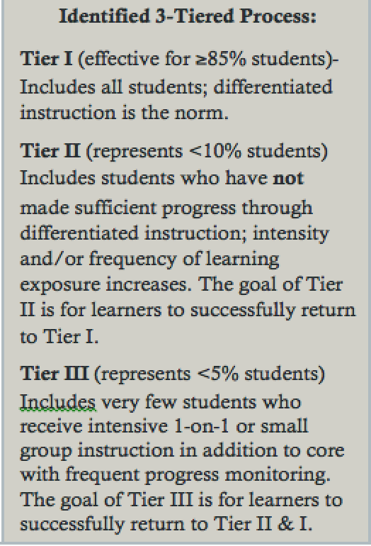
For all students, and in particular students who need intervention or enrichment services, three criteria must be in place to do so effectively:
(1) high quality, core instruction, where differentiation is a standard feature,
(2) systemic universal screening and progress monitoring through periodic, planned student assessment, and
(3) ongoing, transparent and proactive parent communication.

The purpose of this article is to highlight District commitments in relation to “ongoing, transparent and proactive parent communication” for intervention and enrichment services.

Response to Intervention Communication Practices
A 3-tiered process of supports is offered, based upon need, for students receiving intervention services. The table below shows communication guidelines relative to each intervening level of support.

Level of Support | Communication Guidelines
Tier II  (In class support or pull-out/push-in support from identified Specialist | A child’s classroom teacher will make direct contact with parent(s) via phone to share a recommendation for intervention services. Should a Specialist be identified, the Specialist will then also follow classroom teacher contact with a personal introduction and provide further clarification as needed.  Information Highlighted  What present data indicate need? What skills/needs will be targeted? Who will deliver intervention? Frequency of programming? How will progress be monitored? Anticipated timeframe? When can parent(s) anticipate progress updates?  Formal quarterly progress monitoring information will be communicated.
Tier III  (Pull-out support from identified Specialist) | Parents of students newly identified for Tier III support will be invited to a problem solving meeting* at the child’s home school to discuss intervention and a support plan for the child.  *Typical meeting attendees will include the following: child’s classroom teacher(s), parent(s), instructional specialists, and the building principal.)  Parents of students returning at the start of the school year to Tier III support can anticipate personal contact from the identified Specialist to review student’s support plan. A personal meeting date will be offered to parents if preferred.  Quarterly progress monitoring information will be communicated.

Enrichment Communication Practices
Enrichment services are offered K-5 in English-language arts and K-3 in mathematics (may include cross-curricular opportunities such as science, social studies, art, etc.).

Formal advanced math classes replace math enrichment services starting in grade 4. Advanced English language arts and math classes are offered in grades 6-8.

Enrichment groups, both in and out of the classroom, are formed through ongoing collaboration between classroom teachers and the enrichment teacher in conjunction with ongoing reviews of student performance. The following specific factors are considered:

- Standardized data including Fountas and Pinnell reading assessment (grades K-2), Measures of Academic Progress (MAP) (grades 2-5), Cognitive Abilities Test (CogAT) (grades 3 & 5) and Illinois Assessment of Readiness (IAR) (grades 4-5)
- Formal and informal classroom assessments
- Daily classroom performance (quality of work and task completion)
- Ability to apply high-level analytical and critical thinking skills
- Initiative and desire to investigate areas of the curriculum in greater depth

As always, if you have any questions regarding intervention or enrichment services, please contact your building principal or Sarah Coffey directly.

Understanding District 101’s Advanced Placement Process

Western Springs School District 101’s expectation of classroom teachers is the consistent provision of differentiated instruction and materials that meet learning needs and provide appropriate challenge for all students. Extensions to our standard curriculum are also offered by building enrichment teachers, on a flexible basis, to students who demonstrate need for challenge beyond daily classroom differentiation. Additionally, as part of this effort to ensure appropriate challenge for all students, District 101 offers advanced math classes in 4th through 8th grades and advanced English language arts classes starting in 6th grade. These sessions are full year classes that students take in place of standard math and/or English language arts offerings.

Our identification process for advanced placement is comprehensive. Many aspects of a student’s performance are considered in determining the need for advanced placement. Our process is ultimately focused on identifying students whose challenge level is significantly beyond local grade level peers. In order to do so, through the use of local normative information, we systematically review the following pieces of data:
Assessment | Assessment Description | Local Qualifying Score Ranges
Cognitive Abilities Test  Quantitative (Math only)  Verbal (ELA only)  Composite (Math & ELA) | Standardized, nationally normed measure of learned reasoning and problem-solving skills in verbal, quantitative and nonverbal areas. | Standard Age Scores (SAS) of >130-140+  (Bottom value of 130 equates roughly to the >90th local %ile and the 97th national %ile score.)
Educational Records Bureau (ERB) Out-of-Level Assessment  Math  English Language Arts | Standardized, locally normed, out-of-level test that assesses students’ problem solving and academic skills on content that has not yet been taught.  (Optional testing is conducted at home school sites each May. Registering for this test initiates advanced placement interest for students not already enrolled in AP programming. | ERB Raw Score Ranges  Math ELA  4th: >326-366+  5th: >336-376+  6th: >346-386+ >336-376+  7th: >356-396+ >346-386+  8th: >366-406+ >356-396+
Professional Judgement  Math  English Language Arts | Standardized, locally written and normed, criterion-based based profile that teachers complete and assesses students’ present proficiency in math and/or ELA relative to grade level outcome expectations. | Qualitative observations resulting in a judgement score range of >45-54 (math) & >45-58 (ELA) points.
Measures of Academic Progress (MAP)  Math Comprehension  Reading Comprehension | Computerized and standardized, nationally normed adaptive assessment that gives educators growth and achievement data to target instructional planning.  (Qualifying scores may vary slightly from year to year based upon RIT values that equate roughly to the >90th local %ile and the 97th national %ile score.) | Rausch Interval Unit (RIT) Scores Ranges  Math ELA  4th: >220-234+  5th: >231-244+  6th: >240-254+ >231-243+  7th: >246-262+ >235-248+  8th: >253-267+ >238-250+
Students’ assessment data is applied to a 100-point matrix (10-20 qualifying points can be earned for each of the above criteria), and students are initially recommended for advanced placement courses when they earn a total of 50 qualifying points. Letters notifying parents of initial placement recommendations are then mailed to the parents of all children who indicated interest in advanced placement classes by registering for the out-of-level assessment. If parents do not agree with a placement recommendation, they may submit a placement appeal. Appeal paperwork is available at the Board Office of Education by phone or in person. The Appeals Committee, a representative group of teachers and administrators from each school, anonymously review submissions and make final determinations for placement.

Did You Know…

A typical D101 Cognitive Abilities Test (CogAT) Standard Age Score (SAS) composite average is ~117.
This means that our students, on average, scored the same or better than ~86% of students nationally. This same score translates locally to the 59th percentile.

4th Grade: 10-20%
5th Grade: 20-25%
6th Grade: 30-37%*
7th Grade: 40-45%*
8th Grade: 42-47%*

Typical Percent Ranges of D101 Students Enrolled in One or More* Advanced Classes By Grade Level

Our advanced placement process, by design, could be visually represented using an “upside down funnel.” This means that we intentionally, as children progress through the system, capture more students into advanced programming--students who present as academically gifted as well as students who present as academically talented by evidence of consistently strong academic skills and behaviors.

If you have any questions regarding the Advanced Placement process, please contact your building principal or Sarah Coffey.

