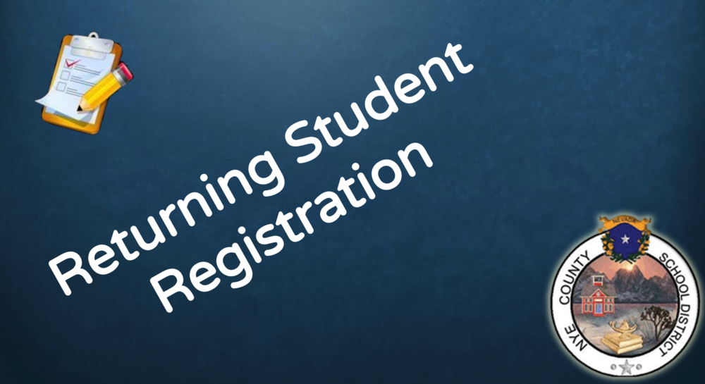

RETURNING STUDENT REGISTRATION
NCSD - STUDENT INFORMATION DEPARTMENT

Returning Student Registration
For students who will be new to the Nye County School District or changing schools as a result of moving addresses, not promotion to middle or high school, please look at this: New Student Registration.
All students returning to NCSD must go through a process of verifying the information in the student information system, which is Infinite Campus. We call this process Returning Student Registration. It can be completed after the start of school, but it does need to be completed each year.
This process has always been done through sending home giant packets of information and forms for parents and guardians to fill out, sign and return with their children to schools.
Now this process can be done using the Infinite Campus parent app or the Infinite Campus Website.
If you need a parent/guardian account for Infinite Campus, please see your school's registrar or secretary. Parents and guardians can use one account to track all of their children in different schools. The parent portal has several features that allow guardians to see how their kids are doing in school.

Dear Beatty High School Parents/Legal Guardians:
In past years we sent home a packet of papers which parents or guardians would fill out and return to the school to update their student’s information. Beatty High School no longer sends home paper permissions or updates. All permissions and updates can now be accessed using the Online Registration link located in the Campus Parent Portal.
You can access the parent portal using our school or district websites. We also have a short video under “NEWS” that can answer all questions about the update process.
Please understand that we are required to have updated information on each student, so you will continue to receive notifications from us until the update has been completed. Upon completion of the update, your name will be removed from this call list.
If you do not have internet access or need assistance getting on to your Campus Parent Portal account, you are welcome to come to the school during schools hours, 8:15 AM to 3:00 PM or to the Southern District Office from 7:00 AM to 4:00 PM. No information regarding the update or accessing your Parent Portal account will be given out over the phone.
Thank you

