Dear Parent or Guardian;
Nye County School District (NCSD) has opened Online Registration (OLR) for the 2020-2021 school year for current students. OLR allows you to register your current student(s) for the upcoming school year and fill out the transportation application. Transportation will not be mailing out paper bus applications this year. You must log into your Parent Portal and fill out the Online Registration application.

Once in the portal, you will click on the More button in the menu on the left-hand side, then click on Online Registration, then Click here to go to the Annual Update (please refer to the next page for screenshots of the steps 1-3).
If you have a student enrolled in NCSD and a new Pre-Kindergarten or Kindergarten student, once you have updated all your current student’s information, you will click Add New Student on the Student Section of the application (step 4 on next page).

The link to the Parent Portal is: https://nye.infinitecampus.org/campus/portal/nye.jsp

If you do not have your Parent Portal account set up, please email school secretary name & email, with a copy of your driver’s license to be given your activation key. If you do not remember your username/password, please email the person above with a copy of your drivers license to receive your username and temporary password.
Sincerely,
Nye County School District

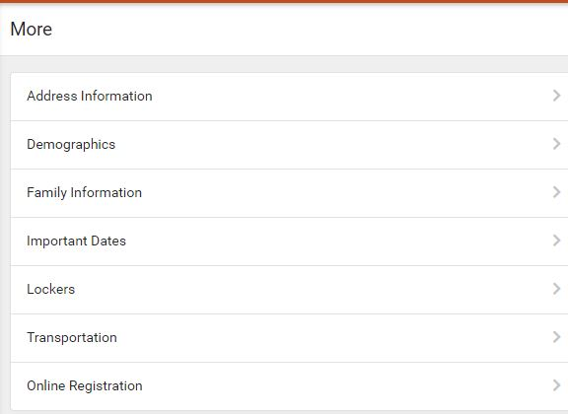
Step 1: Step 2:
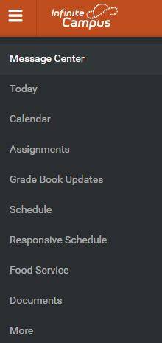
Step 3:
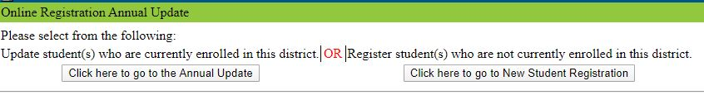
Step 4: 