Mondovi Elementary School Summer Reading 2020
Fiction/Nonfiction Read and Retell
Why Read?
Summer is here and with it lots of time for recreational reading. Our summer reading program is designed to help students understand that reading is an enjoyable pastime and that we read for pleasure as well as to acquire information. It is not a secret that reading skills improve with practice so it then becomes even more entertaining. Making time in the day to read is good for the mind and it is a wonderful way to reduce the noise, stress and stimulation often associated with busy lives in our fast paced world. It is well known that reading is essential to providing a solid basis for academic achievement. But most of all, reading is totally fun!
Summer Reading Program Requirements:
1. Students need to set a personal reading goal.
How many books will you read over the summer? It is different for everyone. Parent/adult support is often necessary to help you get books. Check out the public library, bookstores, audio books, and don’t forget to share with friends to find “good fit” age appropriate books.
2. Students MUST read a MINIMUM of 4 “good fit” age appropriate books that you have not previously read to be eligible to take part in the Summer Reading Celebration that will take place in the fall. Your personal reading goal may be higher – that’s awesome!
3. Students MUST fill out a reading log and turn it in no later than September 16, 2020.
You will find a “Summer Reading and Retell Record” on the back of this page. If you need another one click on the form link that can be found on the Mondovi Elementary Website. Your completed Reading and Retelling record should be turned into your teacher on the first day of school.
4. Students can read what they want! (4K parents please read to your child. Then have your child retell the story to you.)
Free choice is an important component of this program. Students are encouraged to read at their appropriate reading level. Not sure? Talk with your parents to see if a particular book is a good fit for you. There are so many wonderful books out there. You are encouraged to read both fiction and nonfiction books!
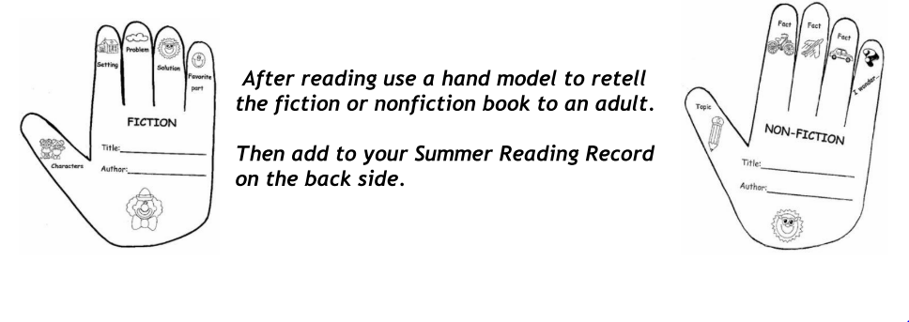

Mondovi Elementary Summer K4-2nd Grade Reading Log
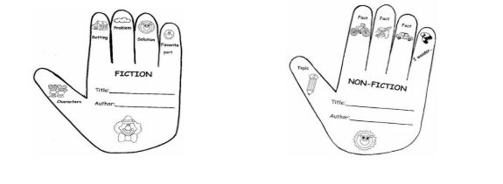
Name: ______________________________ (2020 - 21 School Year) Grade: _______
Please print information neatly so it is easy to read. Thank You
Title | Author | Date Book Finished | Parent Signature
1
2
3
4
5
6
7
8
9
10
11
12
13
14
15

Remember! You must turn in completed reading log/s by Sept. 16 to your 2020-21 classroom teacher if you want to be invited to the Summer Reading Celebration planned for late September.

