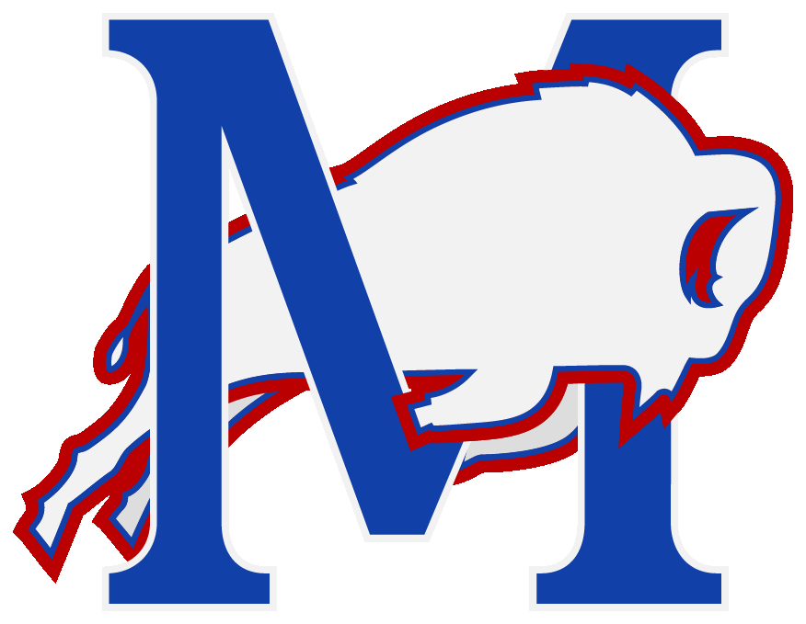
Mondovi School Summer Reading
5th Grade to 6th Grade
Requirements for Reading Celebration and Reading Log
Why Read?
Summer is here and with it lots of time for recreational reading. Our summer reading program is designed to help students understand that reading is an enjoyable pastime and that we read for pleasure as well as to acquire information. It is not a secret that reading skills improve with practice so it then becomes even more entertaining. Making time in the day to read is good for the mind and it is a wonderful way to reduce the noise, stress and stimulation often associated with busy lives in our fast paced world. It is well known that reading is essential to providing a solid basis for academic achievement. But most of all, reading is totally fun!
Summer Reading Program Requirements:
1. Students need to set a personal reading goal.
How many books will you read over the summer? It is different for everyone. Check out the public libraries, bookstores, online bookstores, electronic books (very cool) and don’t forget to share book titles with friends.
2. Students MUST read a MINIMUM of four “good fit” age appropriate books that you have not previously read to be eligible to take part in the MS Summer Reading Celebration that will take place in the fall. Your personal reading goal may be higher – that’s awesome!
Check out the attached book list of great, new book title suggestions to read.
3. Students MUST fill out a reading log and turn it in by September 16, 2020.
Reading logs are to be filled in with the date the book was finished, the title and author of the book, and a parent signature for each book completed. Reading logs are found at the bottom of this page under the heading “Summer Reading Logs.” Reading logs are to be turned into your 2020-21 Mrs. Lisa Sandberg, MS Reading Teacher. Don’t forget to fill in your first AND last name too!
More book recommendations? Of course! Go to the these websites to find “good fit” age appropriate books:
Mondovi Public Library http://www.wrlsweb.org/mondovi/ Summer Reading: What’s Hot? (Goodreads) https://www.goodreads.com/list/tag/middle-school
* Remember, you don’t have to read books. It’s OKAY to read magazines, comics, and graphic novels! They count as reading too....just read! *

5th to 6th Grade Summer Reading Log
Reading Logs can be downloaded from the Elementary Website

Reminder: Students MUST read a MINIMUM of four “good fit” age appropriate books they have not read before to be eligible to take part in the Summer Reading Celebration event that takes place in the fall
If you prefer reading information books, go to a public library, and ask the librarian to show you the non-fiction section that interests you...then BROWSE THE SHELVES, until you find a book you will enjoy reading! YAY Nonfiction! ***
Print neatly so it is easy to read the information. Name: ______________________________ (2020 - 21 School Year) Grade: _______
Fiction and Nonfiction Reading
Title | Author | Parent Signature
1

2

3

4

5

6

7

8

Turn in completed reading log/s to your by Sept. 16 to Mrs. Lisa Sandberg Reading, MS Reading Teacher.

