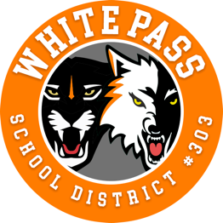
TO: MEMBERS OF THE BOARD OF DIRECTORS, WHITE PASS SCHOOL DISTRICT NO. 303 FROM: DR. PAUL FARRIS, SUPERINTENDENT

SUBJECT: SPECIAL MEETING OF THE BOARD OF DIRECTORS
May 7, 2020 6:00 P.M., ROOM 205
Virtual Meeting Via Zoom, per COVID-19

This Special School Board Meeting will be held as a Virtual Meeting Via Zoom, per COVID-19 social distancing guidelines, Governor Inslee’s Stay at Home Order, and the Governor’s suspension of aspects of the Open Public Meeting Act.: attendance is limited to remote attendance. (At this time, in accordance with the current State of Emergency in Washington state, public comment has been limited to written comments. Written communications must be mailed to district office or superintendent and received by 3pm May 7, 2020 to be included in the meeting agenda)

Zoom Link – For computer login - https://us02web.zoom.us/j/85200038120
Meeting ID- 852-0003-8120 For Phone Connection
Call in Phone Numbers- Toll Free Number
1-833-302-1536

AGENDA
1. Welcome
A. Virtual Meeting Protocol
B. Verification of Quorum
2. Call to Order Pledge of Allegiance.
3. Written Public Comment Related to Agenda Items
4. Presentations
A. Superintendent’s Update – Dr. Paul Parris
B. Reports – Continuous Learning Plans
a. Chris Schumaker – Jr. Sr. High School (action)
b. Nathan Coutsoubos – Elementary School (action)
c. Brian Carter – ALE (action)
4. New Business
A. Co Curricular 1, White Pass Co-Curricular Association (MOU) (action)
B. Transition to SEEB insurance – (MOU) (action)
C. Closure of School – (MOU) Between WPSD and WP Education Assc. (action)
D. Leave – Extension of 1 Year (MOU) (action)
E. Calendar Extension – Last day of School – June 19, 2020 (action)
F. Board Resolution No. 03-20 Resolution 2019R – Continuous Learning Plan for the White Pass School District and Emergency Waiver of School Days and Instructional Hours
5. Adjournment

