1st Grade P.A.L.
Parkview At-Home Learning

Parkview At-Home Learning is as easy as 1, 2, 3! Thank you for your support at home as we work to retain and strengthen the skills learned in 1st Grade this year.

 | May 4 - May 8 | Online Resources | Teacher Tips
Reading | Passage 43 | https://www.teachyourmonstertoread.com/ | Have your child pick a sentence from passage #43 and ask them to read it in a football player’s voice, a cheerleader’s voice, a baby’s voice, a grandmother/grandfather’s voice, etc. (A great way to build fluency and confidence for reading is to read familiar material over and over and make it fun...switch up voices, be silly with it! Happy reading!)
 | Main Idea and Details: Games With a Ball | https://www.raz-kids.com/ | Give your child a simple, easy topic statement such as “Lots of vegetables are grown in gardens.” or “This is how you should wash your hands.” Then, have your child come up with sentences that give more detail about your statement. (Vegetable examples: People grow green beans in their gardens. Corn can be grown in gardens. Peppers are grown in gardens. Washing hands examples: Wash your hands for at least 20 seconds. Sing a song to help you. Wash all parts of your hand, like between your fingers and your nails. Use plenty of soap.)
 | Long Vowel: Kate Bakes a Cake | www.abcmouse.com/login | 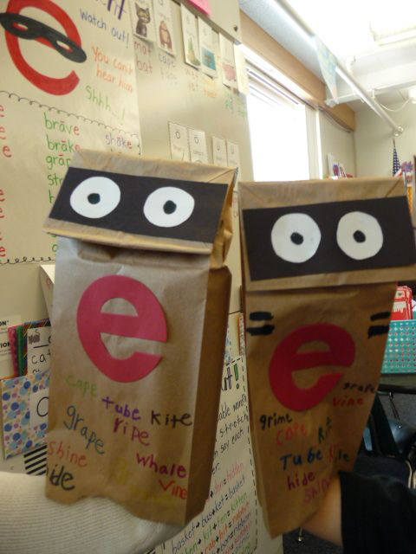  Make a “Sneaky e” puppet with a paper sack or an old sock, or just whatever you have! Have your child write vowel-consonant-e words (also known as “Sneaky e” words) on their puppet. As you and your child read books together, have your child use their puppet to find any “Sneaky e” words that they can and have their puppet pretend to “eat” the words. (Examples of “Sneaky e” words are: safe, grape, ripe, kite, whale, tube, hide, cape, note, Steve, rope, joke, these, here, etc.)
Math | Addition and Subtraction Word Problems Review packet | https://drive.google.com/file/d/1-OxJwGfUh2WaKYZ4HXwDbQD75QIfi39_/view?usp=sharing  https://drive.google.com/file/d/1Kfby_AlYnKELa6okgrdBEFVJ7bh6n7ae/view?usp=sharing | Complete the review packet for addition and subtraction word problems.
 | Nature Walk Story Problems |  | Go on a Nature Walk or just a walk around the block with a parent. Create your own story problems as you walk around and solve them with your families. Don’t forget to ask the question at the end to solve the problem.
 | Addition and Subtraction Choice Board | https://docs.google.com/document/d/15H9v05YXAgYnnzg3-uJG7ssrP5DuT72adlwmZJrmTUA/edit?usp=sharing  https://drive.google.com/file/d/0B_nlFv34oalYSnhvMUVyNGhfUDA/view?usp=sharing | Choose 3 activities to do from the choice board. You can do them all if you want, it’s YOUR CHOICE
Writing | Use the ORC Writing format to answer this question: “What is your favorite game to play with a ball?” |  | Have your child write about their favorite game to play with a ball using the ORC format:  Opinion: I think ____ is the best game to play with a ball.  Reason 1:  Reason 2:  Reason 3:  Conclusion: ______ is a great game to play with a ball.
 | Pronouns and Nouns Sort Set 1 |  | Write a simple sentence on a card or piece of paper, such as “The book is on the bed.” or “Your brother is five years old.” Underline the subject (noun) in each sentence. Make 5 or 6 sentences in all. Spread them out in one area of the house. Have your child move in a fun way (on tiptoes, like a snake, crawl like a baby, etc.) to go get one of the sentences and bring it back to you. Once your child has brought the sentence to you, read it or have your child read it. Then ask them to replace the underlined words in the sentence with a pronoun. (Example: “It is on the bed.” or “He is five years old.”)
 | Fix it Up Sentences Set 2 |  | Look over your opinion writing piece and check for capitalization and punctuation.

