Preschool P.A.L.
Parkview At-Home Learning

Parkview At-Home Learning is as easy as 1, 2, 3! Thank you for your support at home as we work to retain and strengthen the skills learned in preschool this year.
Week 7 | 4-27 to 5-1 | Online Resources | Teacher Tips
Language Arts | 1.Fundations: Practice writing lowercase w and y. (Don’t forget to keep practicing using your letter mat just like baby Echo!) | 1https://youtu.be/r7jYs49udFg?list=PL9zXaH17WT2hl149hawBoaVlFiBEfIQtl  https://drive.google.com/file/d/18MbqsAhhDpTGaxEY_bvH1X1_SWnK9bqn/view?usp=sharing | 1.
 | 2.Practice writing your name using the caterpillar circles and answering the questions about the letters in your name. | 2.  https://drive.google.com/open?id=1QeopQB0GaUcAw4TqRMjic7uo5z40rtTE | 2.Use a sheet protector and a marker if you would like to use this over and over again.
 | 3. Go on a scavenger hunt to find things that start with this week's letters (w & y). | 3. | 3.
Math | 1.Hop with 2 feet around the house and count your hops. | 1. | 1.
 | 2.Make a pattern using red/blue/red/blue | 2. Practice Math concept in virtual preschool. https://www.youtube.com/channel/UCdL1MZnGotv0uN6-ROztqdw A few of her videos show how to make patterns. | 2.
 | 3. Scoop water into a cup. Count each scoop. How many to fill it up? | 3. | 3.
Gross Motor | 1. Lay on your belly and blow bubbles. This will help strengthen your core. | 1. | 1.
 | 2. Race a family member. Put items (5-10 each) on one end/side of the room (same number in each pile). Go as fast as you can, grabbing one item at a time to bring back to the side you started on. | 2. | 2. Start by running, then try hopping, skipping, etc. How many different ways can you race your family member?
Fine Motor | 1.Mystery 4 piece puzzle--cut out the pieces and then place them in order on the ‘At the Zoo’ mat. Once you have them correctly placed, glue them down and color. What animal was it?Only need to print the zebra 4 piece puzzle and the corresponding mat. | 1.  https://drive.google.com/file/d/1_PEmlQdLS8gBBu9_3I3hEkxCgKOOZWGp/view?usp=sharing | 1.Remind your Preschooler to cut with their thumb up and to use their other hand to hold/guide the paper.
 | 2.Fine Motor shapes--practice tracing your shapes and then turn it over and try to draw your own. | 2.  https://drive.google.com/file/d/19XpoEh8ci-7e1B6lju9rIf1OUKMkuSTP/view?usp=sharing | 2.

Week 8 | 5-4 to 5-8 | Online Resources | Teacher Tips
Language Arts | 1.Fundations: Practice writing lowercase x and q. (Don’t forget to keep practicing using your letter mat just like baby Echo!) | 1https://www.youtube.com/watch?v=2MMiie4vNwk  Fundation letter sounds  https://drive.google.com/file/d/1DOnnJ_7iXWQ7rZUU5kfDwhdkW1g9fwU2/view?usp=sharing | 1.
 | 2.Play the alphabet “I have, who has” game. Start with the starting card and then keep picking until all the cards are matched up.Only need to print the cards because the last card has the directions on it. | 2.  https://drive.google.com/file/d/1snvu9_RVp5FRVBz_bVyFxQr-y5UUTotn/view?usp=sharing | 2.
 | 3. Match the rhyming words--draw a line from the picture on the left to the rhyming word on the right. Only need the first page as the other one would have too many options for our kiddos. | 3.  https://drive.google.com/file/d/1K0woHff9w1PXuX66dx-F0HnaPMxwDJtD/view?usp=sharing | 3.
Math | 1.Count the number of books around your house. | 1. | 1. Where do you have the most books? Which room has the least books?
 | 2.Make numbers out of Playdough | 2. Kool Aid Play Dough | 2. If you don’t have playdough consider making “cloud dough” mix flour and water together to make a packable consistency.  PRO TIP: Use it on a cookie sheet or in a box lined with a trash bag or plastic bags to contain it. Write the numbers in cloud dough using your hands **Supervision required
 | 3. Count the number of letters in your name. | 3. | 3.Can you count the letters in other family members' names too? Who has the most?
Gross Motor | 1.Go on a walk through your house. How many steps does it take to get from one space to another. | 1. | 1.
 | 2.Bear Walk around the house. | 2. | 2.
Fine Motor | 1.Create a Face--cut out the shapes and use them to make a face. You could glue them down, or just keep making different faces with your pieces. | 1.  https://drive.google.com/file/d/1oFJ-oUZSAmoquNKlHahlYhOQiwrz6lbg/view?usp=sharing | 1.It might be easier for your Preschooler to cut them out if they were already individually separated.
 | 2.Springtime Playdough mat--cut out the number boxes, then pick a number and make that many objects using the tens frame. Make bugs, flowers, nuts, etc.Only need to print the last 2 pages for this activity. | 2.  https://drive.google.com/file/d/1eRqSzcHJEMs8ApPn0l11WvOHzURjHJVd/view?usp=sharing | 2.You could have your child help you cut out the numbers to use the mat.
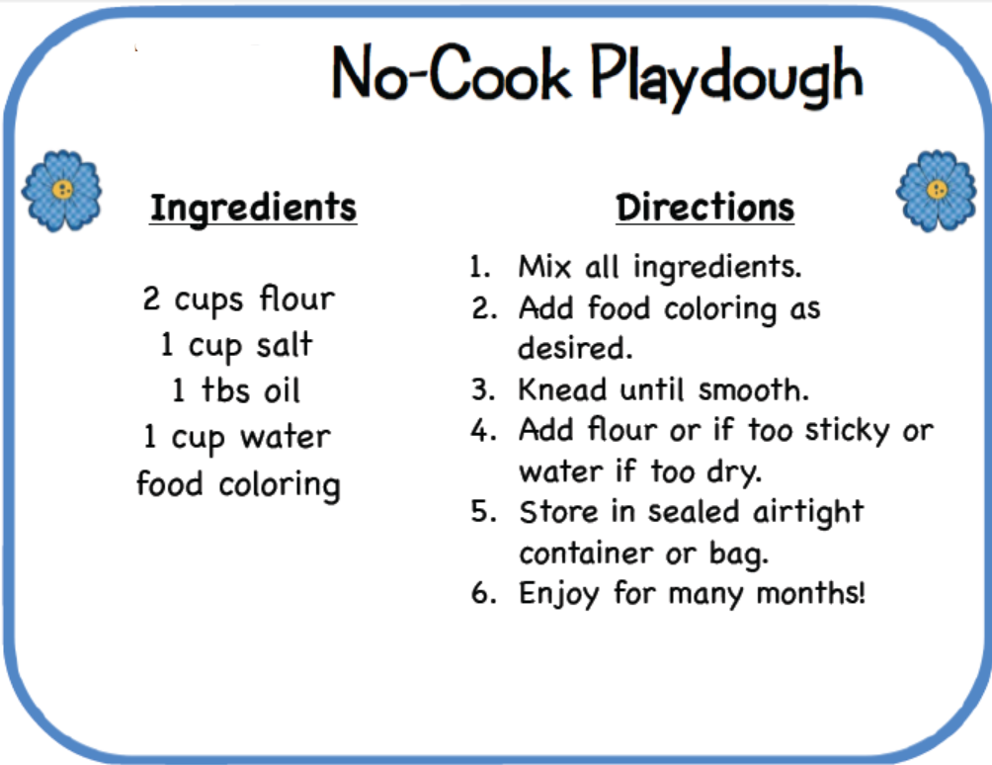

Week 9 | 5-11 to 5-15 | Online Resources | Teacher Tips
Language Arts | 1.Fundations: Practice writing lowercase z. (Don’t forget to keep practicing using your letter mat just like baby Echo!) | 1  https://drive.google.com/file/d/1RzQ964FkGH431fvvK3M1E_Brn3eMej-F/view?usp=sharing | 1.
 | 2. Play “Oh No!”--cut out all of the pieces and then place them in a bowl or something. Have your child pull out a card and name the letter. If they pull out an Oh No card they have to place the pieces back and start again. Only need to print the letter cards for this game with the Oh No cards | 2.  https://drive.google.com/file/d/1VUzles9hwOQVqvTOFBALnkGINZaFivzX/view?usp=sharing | 2. To simplify the game you don’t have to use all of the Oh No cards so there is more letter work. Also for added practice they can say the letter sound and possibly something that starts with that letter.
 | 3. I can write my name in--Practice writing your name using the different writing utensils .Just need the first one with the words printed for each utensil. | 3.  https://drive.google.com/file/d/1Ypf-miDQnMcQ5uTo0jjDMluGh7IJRc-e/view?usp=sharing | 3. For added practice you could use the first line for your first name and the second for your last name.
Math | 1.Toss a ball back and forth and count how many tosses without dropping. | 1. | 1.
 | 2.Graph the weather each day the rest of the days in April and beginning of May. Compare your monthly findings. ((Print double Sided please, uploaded in Preschool folder)) | 2.  https://drive.google.com/file/d/1pnH4AqGeuhmM1ALiEPcJOUnmfsHvhaJ-/view?usp=sharing | 2.
 | 3.Question of the Day (Form on Crystal’s cubbies). Use tally marks. Count each one. | 3. | 3.
Gross Motor | 1.Turn on music and take turns choosing ways to move. | 1. | 1.
 | 2. Loud and soft- first walk on your tip toes trying to be really quiet, then stomp your feet trying to be really loud. | 2. | 2.
Fine Motor | 1. Spring Tracing Cards--Trace the line from the birdhouse all the way to the bird. Only print the first 2 tracing cards please | 1.  https://drive.google.com/file/d/1u30qbCnwRyA0YBI1Aksv5Mo9_G2qw3L7/view?usp=sharing | 1.Place in a sheet protector if you would like to practice more than once.
 | 2.Stringing--use a ball of playdough with a stick or piece of spaghetti standing vertically then use cheerios, buttons, beads, etc. to place on the stick/spaghetti. | 2.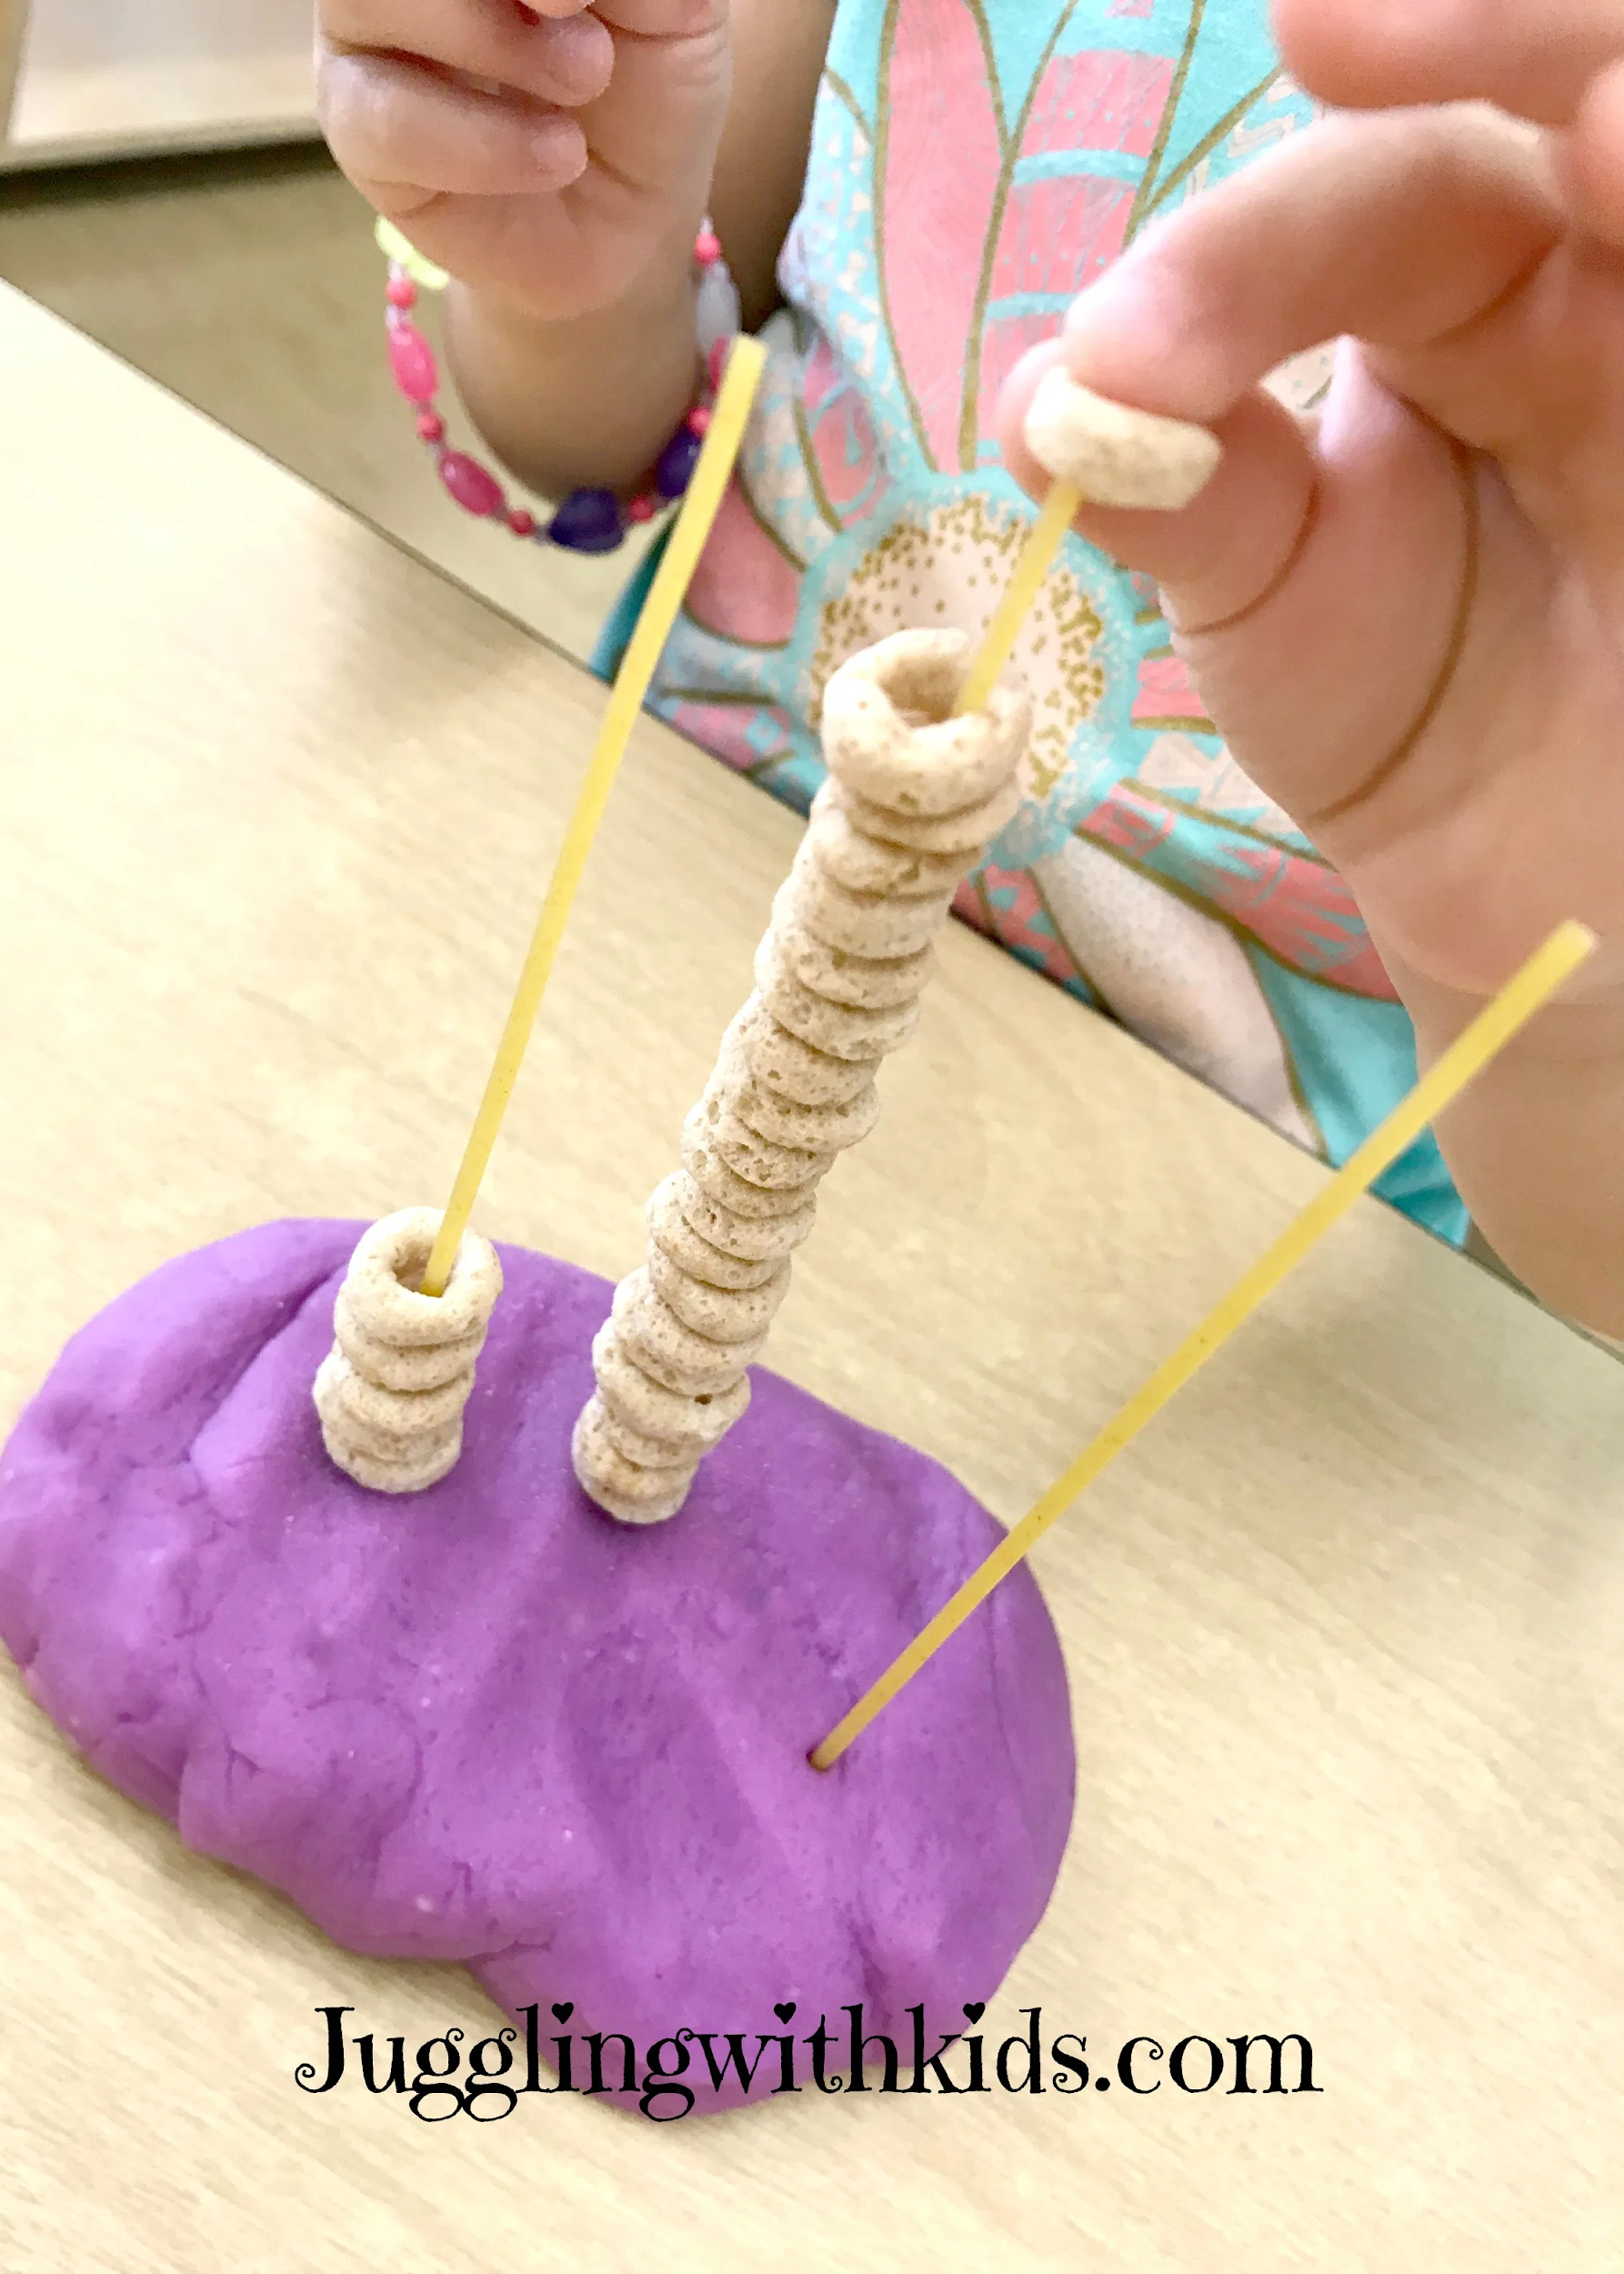 | 2.You could also try giving your child a set number to place on the stick or even have them make a pattern.

