Alicia Blaakman-Abney
Principal, Dennis Chavez Elementary School

19670 Hwy 314
Belén, NM 87002
Email: blaakmana@beleneagles.org
Cell: 505-238-8404
PHONE (505) 966-1810 FAX (505) 966-1850

K6+ Information
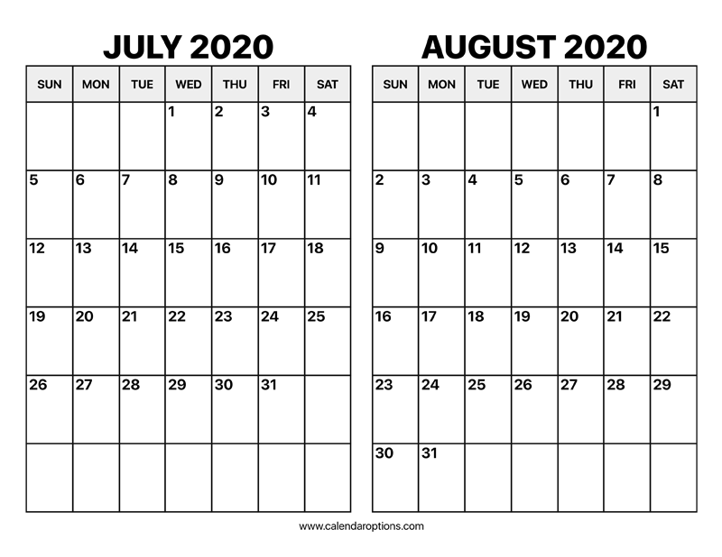
PENDING FUNDING
Program Dates: July 6th-August 7th
Program Schedule: Monday-Friday (Time to be determined)

Students and their families must commit to the items listed below:

- My child will attend the 25 days of instruction with very limited absences that need to be addressed to the site.
- Classes will be filled on first come first serve basis; parents will be notified ASAP of acceptance into the program
- Others may be placed on waiting list.

You will NEED to register for K6 summer program with Celeste Sena. If needed, she can talk to you at the school through the door camera. She will contact you with further information when available. Please register your new Kindergarteners for the summer program as well as for the school year (2020-2021). Kindergarten registration information is available at DCE Grab and Go!

Celeste Sena:
senac@beleneagles.org
966-1800

