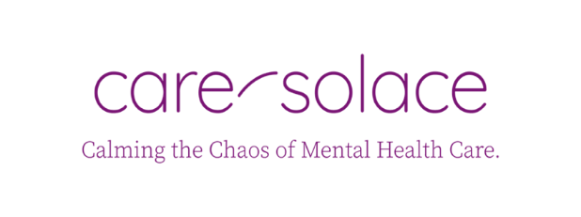
Dear Placerville Families,
The Placerville Union School District fosters a culture that promotes the health, safety, and well-being of students and parents. In an effort to continuously support this commitment, the District has approved an agreement with Care Solace. During this uncertain time, we felt it was important to provide these added services so that you as families can obtain the resources that you might need. This service is available for anyone in your family not just PUSD students.
Our PUSD counselors are still available to provide support for your child as well. If there is a need please email them and they will be getting back to you as soon as possible. They are also able to help you through the beginning process with Care Solace as well.
Care Solace is an online resource with a live 24X7 concierge line meant to assist individuals in finding local mental health related programs and counseling services. To use Care Solace, individuals answer ten basic questions in order to receive an extensive list of referrals to applicable care providers. Care Solace takes into account all types of private insurance including Medi-Cal, Medicaid, and Medicare and those that have no insurance. The system also filters by age, gender, zip code and special request.
Care Solace is uniquely equipped as a virtual mental health support resource. Their proprietary web-based tool makes it easy to connect with vetted mental healthcare resources and providers in the community.
The Care Solace operations are running as usual and are available to help our community. If you or a family member is experiencing anxiety, stress, depression, or other mental health conditions triggered by the current pandemic, we encourage you to utilize their free services to help access vetted mental health care resources.
Care Solace is now available for use by Placerville students and families at no cost. Please note, this service is an optional resource available by choice and is not mandatory in any way. Care Solace does not require a user’s name, address, phone number, or date of birth. All of the information that is entered in on their platform is completely confidential and stored securely.
If you are in need of counseling-related services at this time, please contact Care Solace at (888) 515-0595 or follow the link at, caresolace.com/placervillefamilies
Sincerely,

Eric Bonniksen
Superintendent

