8th GRADE SOCIAL STUDIES WORK PACKET - MAY

8th Grade Students,
Below you will find the checklist and required items to complete during our final weeks of school. Each of these assignments should take you 30-45 minutes, and I suggest working on one each day as listed below. Of course you may work at your own pace, just make sure each assignment is complete to the best of your ability. Please reach out to me if you have any questions. I can be reached at emrutter@myleadacademy.com or by phone at 864-497-5034. I will also be holding daily Google Meetings from 9:30-10, where we will work through that day’s assignment together, and I will also answer questions you have. I hope you all stay safe and healthy during this time away from school!

Mrs. Rutter

Checklist:
- Wednesday, May 6: Read, highlight and annotate the article “WESSKA: The Civil Rights Movement.” (p. 1-2)

- Thursday, May 7: Answer the questions on the article “WESSKA: The Civil Rights Movement.” (p. 2)

- Friday, May 8: Complete the “Important Civil Rights Cases” Chart using the reading and internet research (p. 3)

- Monday, May 11: Read the Introduction to “10 Supreme Court Cases..” and answer the reflection questions (p. 4)

- Tuesday, May 12: Read Court Cases 1 and 2 carefully and fill in the question grid box for each case. (p. 4-11)

- Wednesday, May 13: Read Court Cases 3 and 4 carefully and fill in the question grid box for each case. (p. 4-11)

- Thursday, May 14: Read Court Cases 5 and 6 carefully and fill in the question grid box for each case. (p. 4-11)

- Friday, May 15: Read Court Cases 7 and 8 carefully and fill in the question grid box for each case. (p. 4-11)

- Monday, May 18: Read Court Cases 9 and 10 carefully and fill in the question grid box for each case. (p. 4-11)

- Tuesday, May 19: Answer the Post-Reading Questions in the final grid box. (p. 11)

- Wednesday, May 20: Write your own Supreme Court Ruling on an issue that is important to you! (p. 12)

- Thursday, May 21: Read Station 1 of the Modern SC Stations Activity, and answer the questions (p.13)

- Friday, May 22: Read Station 2: Changes in Agriculture, and answer the questions (p. 14)

- Tuesday, May 26: Read Station 3: Economic Changes, and answer the questions (p. 15)

- Wednesday, May 27: Read Station 4: Right to Work State, and answer the questions (p. 16)

- Thursday, May 28: Read Station 5: Globalization in SC, and answer the questions (p. 17)

- Friday, May 29: Read, highlight and annotate the article “WESSKA: Environmental Issues Today.” (p. 18-19)

- Monday, June 1: Answer the questions on the article “WESSKA: Environmental Issues Today.” (p.19)

- Tuesday, June 2: Write a Letter to the Editor to convince the public to help protect the environment! (p. 20)

- Wednesday, June 3: Review your work packet to ensure everything is complete! Have a great summer!
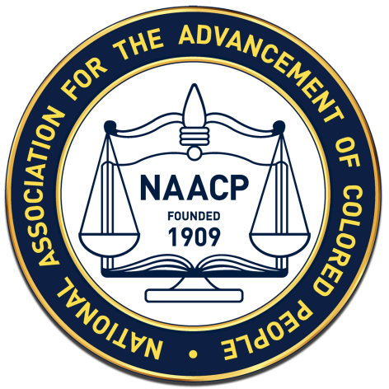
What Every Student Should Know About the Civil Rights Movement
Jim Crow laws, restrictions on voting through poll taxes and literacy tests, and discrimination in the workplace, continued to limit the social, political, and economic opportunities of African Americans in the twentieth century. It is important for students to understand that the movement for civil rights in the U.S. continued from the colonial period. Throughout the twentieth century, many organizations actively sought the recognition of African American rights and the fulfillment of the promises of the Declaration of Independence and the thirteenth, fourteenth, and fifteenth amendments. The National Association for the Advancement of Colored People (NAACP) took the legal approach to equality and brought cases to the courts that challenged the normal practices of discrimination and laid the groundwork for change. Among many other cases, the NAACP challenged the exclusion of African American voters from participation in the South Carolina Democratic Party’s selection of candidates. The Democratic Party had dominated politics in South Carolina and the South since Reconstruction so the white primary effectively excluded blacks from having any say in selecting the state’s elected officials. The United States Supreme Court ruled in Elmore v. Rice (1947) that the white primary was unconstitutional. African Americans, who continued to face white hostility, still had to overcome intimidation but they now had the opportunity to truly vote on the issues.
The landmark case of Brown v. Board of Education (1954) started with a simple request. The parents of African American students in Clarendon County, SC requested a bus to take their children to their all-black school. Some children had to walk 18 miles to and from school each day. Since the county’s [2375] white children had [30] school buses for their use and its [6531] black students had none, parents at Scott’s Branch School felt that the “separate-but-equal” doctrine established by the Supreme Court in Plessy v. Ferguson required the school district to pay for the gas and repairs on the used bus that the families bought to take their children to school. Parents did not originally seek integration but equality. The original case was dismissed due to a technicality. With the assistance of local leaders including Modjeska Monteith Simkins and the NAACP, parents brought suit against the school district in a new case, Briggs v. Elliot, for equal treatment under the law as required by the 14th amendment. In federal district court, the counsel for the state of SC admitted that separate schools for African Americans were unequal but claimed that the state had initiated a building program that would bring the African American schools up to par with the white schools. The court, therefore, ruled in favor of the school district. The NAACP then appealed the case to the Supreme Court. Briggs v. Elliot was one of five cases that became part of the landmark Brown v. Board of Education decision. In Brown, the Supreme Court overturned Plessy v. Ferguson and ruled that separate was inherently unequal. The court further ruled that African American students should be integrated into white schools with “all deliberate speed.”
South Carolina officials resisted efforts to integrate schools in a variety of ways. While the Briggs case was still pending in the federal courts, South Carolina launched a statewide effort to improve education by making separate African American schools equal to schools for whites and were able to remain segregated under the Plessy “separate but equal” doctrine. This massive building program is known as the equalization effort. Modern schools for African American students were built throughout the state. When the equalization effort was not successful in persuading the courts that “separate but equal” should be upheld, the Brown ruling was met with widespread and sometimes violent opposition and delay. The Governor of SC, James F. Byrnes, encouraged this resistance. White Citizens Councils were established to coordinate efforts to intimidate African Americans who fought for equal treatment and to label whites who supported the court’s ruling as traitors to their race. South Carolina’s Senator Strom Thurmond authored the Southern Manifesto. This document condemned the Brown decision for upsetting the relationship of whites and African Americans in the South and encouraged resistance to desegregation. Resistance included the establishment of many ‘white flight’ private academies, school choice, and the voluntary closing of public schools. For 20 years, SC avoided integrating schools.
The Brown decision prompted other civil rights actions throughout the South. In response to the actions of Rosa Parks and the Montgomery Bus Boycott, the Supreme Court ruled that city buses could not be segregated. This case, Browder v. Gayle, meant all bus segregation was unconstitutional. South Carolina’s bus companies ignored the ruling. When students staged a sit-in at a North Carolina lunch counter, South Carolina students followed their example throughout the state and initiated a new tactic. Grassroots protests and demonstrations throughout SC echoed the national movement led by Martin Luther King, Jr. The response of the white leadership of SC was tempered by their desire to attract economic investment to the state. Pictures of protests and violence in other southern states broadcast on nationwide television and newspapers did not encourage such investment. Consequently in 1963, South Carolina began to slowly and deliberately integrate public facilities.
Beginning with Clemson College and followed by the University of South Carolina, state colleges were integrated without violence. SC college students also played a role in the Civil Rights Movement. The Friendship Nine were students at Friendship College who introduced a new tactic in the 1960s. While planning a sit-in at a Rock Hill lunch counter, the students decided that if arrested, they would not accept bail but would serve out their sentences. By so doing, they brought greater public attention to their protest against segregation. Other protesters across the country adopted the "jail no bail" tactic, and served out their jail sentences, straining the local prison system and drawing national attention.
1. Annotate the text as you read. Highlight important terms. Put a star by unfamiliar concepts.
2. What rights are given in the 13th, 14th and 15th Amendments? (You may need to look back in your notes for this.)

3. What was decided in Elmore vs. Rice? Why do you think this was important, especially in South Carolina?

4. What happened in the case of Briggs vs. Elliott? Why was this important on a national level?

5. Explain three ways South Carolina resisted integrating schools after the Brown vs. Board decision.

6. What was the Southern Manifesto? Why did Thurmond write it?

7. What finally convinced politicians in SC to begin integrating schools?

8. What is the “jail no bail” tactic? Why did this have such a big impact on the resistance movement?

Important Civil Rights Cases
Directions: Use the article “WESSKA: The Civil Rights Movement” as well as Internet research (if needed) to complete the chart below. Each case was an integral part of the Civil Rights Movement!

Court Case | Date | Summary | Importance
Plessy v. Ferguson
Elmore v. Rice
Briggs v. Elliot
Browder v. Gayle

Brown v. Board of Education
10 Supreme Court Cases Every Teen Should Know
The nation's highest court has had plenty to say about everything from free speech at school to teenagers' rights in the legal system. By Tom Jacobs

Introduction
For those of us on the outside, the U.S. Supreme Court can seem remote and mysterious. But the Court, whose nine Justices are appointed for life and deliberate in secret, exerts a powerful influence over the course of the nation and over the lives of Americans—including teenagers. In a landmark 1967 case known as In re Gault ("in re" is Latin for "in reference to"), which concerned the arrest of a 15-year-old Arizona boy, the Court ruled that teenagers have distinct rights under the U.S. Constitution. (Prior to that, the law generally regarded children as the property of their parents). In the 40 years since, the Court has weighed in on a host of issues involving people under 18—from freedom of speech and privacy at school to the rights of teenagers in the legal system.

Reflection:
Why do you think Supreme Court cases are important?

How do you think these cases might affect you today?

Make a prediction about how the Supreme Court might handle students’ rights in a school setting.

- Tinker v. Des Moines Independent School District (1969)
Issue: Freedom of Speech at School
Bottom Line: You Have the Right To Express Yourself—Up to a Point

Background
In December 1965, John and Mary Beth Tinker and their friend Chris Eckhardt wore black armbands to school in Des Moines, Iowa, to protest the war in Vietnam. School officials told them to remove the armbands, and when they refused, they were suspended (John, 15, from North High; Mary Beth, 13, from Warren Harding Junior High; and Chris, 16, from Roosevelt High). With their parents, they sued the school district, claiming a violation of their First Amendment right of freedom of speech.

Ruling
The Supreme Court sided with the students. Students and teachers don't "shed their constitutional rights to freedom of speech or expression at the schoolhouse gate," the Court said. The Court did not, however, grant students an unlimited right to self-expression. It said First Amendment guarantees must be balanced against a school's need to keep order: As long as an act of expression doesn't disrupt classwork or school activities or invade the rights of others, it's acceptable. Regarding the students in this case, "their deviation consisted only in wearing on their sleeve a band of black cloth," the Court said. "They caused discussion outside of the classrooms, but no interference with work and no disorder."

Impact
In 1986, applying the "disruption test" from the Tinker case, the Supreme Court upheld the suspension of Matthew Fraser, a 17-year-old senior at Bethel High School in Tacoma, Washington, who gave a school speech containing sexual innuendos (Bethel School District v. Fraser). The Court said "it is a highly appropriate function of public school education to prohibit the use of vulgar and offensive terms in public discourse." Lower courts have relied on Tinker in rulings on school attire, allowing nose rings and dyed hair, for example, but disallowing a T-shirt displaying a Confederate flag. In June, the Supreme Court weighed in on another student expression case, Frederick v. Morse, ruling that schools can limit student speech that seems to advocate illegal drug use. The case concerned Joseph Frederick, an 18-year-old senior at Juneau-Douglas High School in Alaska, who was suspended in 2002 for holding a banner that said "Bong Hits 4 Jesus" while standing across the street from the school during the Olympic torch relay.

- New Jersey v. T.L.O. (1985)
Issue: Privacy Rights at School
Bottom Line: Your Belongings Can Be Searched, But Not Arbitrarily

Background
T.L.O. (Terry), a 14-year-old freshman at Piscataway High School in New Jersey, was caught smoking in a school bathroom by a teacher. The principal questioned her and asked to see her purse. Inside was a pack of cigarettes, rolling papers, and a small amount of marijuana. The police were called and Terry admitted selling drugs at school. Her case went to trial and she was found guilty of possession of marijuana and placed on probation. Terry appealed her conviction, claiming that the search of her purse violated her Fourth Amendment protection against "unreasonable searches and seizures."

Ruling
The Supreme Court ruled in favor of the school. Students have "legitimate expectations of privacy," the Court said, but that must be balanced with the school's responsibility for "maintaining an environment in which learning can take place." The initial search of Terry's purse for cigarettes was reasonable, the Court said, based on the teacher's report that she'd been smoking in the bathroom. The discovery of rolling papers near the cigarettes in her purse created a reasonable suspicion that she possessed marijuana, the Court said, which justified further exploration.

Impact
T.L.O. is the landmark case on search and seizure at school. Basically, school officials may search a student's property if they have a "reasonable suspicion" that a school rule has been broken, or a student has committed or is in the process of committing a crime. These are called "suspicion-based" searches. There are also "suspicionless searches" in which everyone in a certain group is subject to a search at school.

- Ingraham v. Wright (1977)
Issue: School Discipline
Bottom Line: Teachers Can Use Corporal Punishment, If Your Locality Allows It

Background
James Ingraham, a 14-year-old eighth-grader at Drew Junior High School in Miami, was taken to the principal's office after a teacher accused him of being rowdy in the school auditorium. The principal decided to give him five swats with a paddle, but James said that he hadn't done anything wrong and refused to be punished. He was subsequently held down while the principal gave him 20 swats. While corporal punishment was permitted in the school district, James suffered bruises that kept him out of school for 10 days and he had to seek medical attention. James and his mother sued the principal and other school officials, claiming the paddling violated Eighth Amendment protections against "cruel and unusual punishments."

Ruling
The Supreme Court ruled against James. The Court said that reasonable physical discipline at school doesn't violate the Constitution. The Eighth Amendment, the Justices said, was designed to protect convicted criminals from excessive punishment at the hands of the government—not schoolchildren who misbehave. The Court, however, did direct teachers and principals to be cautious and use restraint when deciding whether to administer corporal punishment to students. The Justices suggested that school officials consider the seriousness of a student's offense, the student's attitude and past behavior, the age and physical condition of the student, and the availability of a less severe but equally effective means of discipline.

Impact
The Court left the question of whether to allow corporal punishment up to states and local districts, which traditionally set most education policies. Twenty-two states currently permit corporal punishment in public schools, and 28 have banned the practice.

- Santa Fe Independent School District v. Jane Doe (2000)
Issue: School Prayer
Bottom Line: Public Schools Cannot Sponsor Religious Activity

Background
A Texas school district allowed a student "chaplain," who had been elected by fellow students, to lead a prayer over the public address system before home football games. Several students and their parents anonymously sued the school district, claiming a violation of what's known as the Establishment Clause of the First Amendment, which states that "Congress shall make no law respecting an establishment of religion, or prohibiting the free exercise thereof."

Ruling
The Supreme Court ruled that the school district's policy regarding prayer was unconstitutional. Although led by students, the prayers were still a school-sponsored activity, the Court said, and they were coercive because they placed students in the position of having to participate in a religious ceremony. "The Constitution demands that schools not force on students the difficult choice between attending these games and avoiding personally offensive religious rituals," the Court said. The Justices added that "nothing in the Constitution ... prohibits any public school student from voluntarily praying at any time before, during, or after the school day."

Impact
Since the Santa Fe decision, several lower courts have held that student-initiated group prayer is protected under the First Amendment if it is not sponsored by the school. This is generally accepted to mean, for instance, that a group of student athletes could pray together before a game in the locker room, as long as the coach or other school officials are not involved.

- Kent v. United States (1966)
Issue: Juveniles and Serious Crime
Bottom Line: Teens Can Be Tried as Adults

Background
Morris Kent, 16, who had been on probation since he was 14 for burglary and theft, was arrested and charged with three home burglaries, three robberies, and two counts of rape in Washington, D.C. Because of the seriousness of the charges and Morris's previous criminal history, the prosecutor moved to try Morris in adult court. Morris's lawyer wanted the case to stay in juvenile court where the penalties were much less severe. He had planned to argue that Morris had a mental illness that should be taken into account when deciding where he would be tried. Without a hearing, the judge sided with the prosecutor and sent Morris to adult court, where he was found guilty and sentenced to 30 to 90 years in prison. Morris appealed, arguing that the case should have remained in juvenile court.

Ruling
The Supreme Court ruled against Morris, and said that a minor can be tried and punished as an adult. However, the Justices said that in deciding whether to remove a case from juvenile court, judges must weigh a variety of factors, including the seriousness of the crime; the juvenile's age; and the defendant's criminal background and mental state.

Impact
How the courts treat juveniles in the legal system varies from state to state. In many states, those under 18 can be tried as adults for crimes such as murder, sexual assault, or possession or sale of drugs, with punishments that range up to life in prison without the possibility of parole. In 2005, the Supreme Court abolished the death penalty for juvenile offenders, saying it violated the Eighth Amendment's protection against "cruel and unusual punishments."

- Hazelwood School District v. Kuhlmeier (1988)
Issue: Student Journalism and the First Amendment
Bottom Line: Schools Can Censor Student Newspapers

Background
Cathy Kuhlmeier, Leslie Smart, and Leanne Tippett, juniors at Hazelwood East High School in St. Louis, Missouri, helped write and edit the school paper, the Spectrum, as part of a journalism class. An issue of the paper was to include articles about the impact of divorce on students and teen pregnancy. The school's principal refused to publish the two stories, saying they were too sensitive for younger students and contained too many personal details. The girls went to court claiming their First Amendment right to freedom of expression had been violated.

Ruling
The Supreme Court ruled against the girls. A school newspaper isn't a public forum in which anyone can voice an opinion, the Court said, but rather a supervised learning experience for students interested in journalism. "Educators do not offend the First Amendment by exercising editorial control over the style and content of student speech in school-sponsored expressive activities," the Court said, "so long as their actions are reasonably related to legitimate [educational] concerns."

Impact
Schools may censor newspapers and restrict other forms of student expression, including theatrical productions, yearbooks, creative writing assignments, and campaign and graduation speeches. But the Court's ruling in Hazelwood encourages schools to look closely at a student activity before imposing any restrictions and to balance the goal of maintaining high standards for student speech with students' right to free expression.

- Vernonia School District v. Acton (1995)
Issue: Student Athletes and Drug Testing
Bottom Line: Schools Can Require It

Background
James Acton, a 12-year-old seventh-grader at Washington Grade School in Vernonia, Oregon, wanted to try out for the football team. His school required all student athletes to take drug tests at the beginning of the season and on a random basis during the school year. James's parents refused to let him be tested because, they said, there was no evidence that he used drugs or alcohol. The school suspended James from sports for the season. He and his parents sued the school district, arguing that mandatory drug testing without suspicion of illegal activity constituted an unreasonable search under the Fourth Amendment.

Ruling
The Supreme Court ruled in favor of the school district. Schools must balance students' right to privacy against the need to make school campuses safe and keep student athletes away from drugs, the Court said. The drug testing policy, which required students to provide a urine sample, involved only a limited invasion of privacy, according to the Justices: "Students who voluntarily participate in school athletics have reason to expect intrusions upon normal rights and privileges, including privacy." The Court noted that all students surrender some privacy rights while at school: They must follow school rules and submit to school discipline. But student athletes have even fewer privacy rights, the Justices said, and must follow rules that don't apply to other students. Joining a team usually requires getting a physical exam, obtaining insurance coverage, and maintaining a minimum grade point average. And athletes must be willing to shower and change in locker rooms, further reducing their privacy. "School sports are not for the bashful," the Court said.

Impact More recently, the Court has ruled in favor of school policies requiring random drug testing for all extracurricular activities (Board of Education v. Earls, 2002).

- West Side Community Schools v. Mergens (1990)
Issue: Student Clubs
Bottom Line: Public Schools That Allow Student-interest Clubs Cannot Exclude Religious or Political Ones

Background
Bridget Mergens was a senior at Westside High School in Omaha, Nebraska. She asked her homeroom teacher, who was also the school's principal, for permission to start an after-school Christian club. Westside High already had about 30 clubs, including a chess club and a scuba-diving club. The principal denied Bridget's request, telling her that a religious club would be illegal in a public school. The year before, in 1984, Congress had addressed this issue in the Equal Access Act, which required public schools to allow religious and political clubs if they let students form other kinds of student-interest clubs. When Bridget challenged the principal's decision, her lawsuit became the Supreme Court's test case for deciding whether the Equal Access Act was constitutional under what is known as the Establishment Clause of the First Amendment: "Congress shall make no law respecting an establishment of religion, or prohibiting the free exercise thereof."

Ruling
The Supreme Court ruled in favor of Bridget. Allowing students to meet on campus to discuss religion after school did not amount to state sponsorship of religion, the Court said: "We think that secondary-school students are mature enough and are likely to understand that a school does not endorse or support student speech that it merely permits."

Impact
If a public school allows only clubs tied to the school curriculum—a French club related to French classes, for instance—it can exclude clubs that don't connect to its educational mission. But once a school allows student-interest clubs—such as a scuba-diving club, environmental club, or jazz club—it cannot exclude religious clubs, political clubs, gay-lesbian clubs, or other groups. If the club is religious in nature, however, the school must refrain from active involvement or sponsorship, so that it doesn't run afoul of the Establishment Clause, the Court said.

- Grutter v. Bollinger (2003)
Issue: Affirmative Action in College
Bottom Line: Colleges Can Use Race as a Factor in Admissions

Background
In 1997, Barbara Grutter, a white Michigan resident, was denied admission to the University of Michigan Law School. Grutter, who had a 3.8 undergraduate grade point average and good standardized test scores, sued the university over the law school's affirmative action policy, which considered race as a factor in admissions. Michigan and many other universities use affirmative action to increase the number of minority students admitted. Grutter claimed that Michigan admitted less-qualified minority applicants in violation of federal civil rights laws and the Fourteenth Amendment, which guarantees citizens "equal protection" under the law.

Ruling
The Supreme Court upheld the use of affirmative action in higher education. "Student-body diversity is a compelling state interest that can justify the use of race in university admissions," the Court said. But the Court emphasized that the University of Michigan's policy was acceptable because the school conducted a thorough review of each applicant's qualifications and did not use a racial quota system—meaning it did not set aside a specific number of offers for minority applicants.

Impact
Affirmative action, which has its origins in a 1961 executive order issued by President John F. Kennedy, continues to be a contentious issue, with critics charging that it amounts to reverse discrimination. Since 1996, voters in three states—California, Washington, and, most recently, Michigan—have approved laws banning affirmative action in public education, in state government hiring, and the awarding of state contracts.

- DeShaney v. Winnebago County Social Services (1989)
Issue: Constitutional Rights at Home
Bottom Line: The Constitution Doesn't Protect Kids from Their Parents

Background
Four-year-old Joshua DeShaney lived with his father, who physically abused him, in Neenah, Wisconsin. At one point, the State Department of Social Services took custody of Joshua but returned him after three days. Later, Joshua was hospitalized with bruises all over his body and severe brain damage. He survived, but was permanently paralyzed and mentally disabled. His father was convicted of child abuse and sent to prison. Joshua's mother sued the Department of Social Services for returning him to his father. She argued that the department had a duty to protect her son under the Fourteenth Amendment, which forbids the state from depriving "any person of life, liberty, or property, without due process of law."

Ruling
The Court ruled against Joshua and his mother. It said essentially that the Constitution does not protect children from their parents and that therefore the government was not at fault in Joshua's abuse.

Impact
The Supreme Court has consistently respected parents' rights to discipline their children. But even though the government isn't required under the Constitution to protect children, all states assume this responsibility through child protection laws. The Supreme Court has generally deferred to state and local governments to enforce these laws and to intervene in cases of mistreatment.

10 Supreme Court Rulings Every Teen Should Know  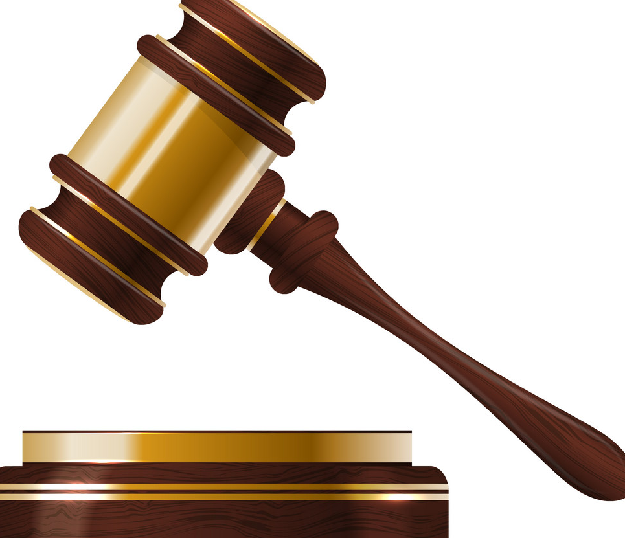  Directions: Read through the New York Times article and fill in the question grid for each case. For the “Background” and “Who Won the Case?” sections, be sure to answer in thoughtful, complete sentences. Use your own words. Do not repeat sentences or exact phrases from the text. I want to see your words. | 1.Tinker v. Des Moines Independent School District  Year:  Background:  Who Won the Case? Why?
2. New Jersey v. T.L.O.  Year:  Background:  Who Won the Case? Why? | 3. Ingraham v. Wright  Year:  Background:  Who Won the Case? Why?
4. Santa Fe Independent School District v. Jane Doe  Year:  Background:  Who Won the Case? Why? | 5. Kent v. United States  Year:  Background:  Who Won the Case? Why?
6. Hazelwood School District v. Kuhlmeier  Year:  Background:  Who Won the Case? Why? | 7. Vernonia School District v. Acton  Year:  Background:  Who Won the Case? Why?
8. West Side Community Schools v. Mergens  Year:  Background:  Who Won the Case? Why? | 9. Grutter v. Bollinger  Year:  Background:  Who Won the Case? Why?
10. DeShaney v. Winnebago Co. Social Services  Year:  Background:  Who Won the Case? Why? | Post-Reading Questions:  - Of the 10 court cases, which did you find most surprising? Why?  - Choose one of the court cases and explain whether you agree or disagree with the court’s ruling. Explain and defend your position.

Write Your Own Supreme Court Case Decision
Directions: Using the 10 Supreme Court cases above as examples, write your own Supreme Court Case Decision on an issue that is important to you.

First, choose an issue that is important to you. There is a list of examples below, but feel free to choose your own! For the Background, create your own pretend scenario around the issue. Next, explain the Supreme Court’s “decision” in the Ruling section. Finally, describe the long-term impact of this pretend Supreme Court ruling.

Example Issues: Freedom of Expression in Schools, Animal Abuse/Treatment, Individual Rights of Protest, Gun Rights, Teens Rights of Emancipation, Pollution by Businesses/Individuals, Constitutional Rights in Schools, etc.

Supreme Court Case Name:

Year:

Issue:

Background:

Ruling:

Impact:

MODERN SOUTH CAROLINA STATIONS
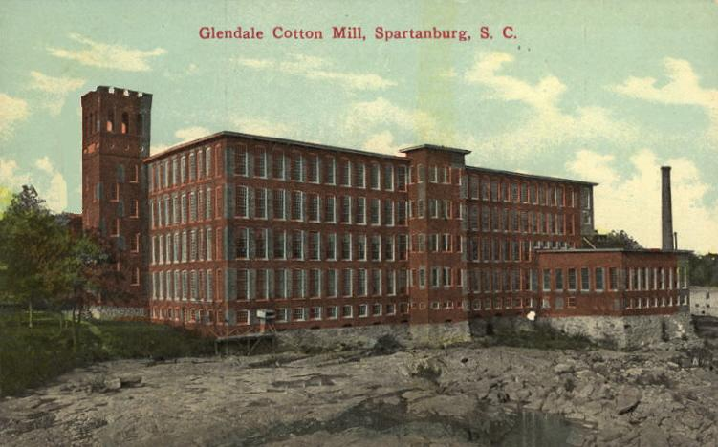
- Decline of the Textile Industry
Changes in the economy of contemporary South Carolina are rooted in economic changes of the post World War II period. During World War II many workers, especially African Americans, left farms for factory jobs in towns in South Carolina or in wartime industries across the nation. After the war ended, demand for textiles declined, hurting this important industry. The textile industry was able to stay competitive by keeping wages low, which helped them keep prices for the textile products low as well. Despite low wages, the textile industry was unable to weather the international competition brought by globalization in the 1990s. Just as declining tariffs contributed to depressed conditions in the textile industry in the 1920s, the removal of all tariffs through agreements such as the North American Free Trade Agreement (NAFTA) and the General Agreement on Tariffs and Trade (GATT) meant that textile jobs went overseas where wages were even lower than they were in South Carolina.

Questions:
- Why did many workers leave farms during World War II?

- How did the textile industry remain competitive when demand for textiles decreased after World War II?

- Why did the textile industry decline for good in the 1990s?

2. Changes in Agriculture
Many workers left farms for factory jobs in towns in South Carolina or in wartime industries across the nation during World War II. Consequently, landowners turned to crops that could be harvested by machine such as soybeans. Many war veterans did not return to the farm. Depopulation led to an even greater reliance on mechanization and fewer acres planted in cotton, which was still harvested by hand. By the mid-1950s, tobacco replaced cotton as the most important crop in the state. Unable to buy the expensive equipment needed to plant and harvest crops, sharecroppers and tenant farmers left the countryside for cities and suburbs. Landowners borrowed money using their land as collateral to buy equipment. In the postwar period, new farming methods and the use of fertilizers led to increased yields. This, yet again, caused overproduction and falling prices, which left small farmers unable to pay their loans so many more left for cities and towns. By the 1970s, more South Carolinians lived in cities than in rural areas. As a result of industrialization and mechanization, South Carolina’s economy changed from one that was based on agriculture to one based on manufacturing and tourism.

Questions:
- How did World War II cause farmers to change the crops they grew?

- Why did farmers rely on mechanization?

- How did overproduction lead to the fall of agriculture as the most important part of SC’s economy?

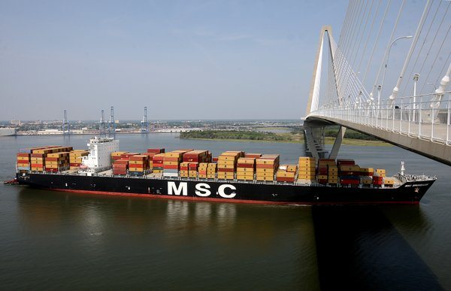
3. Economic Changes
The state government of South Carolina made a concerted effort to attract new industry to the state and those efforts continue today. With the encouragement of Governor Strom Thurmond, the legislature passed bills that provided for the expansion and modernization of the port facilities at Charleston. By the 1950s, Charleston was one of the leading seaports in the United States. To attract shipping, Charleston developed container facilities. The State Ports Authority oversees the development of the ports of Charleston and Georgetown, and has helped to attract foreign companies to the state as well as promote international trade. The future of the Charleston Harbor, however, depends on efforts to deepen the port to allow for larger container ships since the wider Panama Canal opened in 2014. An extensive system of roads and highways built by both the federal government and the state of South Carolina crisscrosses the state and provides transportation for goods to consumers throughout the country. Also South Carolina has developed a system of technical colleges that prepare a skilled workforce and attract new industries. The State Development Board continues to recruit businesses from other parts of the country and from Europe to the state by touting the incentives of tax breaks, low wages, and the state’s opposition to labor unions.

Questions:
- Why did SC want to expand and modernize its port facilities in the 1950s?

- What role do our highways and roads play in the SC economy?

- How do SC’s technical colleges help its economy?

- Right-to-Work State
The textile industry particularly benefited from South Carolina’s long standing hostility to labor unions. In the 1920s, Northern investors moved their mills to South Carolina in order to cut costs in the face of foreign competition. In the 1930s, textile workers were unsuccessful in their attempt to improve wages and working conditions through strikes. Despite New Deal legislation protecting labor unions, the state legislature passed a bill in the late 1940s that established South Carolina as a ‘right to work’ state. Right to work laws support the interests of management over the workers. Laws were written to allow employees to work in a factory without joining the recognized and elected union. This undermines the unity and therefore the effectiveness of the union at the bargaining table, and contributes to the scarcity of labor unions in South Carolina. South Carolina continues to market itself as a ‘right to work’ state and attracts businesses away from states that recognize the right of workers to join a union to protect their interests.

Questions:
- How did a lack of labor unions lead to increased investors in the 1920s?

- What does it mean to be a “right-to-work” state?

- How do unions work to protect workers interests and safety?

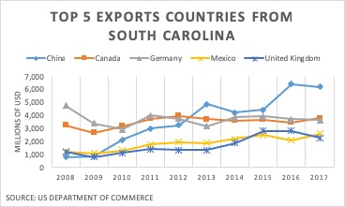
5. Globalization in SC
Although globalization contributed to the loss of textile jobs in South Carolina, globalization has also meant foreign investment in South Carolina. These investments, in turn, attract workers. Workers were attracted to the South when industries in the North suffered from foreign competition and downsized in the 1920s. Hispanic migrant farm workers have taken the place of South Carolinians who left agriculture for better opportunities. Retirees attracted to the South by climate and low taxes have spawned businesses to meet their needs, such as the construction of new housing. Some African Americans have returned to South Carolina due to improving race relations as a result of the Civil Rights movement and economic growth. Environmental hazards like pollution threaten the beaches, natural areas, and wildlife sanctuaries that are an important part of South Carolina tourism. This has led to a recent effort to protect the natural resources of South Carolina. In addition, universities and local organizations have provided an ever expanding array of cultural offerings designed to improve the quality of life and attract businesses and tourism to the state.

Questions:
- How has globalization attracted people to come live and work in SC?

- What were the top three export countries from SC in the year 2017?

- What benefits does SC offer its residents?

What Every Student Should Know About: Environmental Issues Today

The environment has been harmed by population growth, urbanization, and industrialization. Population growth and urbanization have led to an increase in land development, which has harmed or eliminated many animal and plant habitats. The green revolution that began in the 1960s was an attempt to increase food production worldwide through the increased use of fertilizers, pesticides, and new strains of crops. The result was higher yields of crops and lower rates of famine. Increases in agriculture also resulted in an increase in population. A downside to this green revolution, however, was the harmful chemicals released into the environment and increased soil erosion.
With the increase in population came increased urbanization and industrialization. Urbanization often results in problems of increased waste, local pollution, and increased temperatures in the cities compared to rural areas. The change in the use of the land has also changed wildlife habitats, endangering various species around the world. Cities and businesses require more land and agriculture. Urbanization and industrialization have increased the demand for earth’s natural resources and led to changes in the use of our resources, resulting in pollution and environmental issues.
Greenhouse gas emissions from automobiles and carbon dioxide emissions from the burning of fossil fuels have caused air and water pollution, acid rain, damage to the ozone layer, and increased the greenhouse effect. The continued burning of coal and oil has released carbon dioxide into the atmosphere, leading to air pollution and acid rain. The earth’s ozone layer, which protects us against the sun’s ultraviolet rays, has been damaged by the release of chlorofluorocarbons (CFCs). Continued loss of ozone could result in increased levels of skin cancer and damage to plant and animal species. Efforts have been made by groups worldwide to end the emissions of CFCs. In 1992, many nations of the world signed the Kyoto Protocol. This agreement was designed to reduce greenhouse gases emitted by each country by creating limits for how much greenhouse gases each country can emit per year. With increased publicity in recent years, public knowledge about global climate change is increasing.
Around the world, citizens and governments have become more involved in trying to protect the natural environment. On the local level, many communities and schools undertake recycling programs in an effort to reduce waste. Increasingly, some citizens are purchasing products made of recycled materials, opting for reusable bags at grocery stores, using more energy efficient light bulbs, and unplugging electrical appliances in an effort to make a small impact. Other changes such as hybrid and electric cars that use less oil and energy efficient appliances that require less power are increasingly being used. The research and development of alternative sources of energy continues to increase worldwide. Many alternative and renewable energy sources such as solar and wind are being used to provide power for homes and businesses. Nuclear energy, a nonrenewable energy source, is also widely used as a power source.
Despite all of the environmental challenges the world currently faces, many countries (and people) around the world are coming together to protect the environment for future generations to enjoy.
1. Define these terms in your own words.
a. population growth:
b. urbanization:
c. industrialization:
2. What was the “green revolution?” Describe one positive aspect and one negative aspect of the green revolution.

3. What problems are caused by urbanization? How do YOU think these problems could be fixed?

4. What does burning fossil fuels cause?

5. Why has the ozone layer been damaged? What problems has this caused?

6. What did 12 countries around the world do to try to reduce greenhouse gas emissions?

7. Describe four things that are being done to help the environment today. Which do you think has had the biggest impact? Explain your choice.
1.

2.

3.

4.

Letter to the Editor Creative Writing Assignment
Write a letter to the editor explaining what you think average Americans should do to help protect the environment. Describe some of the environmental issues we currently face using the article above, or the Internet, to help you. Then explain what each of us can do to help protect the environment for generations to come. Be sure to use facts from the article or your Internet research to support your ideas about environmental protection. Your letter should be persuasive - you want to convince the reader to make changes to help the environment. The letter should be 5-6 sentences!

Dear Editor,

______________________________________________________________________________________________________________________
______________________________________________________________________________________________________________________
______________________________________________________________________________________________________________________
______________________________________________________________________________________________________________________
______________________________________________________________________________________________________________________
______________________________________________________________________________________________________________________
______________________________________________________________________________________________________________________
______________________________________________________________________________________________________________________
______________________________________________________________________________________________________________________
______________________________________________________________________________________________________________________

Sincerely,

