6th
ELA Packet

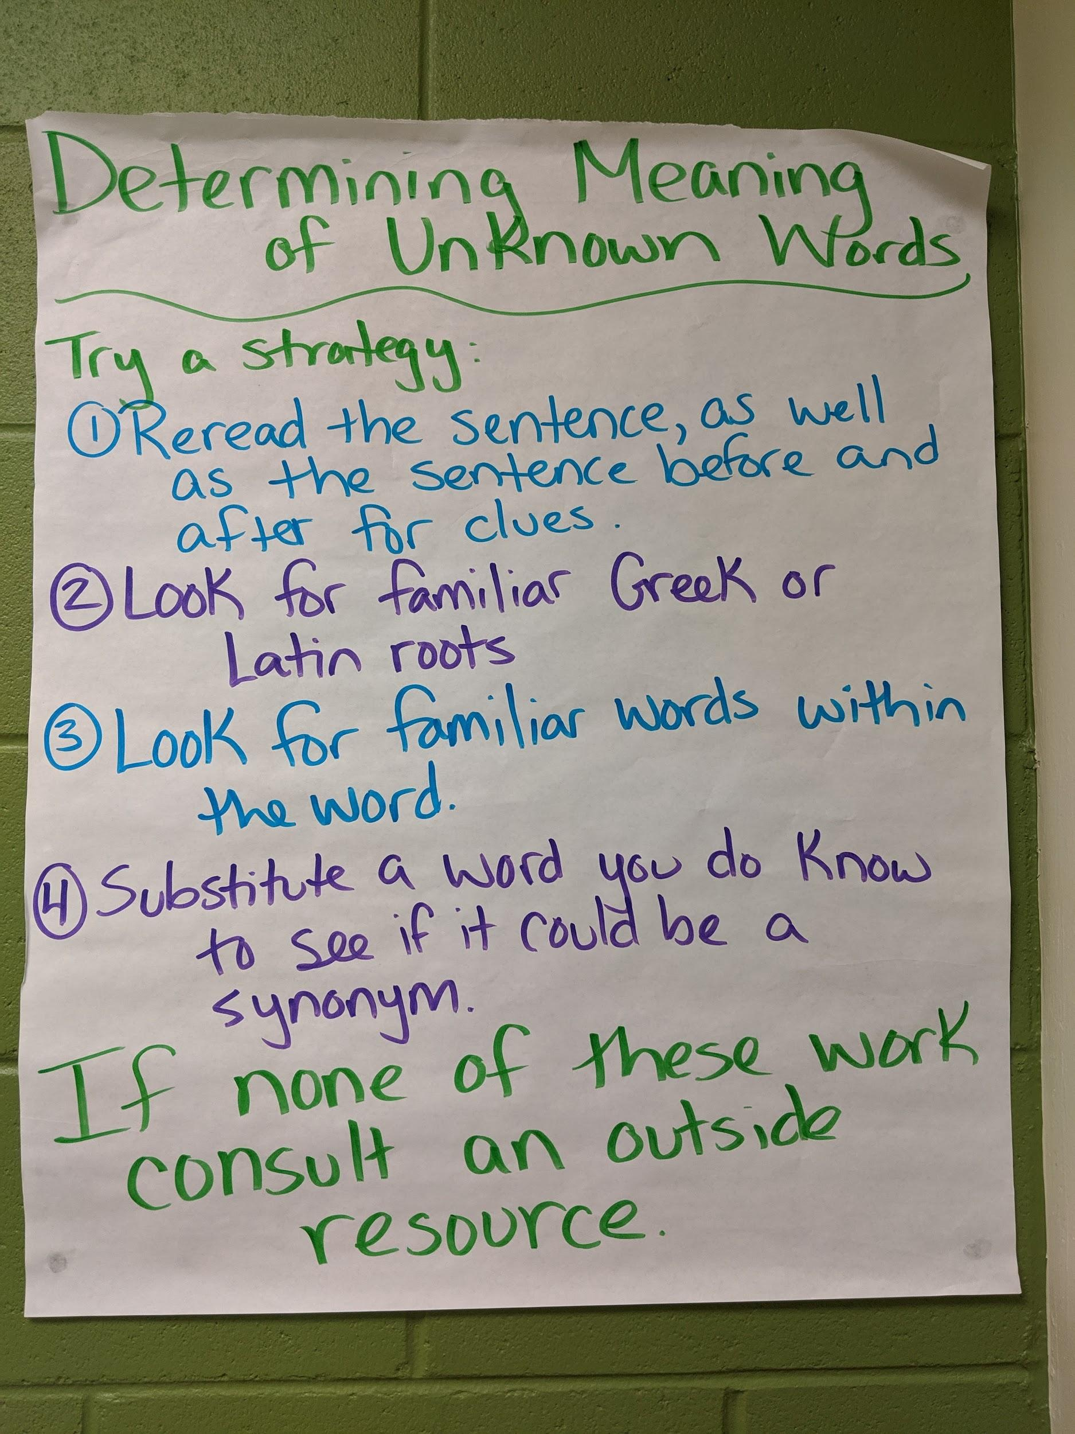
Week 1 (May 4-8): News Article- “12-year Old Celebrates his Birthday at Home”
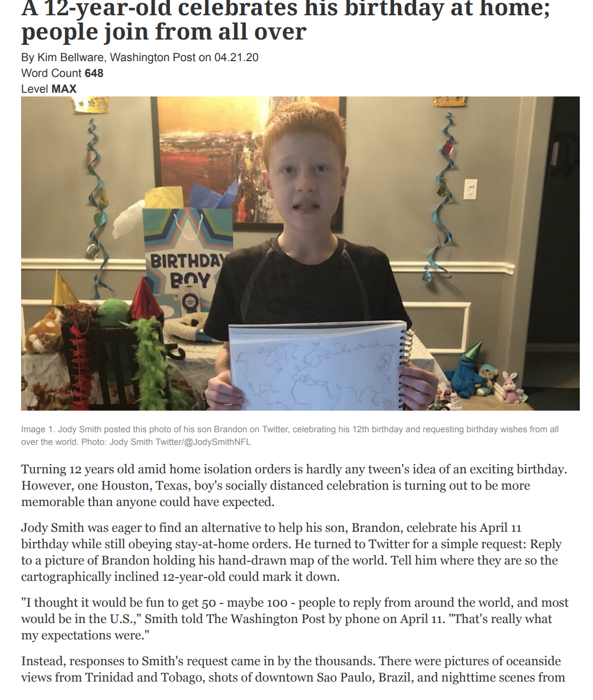
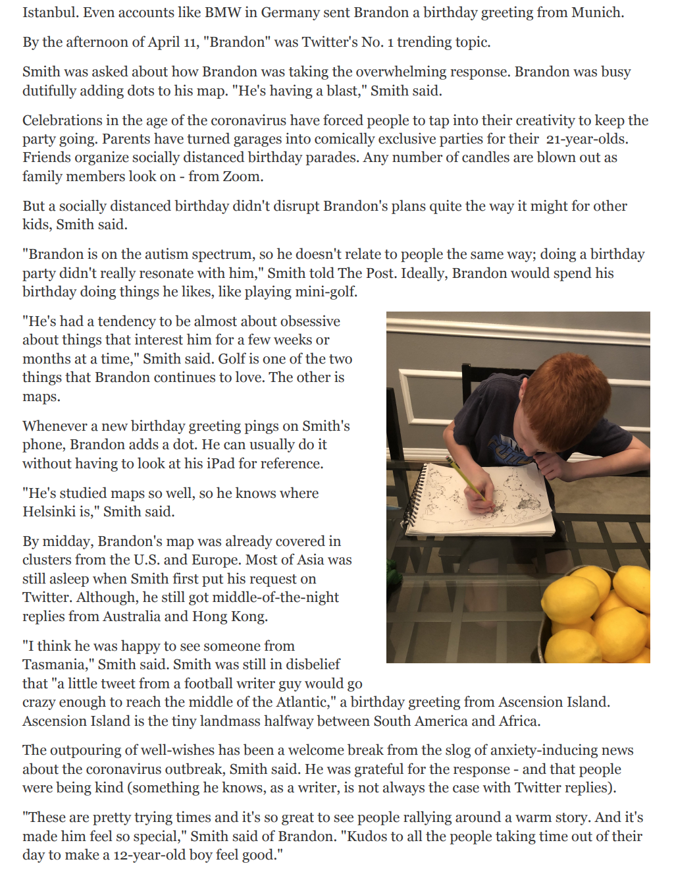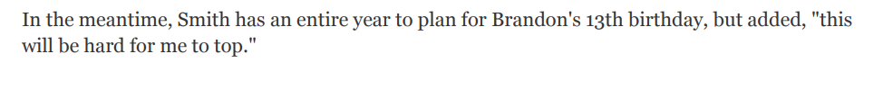
Wednesday: May 6th
Read
Read the article “12-year Old Celebrates his Birthday at Home”

- Read the headline title. What do you think this article is going to be about?

- Read the article through once. What is the gist of the article? What is it mostly about?

- What do you already know about the topic? How does this connect to what you already know?

- What is new learning for you?

- What is one piece of information that you found most interesting? Why?

- Read it again. Circle the words you don’t know.

- Choose 5 words you don’t know. Choose words you think will help you better understand what the text means.

Use one of the strategies on the anchor chart to find out what the words mean:

- Reread the sentence before and after to look for clues
- Affixes and roots: Look for prefixes, suffixes, or roots that you know
- Look for familiar words within the word
- Substitute a word you know and see if it makes sense
Last Resort: consult an outside source, a friend, a dictionary

Word and Pronunciation | Definition
Word | - Use one of the strategies on the anchor chart to tell what this word means in your own words.  - Use a dictionary (online or paper) to check your definition, add any necessary information to your definition.
 | Strategy Used (circle one): 1 2 3 4
 | Strategy Used (circle one): 1 2 3 4
 | Strategy Used (circle one): 1 2 3 4
 | Strategy Used (circle one): 1 2 3 4
 | Strategy Used (circle one): 1 2 3 4

Wednesday: May 6th
Read and Think
- Read the text again looking the way the text is organized. Look at the subheadings. What information is first? What next? Why?

- Read the text again. Think about the main idea(s) in the article. What are one or two things the author wants you to know?

- Which details in the text help you understand the main idea(s)?

- How does the way the text is organized help you understand the main idea(s)?

- Are there any pictures or images in the article? How do they help you understand the key points the author wants you to take away?

- What evidence has the author provided? How does this evidence support the main idea(s)?

- Does the evidence seem reliable? Do you trust the evidence the author has provide? Why or why not?

- Does the author have an opinion? How do you know?

Thursday, May 7th
Think and Talk
Do the following with a family member/caregiver or you could even phone a friend:

- Summarize the article for them. Remember in a summary you retell the article in a few sentences, including the main ideas.

- Ask:

  - What do you already know about the topic?
  - What is new learning for you?

- Discuss and Write Answers:

  - What are you both thinking about now?

  - Do you agree with the author? Why or why not?

  - Do you think you can trust the information? Why or why not?

  - What questions do you both now have?

Friday, May 8th

Write
Choose ONE of the following:

- Write a summary of the article. No more than four sentences and include the main idea.
- Choose one question to research further and write a new article to answer that question.
- Read other texts about the same topic and compare how the information in all of the texts is the same and different.
- Write a new article on a different topic following the same structure as this one.

Quiz
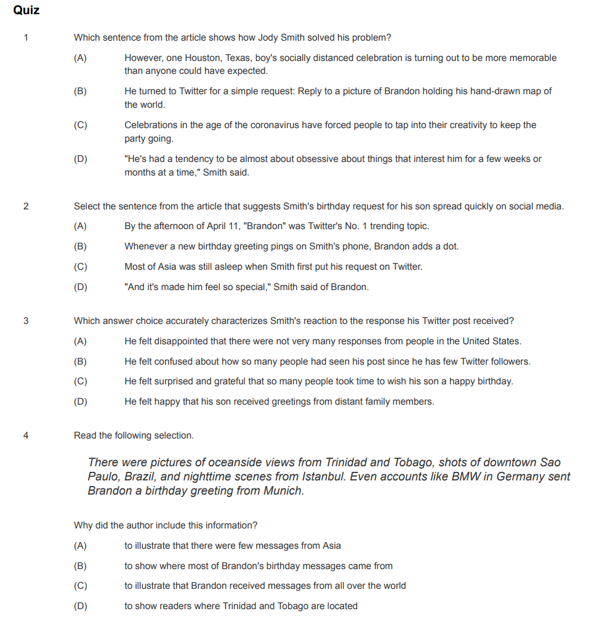

Week 2 (May 11-15): News Article- “America’s VetDogs”
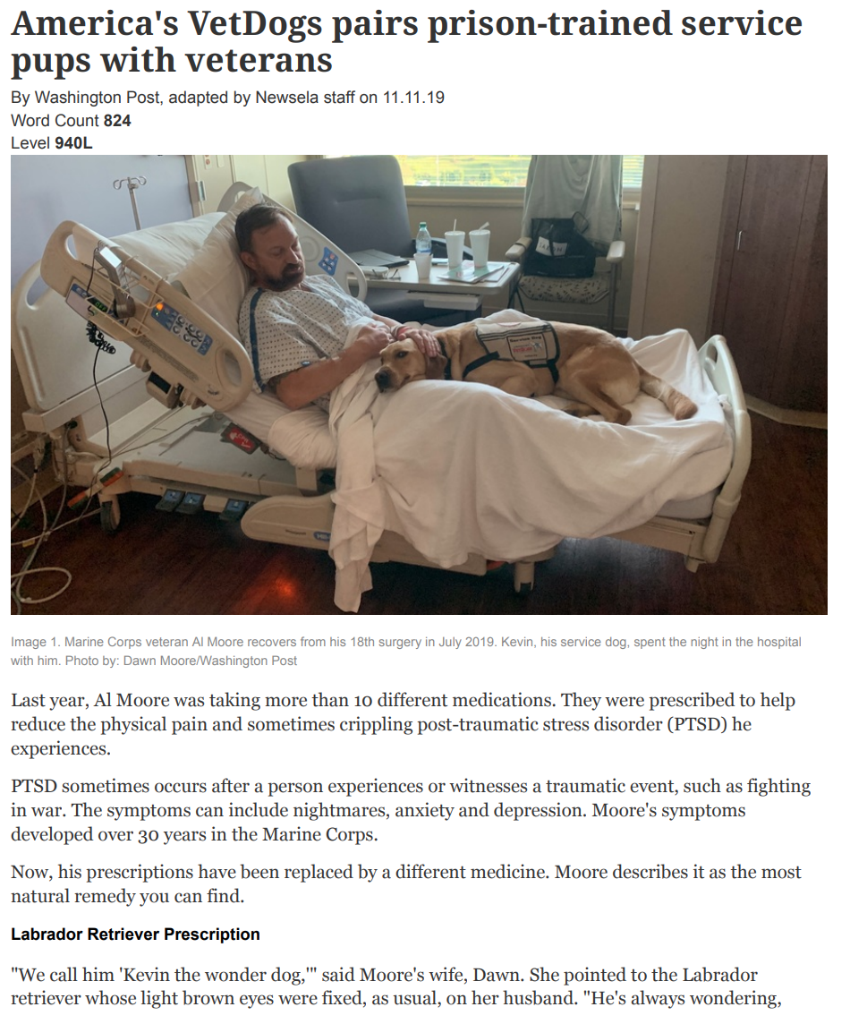
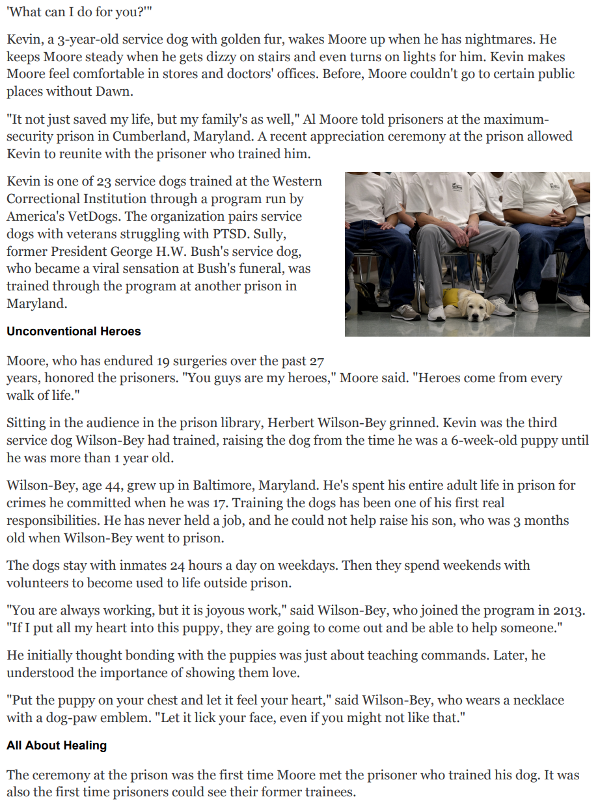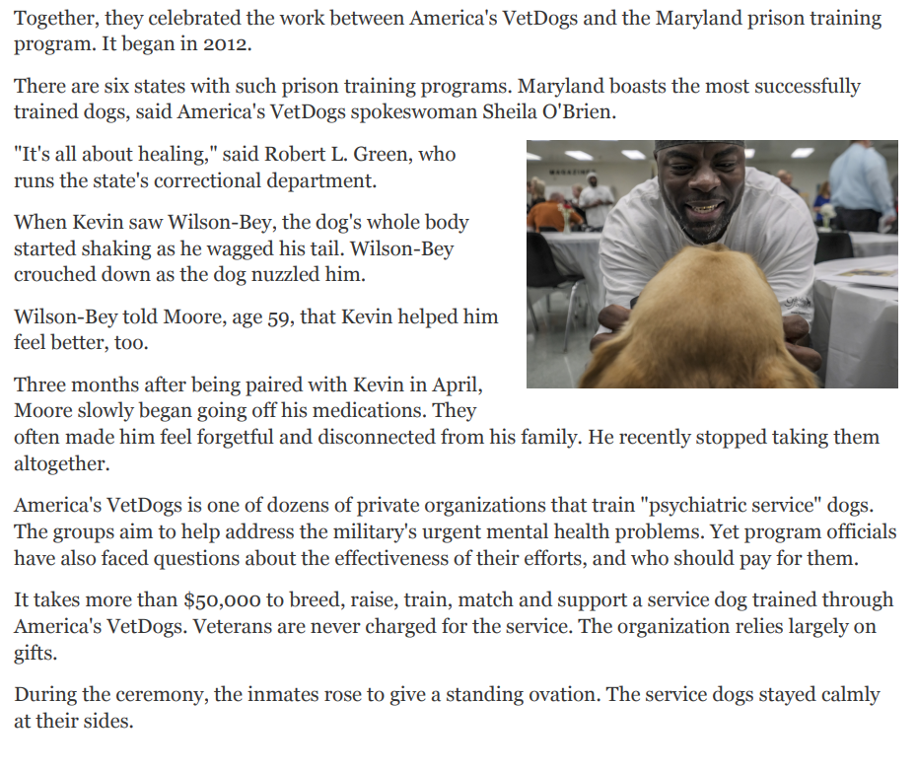

Monday: May 11th
Read
Read the article “America’s VetDogs”

- Read the headline title. What do you think this article is going to be about?

- Read the article through once. What is the gist of the article? What is it mostly about?

- What do you already know about the topic? How does this connect to what you already know?

- What is new learning for you?

- What is one piece of information that you found most interesting? Why?

- Read it again. Circle the words you don’t know.

- Choose 5 words you don’t know. Choose words you think will help you better understand what the text means.

Use one of the strategies on the anchor chart to find out what the words mean:

- Reread the sentence before and after to look for clues
- Affixes and roots: Look for prefixes, suffixes, or roots that you know
- Look for familiar words within the word
- Substitute a word you know and see if it makes sense
Last Resort: consult an outside source, a friend, a dictionary

Word and Pronunciation | Definition
Word | - Use one of the strategies on the anchor chart to tell what this word means in your own words.  - Use a dictionary (online or paper) to check your definition, add any necessary information to your definition.
 | Strategy Used (circle one): 1 2 3 4
 | Strategy Used (circle one): 1 2 3 4
 | Strategy Used (circle one): 1 2 3 4
 | Strategy Used (circle one): 1 2 3 4
 | Strategy Used (circle one): 1 2 3 4

Tuesday: May 12th
Read and Think
- Read the text again looking the way the text is organized. Look at the subheadings. What information is first? What next? Why?

- Read the text again. Think about the main idea(s) in the article. What are one or two things the author wants you to know?

- Which details in the text help you understand the main idea(s)?

- How does the way the text is organized help you understand the main idea(s)?

- Are there any pictures or images in the article? How do they help you understand the key points the author wants you to take away?

- What evidence has the author provided? How does this evidence support the main idea(s)?

- Does the evidence seem reliable? Do you trust the evidence the author has provide? Why or why not?

- Does the author have an opinion? How do you know?

Wednesday, May 13th
Think and Talk
Do the following with a family member/caregiver or you could even phone a friend:

- Summarize the article for them. Remember in a summary you retell the article in a few sentences, including the main ideas.

- Ask:

  - What do you already know about the topic?
  - What is new learning for you?

- Discuss and Write Answers:

  - What are you both thinking about now?

  - Do you agree with the author? Why or why not?

  - Do you think you can trust the information? Why or why not?

  - What questions do you both now have?

Thursday-15th

Write
Choose ONE of the following:

- Write a summary of the article. No more than four sentences and include the main idea.
- Choose one question to research further and write a new article to answer that question.
- Read other texts about the same topic and compare how the information in all of the texts is the same and different.
- Write a new article on a different topic following the same structure as this one.

Friday, May 15th
Write & Quiz
Choose ONE of the following:

- Write a summary of the article. No more than four sentences and include the main idea.
- Choose one question to research further and write a new article to answer that question.
- Read other texts about the same topic and compare how the information in all of the texts is the same and different.
- Write a new article on a different topic following the same structure as this one.

Quiz
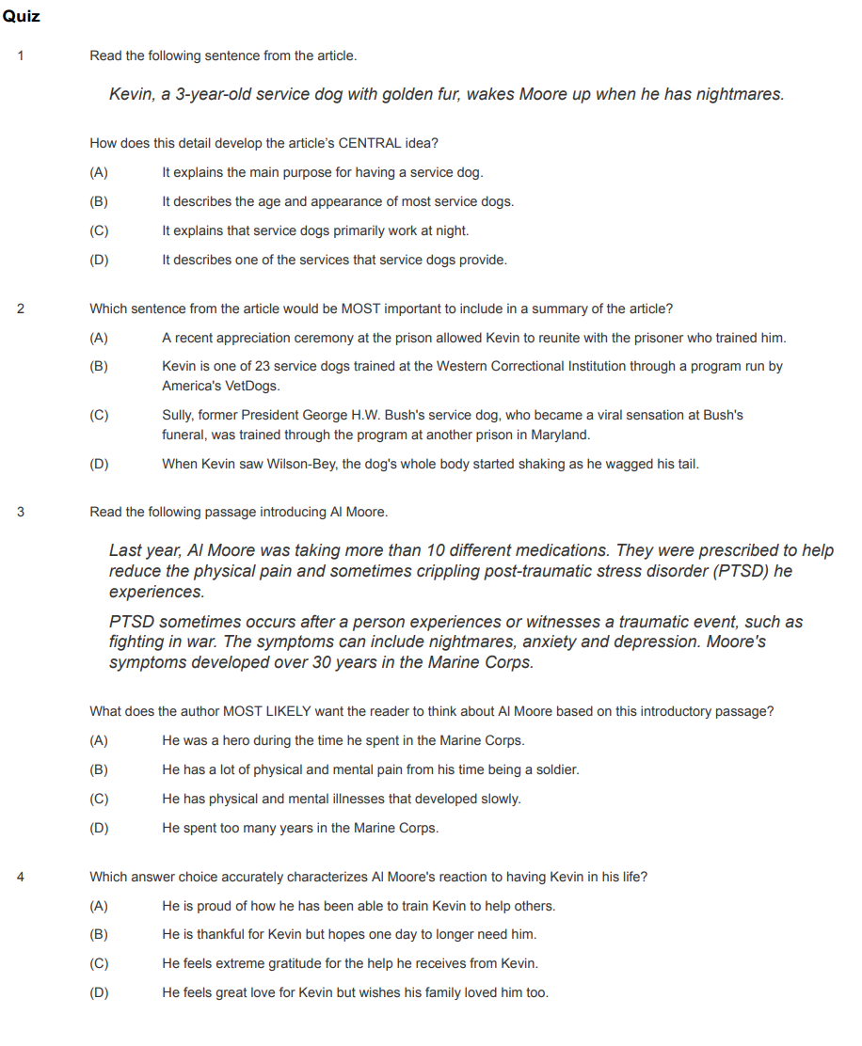

Week 3 (May 18-22): Article- “Tokyo Summer Olympics Postponed”

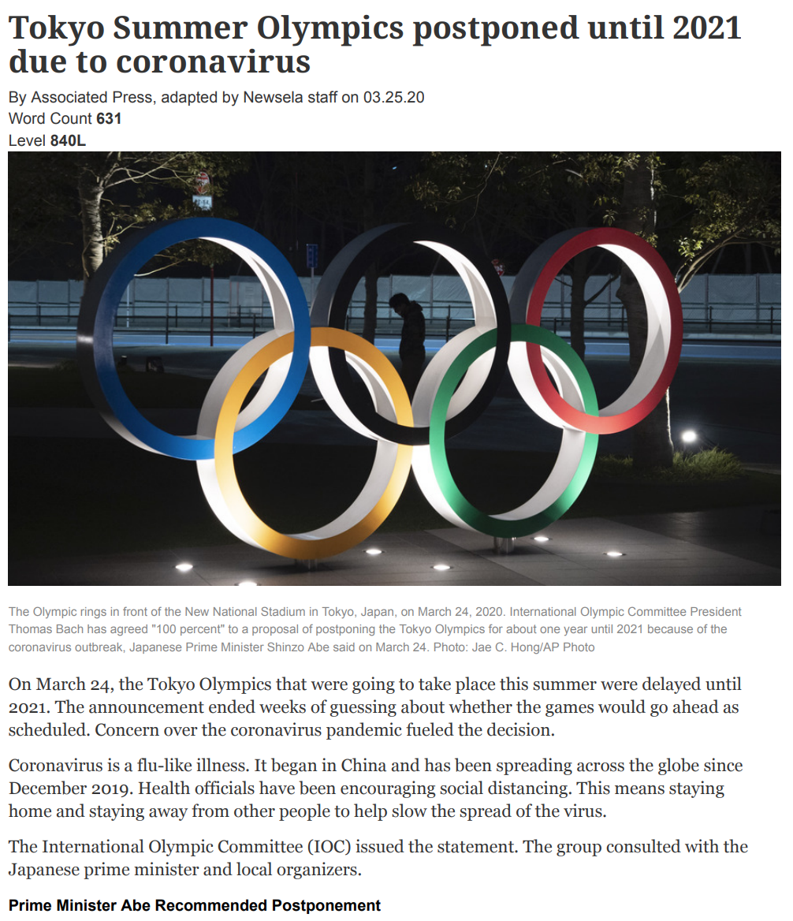
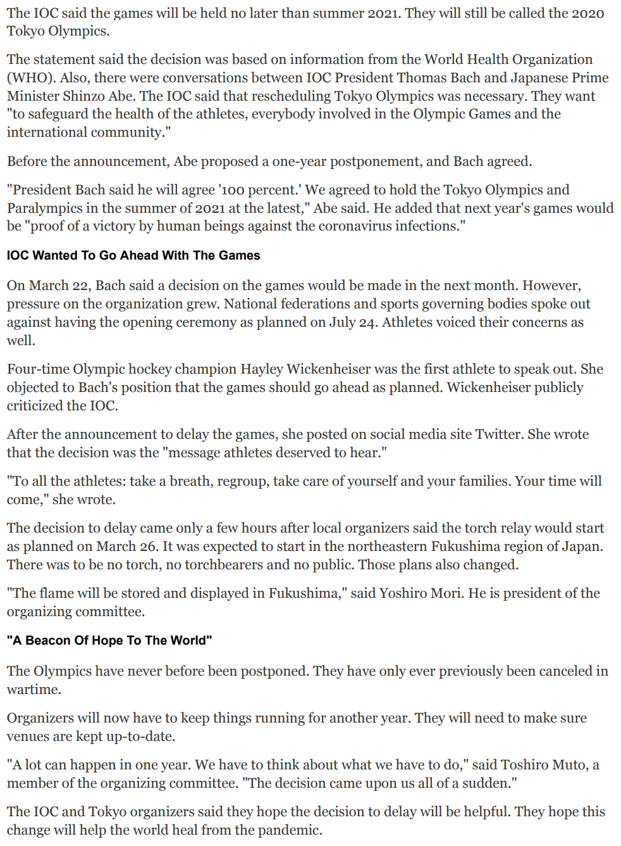
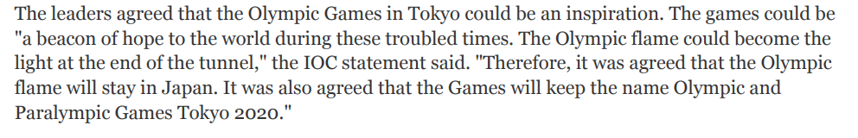

Monday: May 18th
Read
Read the article “Tokyo Summer Olympics Postponed”

- Read the headline title. What do you think this article is going to be about?

- Read the article through once. What is the gist of the article? What is it mostly about?

- What do you already know about the topic? How does this connect to what you already know?

- What is new learning for you?

- What is one piece of information that you found most interesting? Why?

- Read it again. Circle the words you don’t know.

- Choose 5 words you don’t know. Choose words you think will help you better understand what the text means.

Use one of the strategies on the anchor chart to find out what the words mean:

- Reread the sentence before and after to look for clues
- Affixes and roots: Look for prefixes, suffixes, or roots that you know
- Look for familiar words within the word
- Substitute a word you know and see if it makes sense
Last Resort: consult an outside source, a friend, a dictionary

Word and Pronunciation | Definition
Word | - Use one of the strategies on the anchor chart to tell what this word means in your own words.  - Use a dictionary (online or paper) to check your definition, add any necessary information to your definition.
 | Strategy Used (circle one): 1 2 3 4
 | Strategy Used (circle one): 1 2 3 4
 | Strategy Used (circle one): 1 2 3 4
 | Strategy Used (circle one): 1 2 3 4
 | Strategy Used (circle one): 1 2 3 4

Tuesday: May 19th
Read and Think
- Read the text again looking the way the text is organized. Look at the subheadings. What information is first? What next? Why?

- Read the text again. Think about the main idea(s) in the article. What are one or two things the author wants you to know?

- Which details in the text help you understand the main idea(s)?

- How does the way the text is organized help you understand the main idea(s)?

- Are there any pictures or images in the article? How do they help you understand the key points the author wants you to take away?

- What evidence has the author provided? How does this evidence support the main idea(s)?

- Does the evidence seem reliable? Do you trust the evidence the author has provide? Why or why not?

- Does the author have an opinion? How do you know?

Wednesday, May 20th
Think and Talk
Do the following with a family member/caregiver or you could even phone a friend:

- Summarize the article for them. Remember in a summary you retell the article in a few sentences, including the main ideas.

- Ask:

  - What do you already know about the topic?
  - What is new learning for you?

- Discuss and Write Answers:

  - What are you both thinking about now?

  - Do you agree with the author? Why or why not?

  - Do you think you can trust the information? Why or why not?

  - What questions do you both now have?

Thursday-Friday, May 21st-22nd

Write & Quiz
Choose ONE of the following:

- Write a summary of the article. No more than four sentences and include the main idea.
- Choose one question to research further and write a new article to answer that question.
- Read other texts about the same topic and compare how the information in all of the texts is the same and different.
- Write a new article on a different topic following the same structure as this one.

Quiz
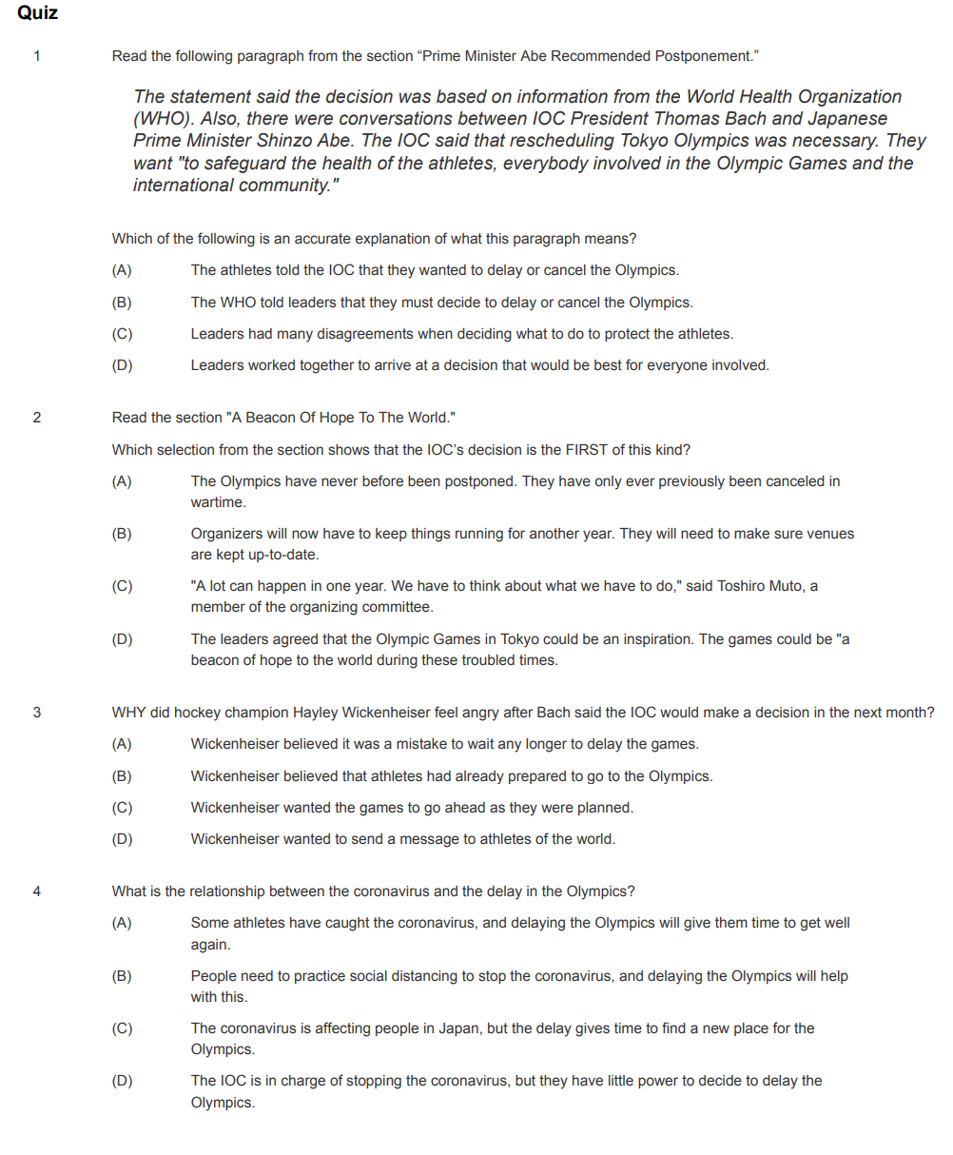

Week 4 (May 26-29): News Article- “They Lived in a Factory for 28 Days...”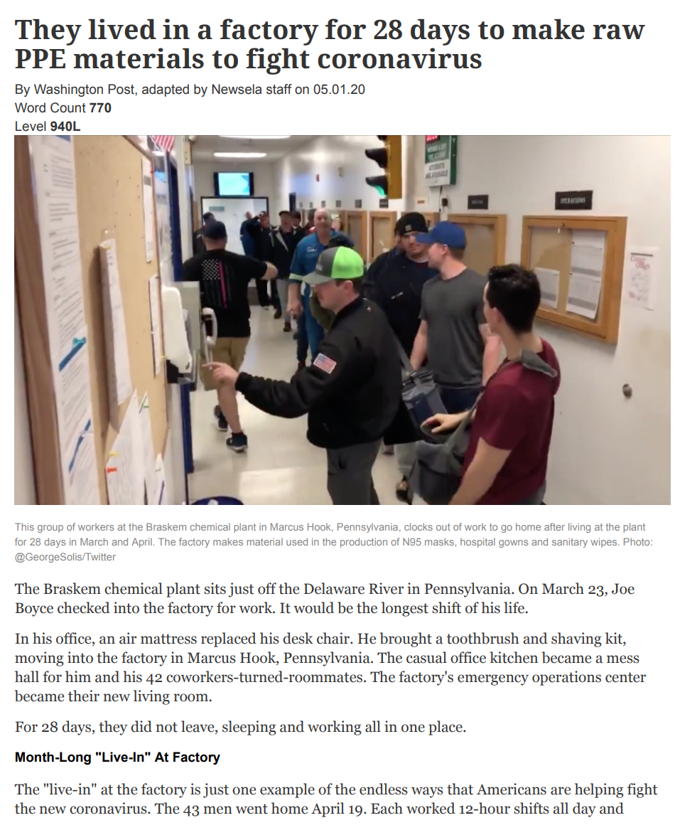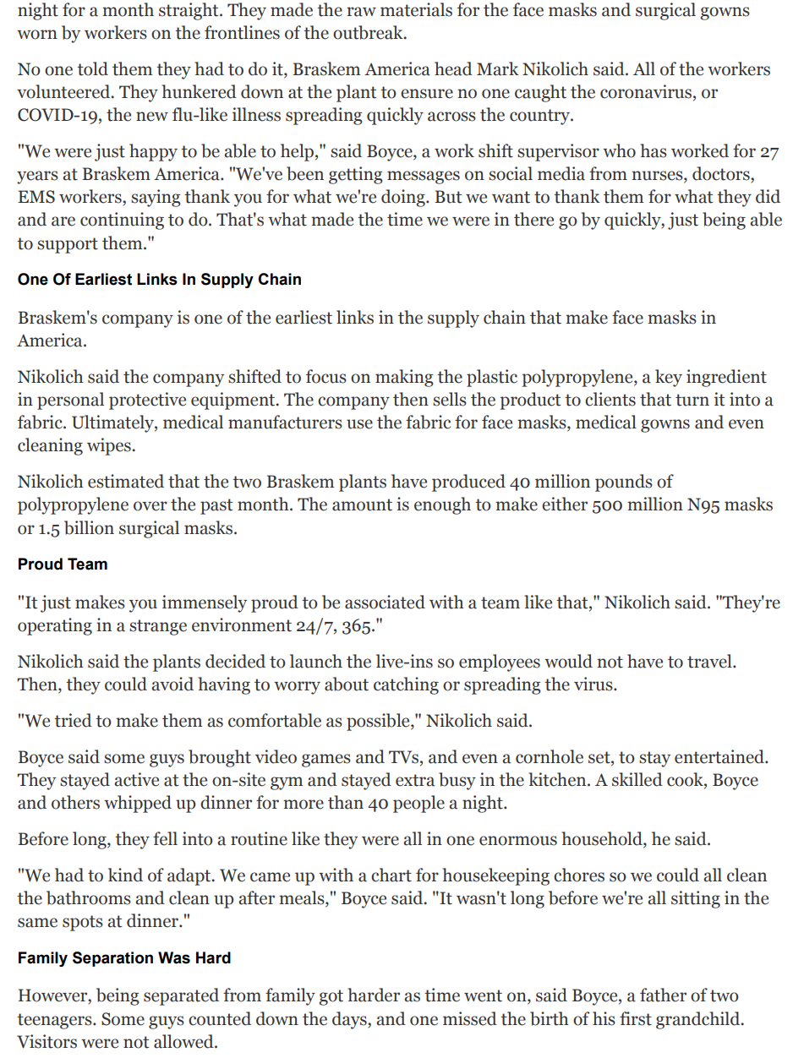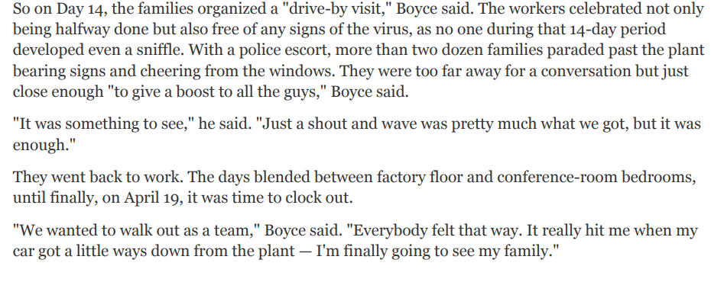

Tuesday, May 26th
Read
Read the article “They Lived in a Factory for 28 Days...”

- Read the headline title. What do you think this article is going to be about?

- Read the article through once. What is the gist of the article? What is it mostly about?

- What do you already know about the topic? How does this connect to what you already know?

- What is new learning for you?

- What is one piece of information that you found most interesting? Why?

- Read it again. Circle the words you don’t know.

- Choose 5 words you don’t know. Choose words you think will help you better understand what the text means.

Use one of these strategies to find out what the words mean:

  - Context: Read around the word
  - Affixes and roots: Look for prefixes, suffixes, or roots that you know
  - Dictionary: Use a dictionary
  - Ask: Ask someone if they know the meaning of the word

Word and Pronunciation | Definition
Word | - Use one of the strategies on the anchor chart to tell what this word means in your own words.  - Use a dictionary (online or paper) to check your definition, add any necessary information to your definition.
 | Strategy Used (circle one): 1 2 3 4
 | Strategy Used (circle one): 1 2 3 4
 | Strategy Used (circle one): 1 2 3 4
 | Strategy Used (circle one): 1 2 3 4
 | Strategy Used (circle one): 1 2 3 4

Wednesday, May 27th
Read and Think
- Read the text again looking the way the text is organized. Look at the subheadings. What information is first? What next? Why?

- Read the text again. Think about the main idea(s) in the article. What are one or two things the author wants you to know?

- Which details in the text help you understand the main idea(s)?

- How does the way the text is organized help you understand the main idea(s)?

- Are there any pictures or images in the article? How do they help you understand the key points the author wants you to take away?

- What evidence has the author provided? How does this evidence support the main idea(s)?

- Does the evidence seem reliable? Do you trust the evidence the author has provide? Why or why not?

- Does the author have an opinion? How do you know?

Thursday, May 28th
Think and Talk
Do the following with a family member/caregiver or you could even phone a friend:

- Summarize the article for them. Remember in a summary you retell the article in a few sentences, including the main ideas.

- Ask:

  - What do you already know about the topic?
  - What is new learning for you?

- Discuss and Write Answers:

  - What are you both thinking about now?

  - Do you agree with the author? Why or why not?

  - Do you think you can trust the information? Why or why not?

  - What questions do you both now have?

Friday, May 29th

Write & Quiz
Choose ONE of the following:

- Write a summary of the article. No more than four sentences and include the main idea.
- Choose one question to research further and write a new article to answer that question.
- Read other texts about the same topic and compare how the information in all of the texts is the same and different.
- Write a new article on a different topic following the same structure as this one.

Quiz
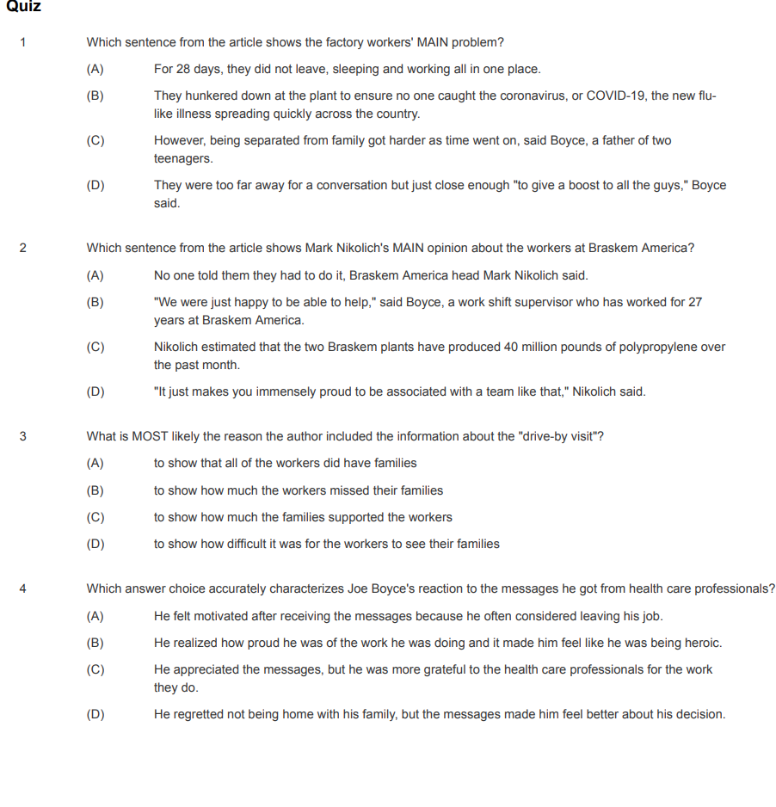

Monday-Wednesday, June 1st-3rd
