|  |  |
| --- | --- |
| Name: | Teacher: |

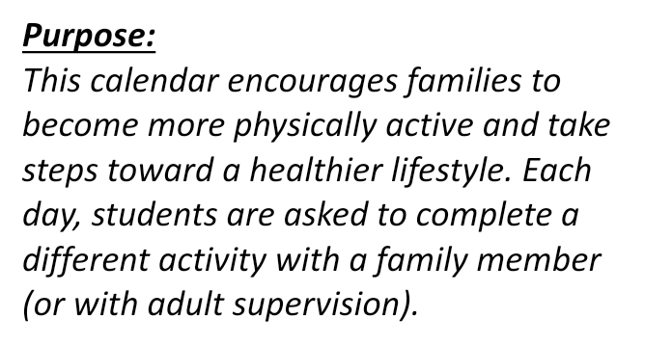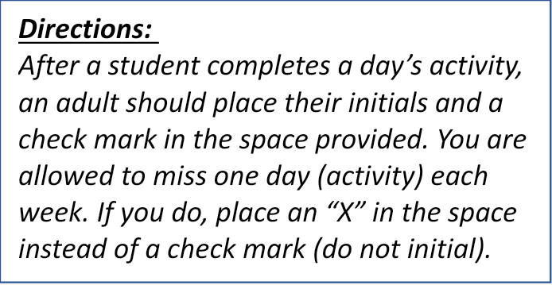

|  |  |  |
| --- | --- | --- |
| * Done | Day | DEAM Activity |
|  | 1 | Take a walk. |
|  | 2 | A kiwi has ~60mg of vitamin C. Do 60 air punches. |
|  | 3 | Pick 5 different muscles to stretch. Hold each stretch for 20 seconds. |
|  | 4 | Family Fun: Play your favorite physical education activity with your family. |
|  | 5 | Do as many trunk-lifts as you can. |
|  | 6 | Juggle a ball with your feet for 5 minutes. |
|  | 7 | Perform jumping jacks while naming words that start with “M.” |
|  | 8 | Take a walk. |
|  | 9 | 1 cup of broccoli has ~60mg of calcium. Do 60 air kicks. |
|  | 10 | Pick 5 different muscles to stretch. Hold each stretch for 20 seconds. |
|  | 11 | Family Fun: Go to the park together. |
|  | 12 | Do as many squats as you can. |
|  | 13 | Spend 5 minutes tossing and catching a ball. |
|  | 14 | Perform squats while someone calls out math problems for you to answer. |
|  | 15 | Take a walk. |
|  | 16 | Beans have ~500mg of potassium. Jog in place as you count to 500. |
|  | 17 | Pick 5 different muscles to stretch. Hold each stretch for 20 seconds. |
|  | 18 | Family Fun: Take turns selecting an exercise to do together. |
|  | 19 | Do as many push-ups as you can. |
|  | 20 | Spend 5 minutes volleying a balloon in the air. |
|  | 21 | Hold a plank while naming all the cities that you can think of. |
|  | 22 | Take a walk. |
|  | 23 | Half a cup of blueberries has ~40 IUs of Vitamin A. Do 40 plank-jacks. |
|  | 24 | Pick 5 different muscles to stretch. Hold each stretch for 20 seconds. |
|  | 25 | Family Fun: Build an obstacle course together. |
|  | 26 | Do any workout you want! |
|  | 27 | Pick any sports skill and practice it for (you guessed it) 5 minutes! |
|  | 28 | Name as many muscles in the body as you can while jumping in place. |
|  | 29 | Take a walk. |
|  | 30 | A serving of spinach has ~20mg of magnesium. Do 20 squat-thrusts. |
|  | 31 | Pick 5 different muscles to stretch. Hold each stretch for 20 seconds. |

