Math AMI Teacher (circle one): Burnett OR Englerth
Monday, May 4: Measuring Circles

By the time you complete this review, you should be able to:
1. Identify and measure parts of a circle.
2. Know and use the formulas for circumference and area of a circle.
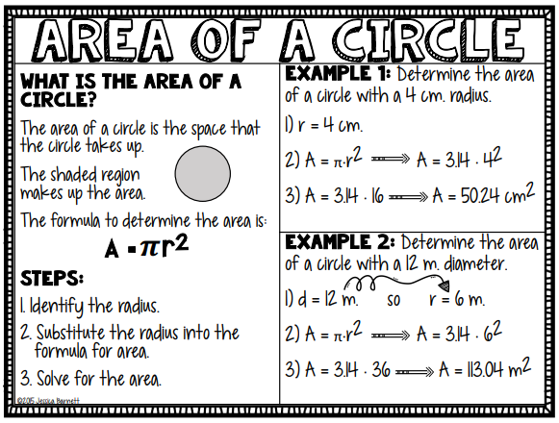

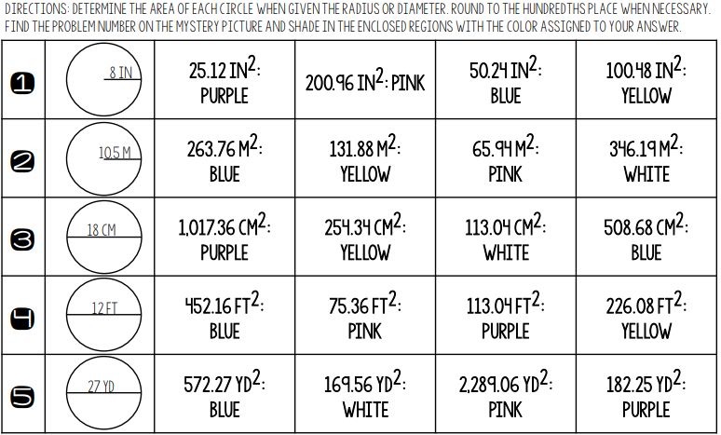
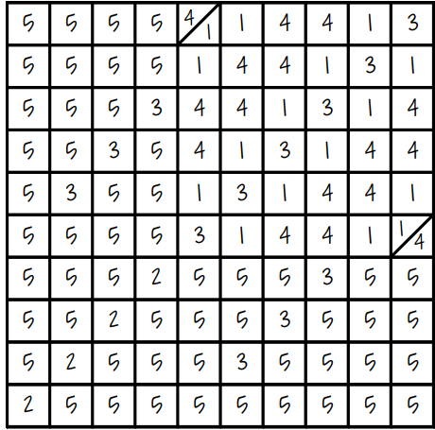
Tuesday, May 5th
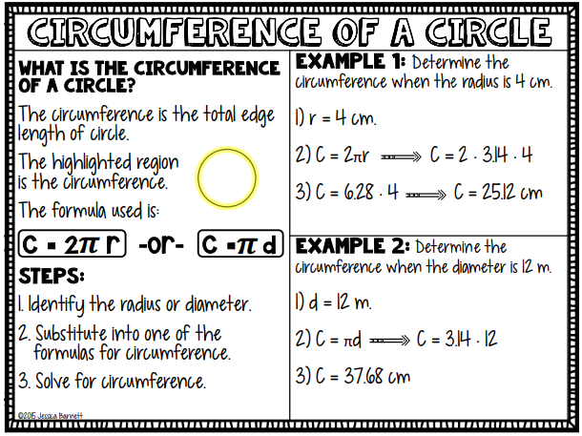

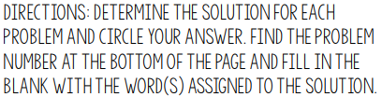
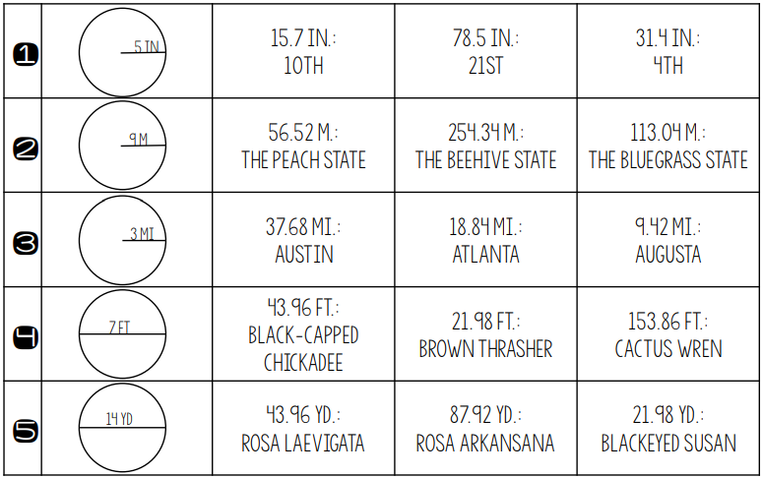

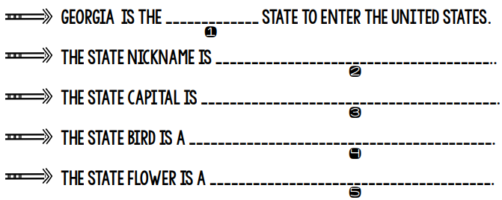

Wednesday, May 6th: More on Rational Number Arithmetic
By the time you complete this review, you should be able to:
1. Convert a rational number to a decimal.
2. Solve real-world and mathematical problems with rational numbers.

Fractions, Decimals, and Percents
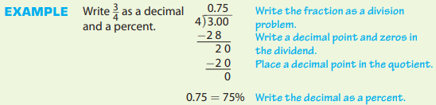
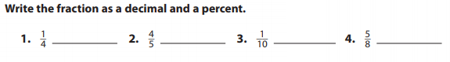
Decimal Operations
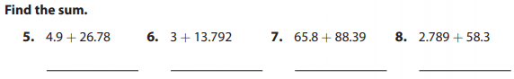

Find the Percent of a Number
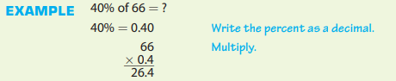
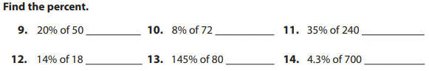
Thursday, May 7th: Probability and Sampling
By the time you complete this review, you should be able to:
1. Understand that the probability of a chance event is a number between 0 and 1 that expresses the likelihood of the event occurring

**If you have access, visit https://tinyurl.com/y6tsoynq and watch the YouTube video titled, “Math Antics - Basic Probability”.**

Probability is the chance or likelihood that an event will happen.
It is the ratio of the number of ways an event can occur to the number of possible outcomes. We'll use the following model to help calculate the probability of simple events.
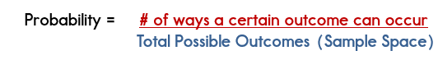
As you can see, with this formula, we will write the probability of an event as a fraction. The numerator is the number of chances and the denominator is the set of all possible outcomes. This is also known as the sample space. Probability can also be expressed as decimals or percentages.
Let's take a look at an example of probability using a standard die:
Given a standard die, determine the probability for the following events when rolling the die one time:
- P(5)
- P(even number)
- P(7)
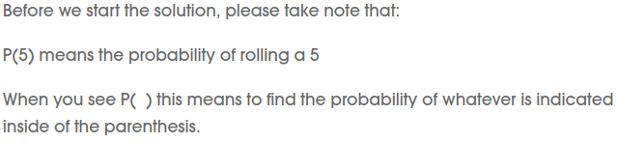
Solutions:
Let’s first identify the sample space. The sample space then becomes the denominator in our fraction when calculating probability.
Sample Space: 6 We are using a standard die. A standard die has 6 sides and contains the numbers 1-6.
Therefore, our sample space is 6 because there are 6 total outcomes that could occur when we roll the die. The 6 outcomes are: 1, 2, 3, 4, 5, 6
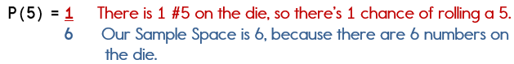
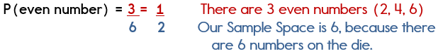
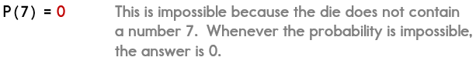
Because probability is the chance that something will happen. It can be shown on a line:
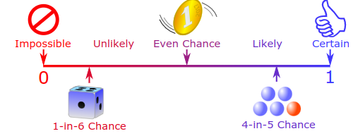
The probability of an event occurring is somewhere between impossible and certain. As well as words, we can use numbers to show the probability of something happening:
- Impossible is zero
- Certain is one
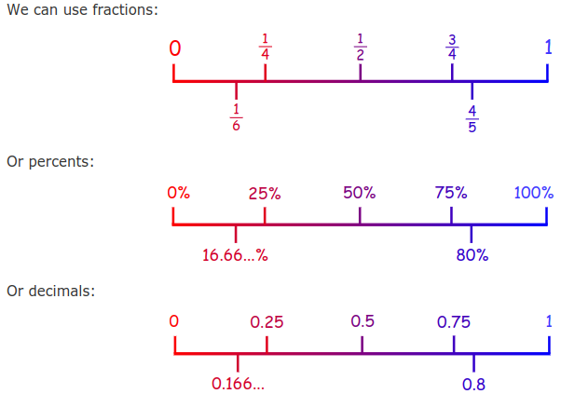
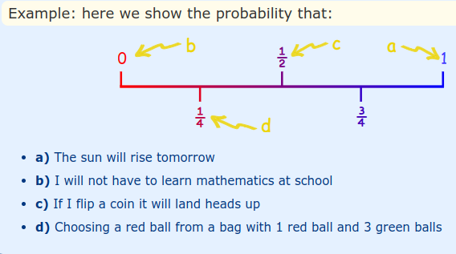
~~~~~~~~YOUR TURN~~~~~~~~
Carson has a bag of marbles. In the bag, there are 3 red, 2 blue, 6 black, and 5 green marbles. Use this information to answer the following questions.
(1) What is the probability of picking a green marble from the bag?

(2) What is the probability of picking a black marble from the bag?

(3) What is the probability of picking a color that isn’t black?

(4) Carson decides to add 4 red marbles to the bag. How much did he increase his chances of picking a red marble? Write your answer as a fraction, decimal, or percent.

Friday, May 8th:

Think about the following probability words:
-certain
-impossible
-likely
-unlikely

Create a beautifully colored picture showing an event that goes along with one of the words. Be sure to fill the space provided with your picture.

Science AMI Monday, May 4th McFarland

Tuesday, May 5th Properties of Matter

Wednesday, May 6th Properties of Matter

Thursday, May 7th Properties of Matter
Friday, May 8th Properties of Matter
Social Studies AMI
Read the short passage and answer the questions related to the Civil War
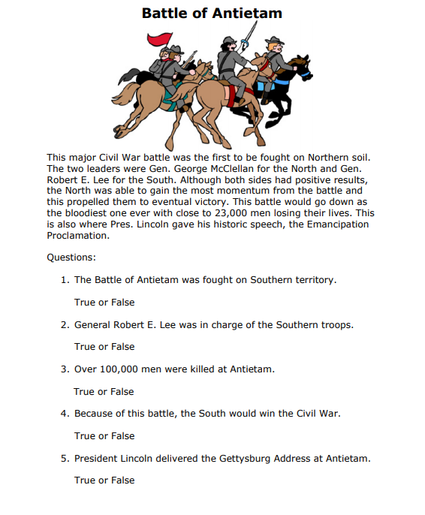
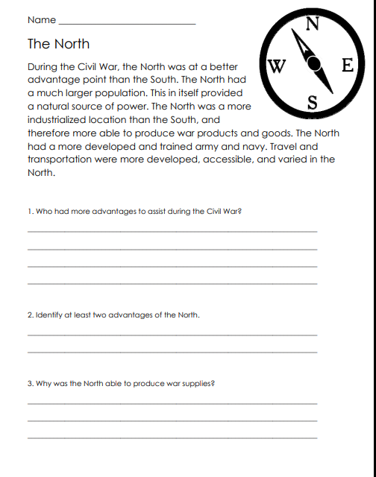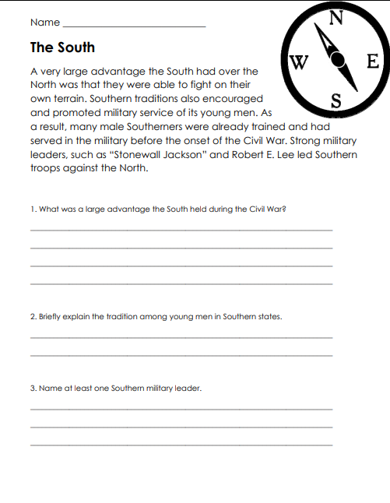

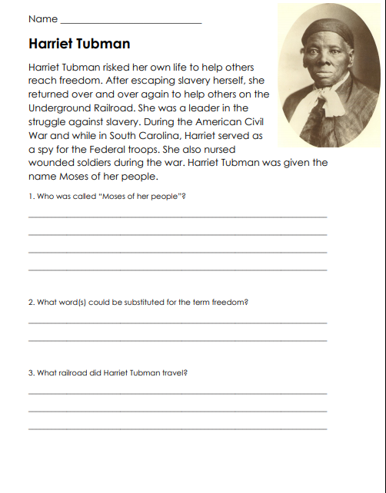
English AMI

Complete 5 assignments to get credit. Complete 5 assignments in a row to get WRITE-O (like BINGO) and extra credit! Length should be at least half a page (10 lines) unless otherwise stated. Make sure all writing is school appropriate. Turn all 5 assignments in with this AMI Packet.

W | R | I | T | E
Write a TV commercial for a product that you have invented. | Write a letter to Mrs. Parker. Tell her what you’d like to change about the school and why. | Write a how-to article explaining how to do or make something. | Have an adult write down three reasons why they are proud of you. | Make a list of things that make you happy.
Write a speech as if you were the President of the United States | Write a joke or riddle that you think will make Mrs. Hale laugh. | Write a song or rap. | Write an “I Dream of. . .” poem. It’s as simple as writing down 10 dreams or goals you have. | Write a made up interview between you and one of your favorite celebrities.
Write about the funniest thing that has ever happened to you. | Write about your favorite sport. | FREE | Write about your favorite children’s story. | Write about a mystery or horror movie you have watched or book you have read.
Write about something that is important to you. | Write about your favorite cartoon. | Write/draw a comic. | Write your own myth. | Convince Mrs. Hale to visit somewhere.
Write down how you are feeling and why. | Write down three reasons why you are proud of yourself. | Write a children’s story. | Write Mrs. Hale a letter. | Write a poem.

