Mason County Central Schools
Scottville Elementary Kindergarten Round-Up

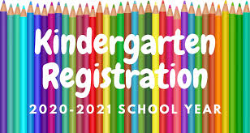
It’s that time of year already! We’re now enrolling children into Kindergarten for the 2020-2021 school year. We’ve uploaded fillable enrollment documents onto our MCC Website for those able to access them. Those needing enrollment papers mailed to them can email me at cetchison@mccschools.org. Please include your name, your child’s name, birthdate and physical address.

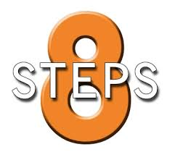

Here is what you need to do to access the online documents:
1. Visit our website at: www.mccschools.org
2. Click on the “schools” link at the top of the page.
3. Select “Scottville Elementary”, this will take you to our building page.
4. Next, click on “Menu” at the top of the page and a blue window will pop up on the side of your screen.
5. Click on “Student Enrollment”.
6. This will take you to a white screen with the instructions you will need to complete the necessary paperwork to get your child enrolled.
7. Once you finish, email the pdf document to Amanda Merkey at: amerkey@mccschools.org.
8. We will need additional documents from you in the near future and will email or call you once we’re at that point.
Please reach out to me via email if you have any questions or need assistance.
Thank you,
Chris Etchison
Scottville Elementary Principal

