Monday, April 13: Read the article, complete a summary sentence (7-14 words) for each paragraph. Do the 5 important words box and answer the questions.
Tuesday, April 14: Complete the Coach Book Lesson on Sound Waves.
Wednesday, April 15: Complete Illustrate It, Organize It, Write It and Access It
Thursday, April 16: Complete the Note Sheet using the PPT
Friday, April 17: Complete the quiz
Monday, April 20: Read the article, complete a summary sentence (7-14 words) for each paragraph. Do the 5 important words box.
Tuesday, April 21: Read the article, complete a summary sentence (7-14 words) for each section. Do the 5 important words box.
Wednesday, April 22: Complete Activity 1-4 of Wave Escape Room.
Thursday, April 23: Complete Activity 5-8 of Wave Escape Room.
Friday, April 24: Write an essay, using the two articles as sources, that compare mechanical and electromagnetic waves.
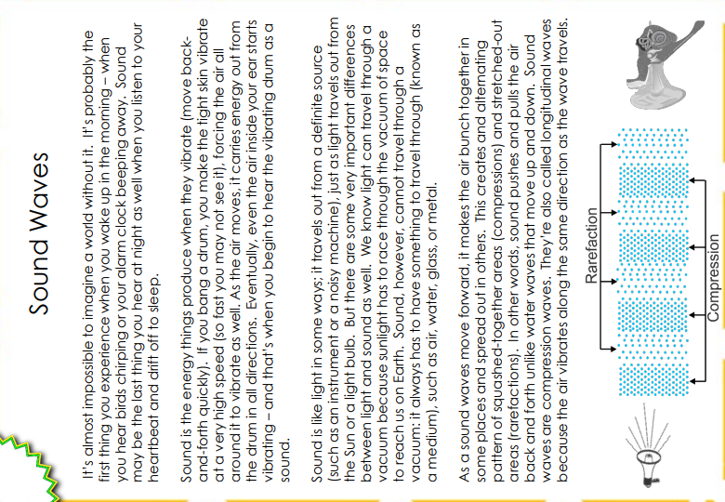
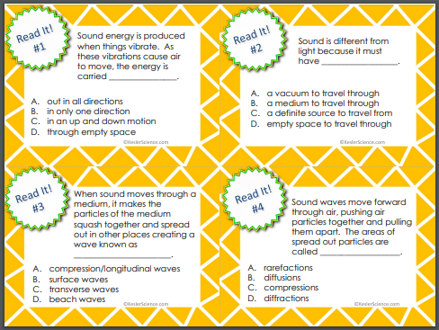
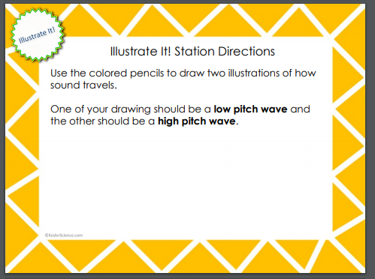

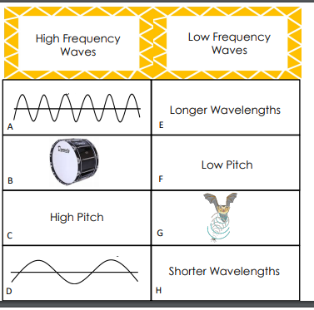
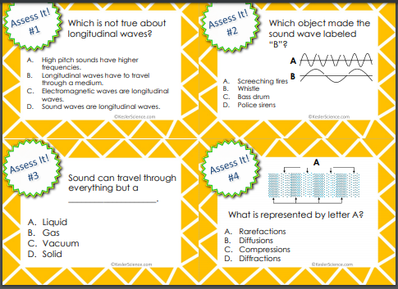

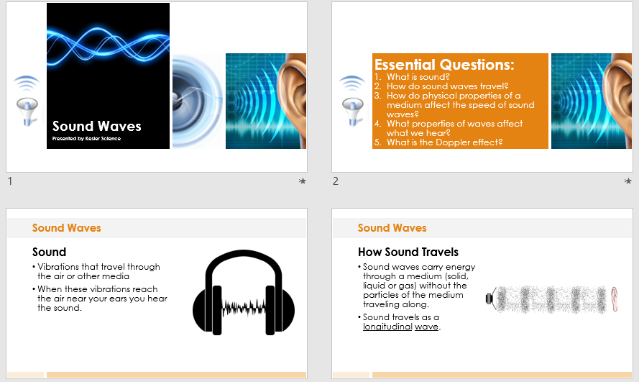

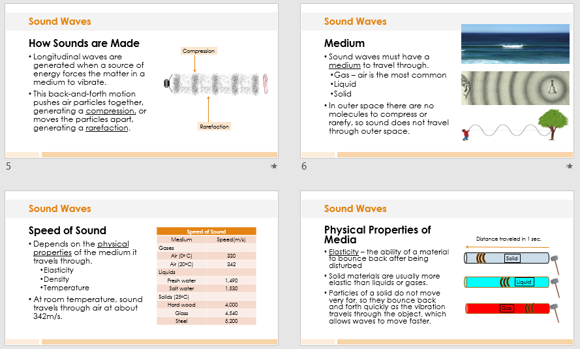

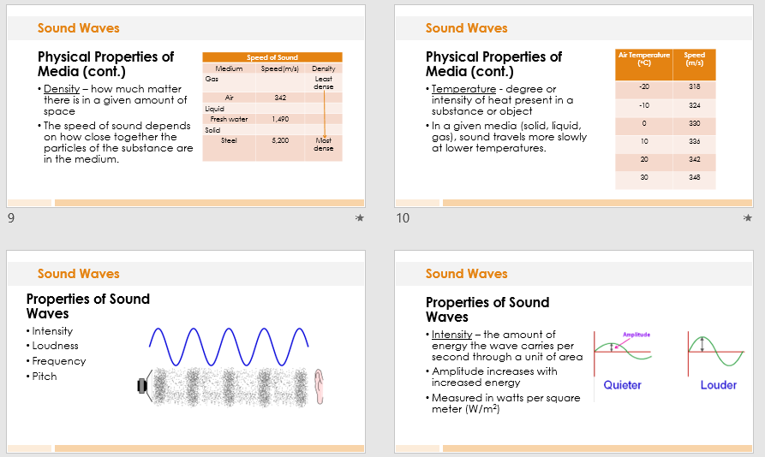

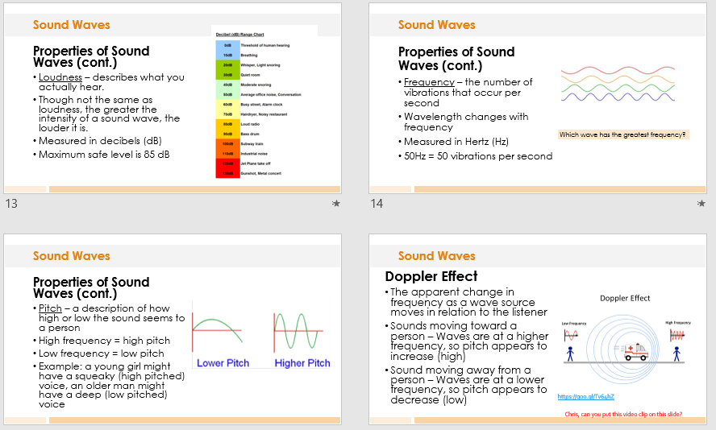

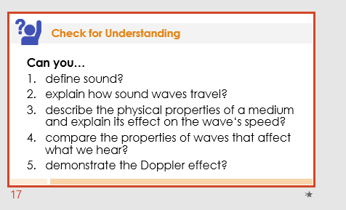

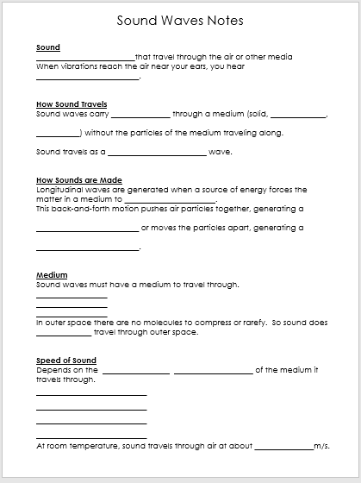

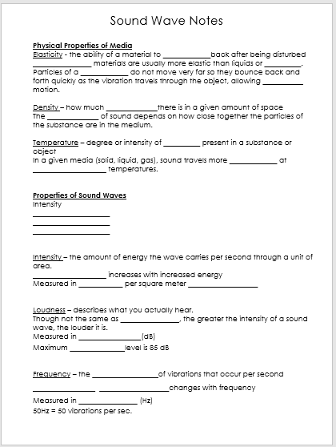

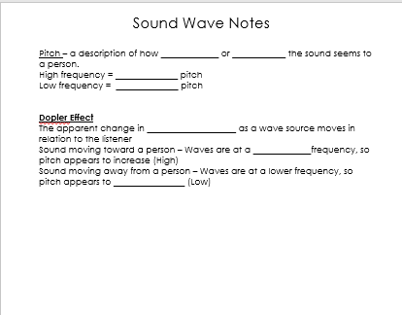

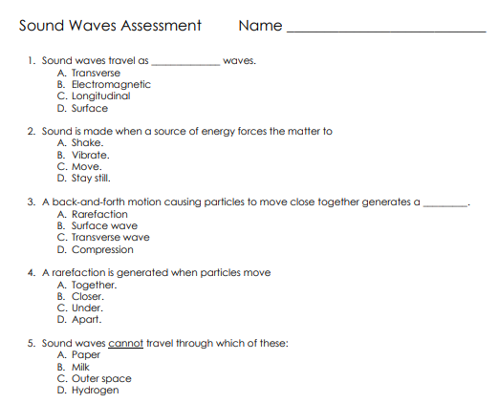
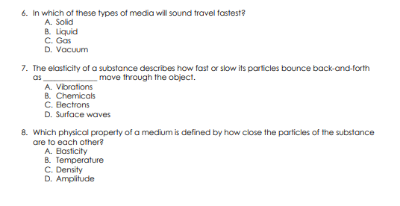
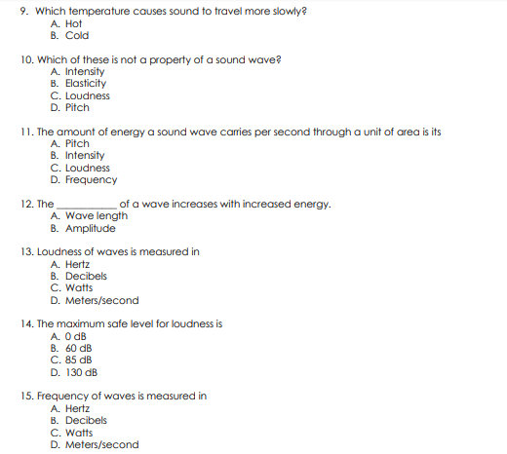

MONDAY, APRIL 20th

Difference Between Mechanical and Electromagnetic Waves
Mechanical vs Electromagnetic Waves
Waves can be divided using several methods. And one such method of differentiating it is by the means of the medium in which they travel. As per the medium, the waves can be differentiated as mechanical and electromagnetic waves. Electromagnetic waves are waves that have no medium to travel whereas mechanical waves need a medium for its transmission.
Electromagnetic waves travel in a vacuum whereas mechanical waves do not. The mechanical waves need a medium like water, air, or anything for it to travel. The ripples made in a pool of water after a stone is thrown in the middle are an example of mechanical waves. Examples of electromagnetic waves include light and radio signals. While an electromagnetic wave is called just a disturbance, a mechanical wave is considered a periodic disturbance.
Mechanical waves are also called elastic waves as their propagation depends on the elastic properties of the medium through which the waves pass. Electromagnetic waves are caused because of the varying magnetic and electric fields. While mechanical waves are caused by wave amplitude and not by frequency, electromagnetic waves are produced by the vibration of the charged particles. When comparing the speed of mechanical and electromagnetic waves, the former travels at low speed.
Mechanical waves are divided into three categories: Transverse waves, longitudinal waves, and surface waves. In transverse waves, the medium moves perpendicular to the wave direction, and in longitudinal waves, the medium moves parallel to the wave direction. In surface waves, both transverse and longitudinal waves mix in a single medium. In very simple words, an electronic wave is that which travels in a vacuum, and a mechanical wave is that which needs some medium for traveling.
Summary:
1. Electromagnetic waves travel in a vacuum whereas mechanical waves do not.
2. The ripples made in a pool of water after a stone is thrown in the middle are an example of mechanical wave. Examples of electromagnetic waves include light and radio signals.
3. Mechanical waves are caused by wave amplitude and not by frequency. Electromagnetic Waves are produced by vibration of the charged particles.
4. While an electromagnetic wave is called just a disturbance, a mechanical wave is considered a periodic disturbance.
TUESDAY, APRIL 21
Mechanical Waves Versus Electromagnetic Waves
Posted by Thomas DeMichele
The Different Types of Waves
There are two types of waves: mechanical waves like sound that must travel through a medium like air, and electromagnetic waves like light that don’t. Both types of waves transfer energy in a wave-like manner, as that is what a wave is, a physical effect of energy being transferred over space and time.
Mechanical and Electromagnetic Waves. Sound is a mechanical wave; that means it must travel through a medium. Light is electromagnetic radiation propagating in a wave-like manner; it can travel through empty space or a medium.
Summary of the Difference Between Mechanical Waves and Electromagnetic Waves
In general:
- Mechanical waves like sound are pressure traveling from a source, through a solid, liquid, gas, or plasma, medium, distorting that medium’s molecules. Mechanical waves aren’t made out of anything and can’t travel through “empty space.”
- Electromagnetic waves describe the wave-like manner in which photons (and other quanta) travel. Electromagnetic waves can travel through a medium like air, passing through it or reflecting off it’s molecules, but they don’t have to. Electromagnetic waves are made out of energy and can travel unimpeded through empty space.
Waves can also be divided into three categories based on the direction of their movement:
- Transverse waves travel perpendicular to wave motion.
- Longitudinal waves travel parallel to wave motion.
- Surface waves travel in a circular motion on the surface of a medium.
FACT: In almost all instances light travels faster than sound, but not always.
What are Mechanical Waves?
Mechanical waves like sound are pressure traveling from a source, through a solid, liquid, gas, or plasma, medium, distorting that medium’s molecules.
For example, a sound wave traveling through the air displaces air molecules, causing them to vibrate and collide with other air molecules at a given frequency as the wave travels through the medium. The molecules bounce back in place; for every force there is an equal and opposite force. The result is molecules vibrating back and forth parallel to the source. This is true for gasses and liquids, but not for a denser matter.
A water molecule doesn’t travel from one place to another with the wave, the wave travels through the water while the molecules bounce back into place. The wave of pressure created from the source of the sound travels through the medium until it reaches our ears, we hear the vibrating of molecules at certain frequencies as sound via our sense of hearing.
What are Electromagnetic Waves?
Electromagnetic waves describe the wave-like manner in which photons (and other quanta) travel. Electromagnetic waves can travel through a medium like air, but they don’t have to. When they do, they travel between air molecules and have their travel slowed accordingly. Even though photons can bounce off some mediums or be slowed down, it doesn’t affect the medium directly like the concussive nature of sound.
Electromagnetic waves travel through the vacuum of empty space and are massless. Thus, they don’t directly affect objects with mass. “The speed of light” is a term that describes electromagnetic energy traveling at it’s constant and only speed in a true vacuum although it can slow down in a non-vacuum when it does interact with the medium.
FACT: This means that in space no one can hear you scream, but they can see you shine a flashlight.
The Major Differences Between Mechanical Waves and Electromagnetic Waves
Given the above, the differences between mechanical waves like sound and electromagnetic waves like light are:
- Mechanical waves have to travel through something, electromagnetic and waves don’t.
- Mechanical waves aren’t made out of anything. They are the disruption of a medium. Just like a wave in water, the wave is pressure displacing water; it isn’t itself a thing. There is no widget, just an effect. Electromagnetic waves, on the other hand, are made out of something, electromagnetic energy. There are only four forces in the universe. The most important by many measures is electromagnetic energy.
Longitudinal Waves, Transverse Waves, and Surface Waves
Mechanical waves can propagate as longitudinal waves, transverse waves, or surface waves, but electromagnetic waves can only propagate as transverse waves. Understanding the ways in which a wave can travel is important for understanding the difference between sound and light.
Most mechanical waves, including sound, are “longitudinal waves” or a wave in which the particles of the medium move in a direction parallel to the direction that the wave moves. When sound displaces molecules in the air, they push forward in the direction of the wave, bump into the next molecule, and then bounce back into place in the opposite direction because the medium is elastic enough and for every force, there is a equal and opposite force. The result is particles moving back and forth parallel to the direction of the wave.
Light waves are always “transverse waves” or a wave in which particles of the medium move in a direction perpendicular to the direction that the wave moves.
Meanwhile, the waves that appear on the surface of a medium are surface waves, they are sometimes called circular waves because in surface waves only the particles at the surface of the medium undergo circular motion that is a combination of transverse and longitudinal motion. Water has surface waves on its surface, and longitudinal waves in its currents. There is no rigid surface in water, so there are no longitudinal waves. There are also elliptical surface waves called Raleigh surface waves.^{[3]}
Some mechanical waves can act as more than one wave type. Earthquakes are capable of producing both transverse waves that travel through the less dense parts of the Earth, like water and the molten core, and longitudinal waves that travel through the denser parts of the Earth, like rock. Transverse waves require a relatively rigid medium to transmit their energy while longitudinal waves require a more elastic medium.
The Difference Between Sound Waves and Light Waves
Other important differences between sound waves and light waves include:
- With sound waves, frequency tells you about the pitch, and amplitude gives you information about the volume. With light, amplitude gives you information about intensity, and frequency tells you about wave type or color.
- Sound travels faster in most solids than it does in air, light typically slows down or reflects off solids.
The Similarities Between Mechanical Waves and Electromagnetic Waves
Some similarities between mechanical waves like sound and electromagnetic waves like light are:
- Both wave types are defined by their frequency. The higher the frequency, the less distance between successive crests of a wave (aka wavelength). We can only hear and see waves in a specific frequency; we can only hear and see specific wavelengths.
- Both types of waves can reflect and amplify under the right conditions.

WEDNESDAY, APRIL 22
Waves Escape Room:
Activity 1:

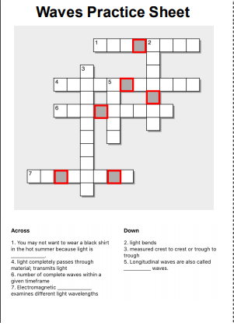

Activity 2

Activity 3

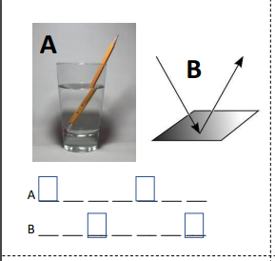

Activity 4

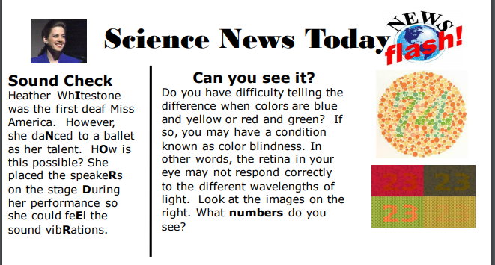

THURSDAY, APRIL 23
Activity 5
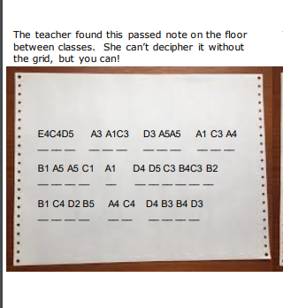

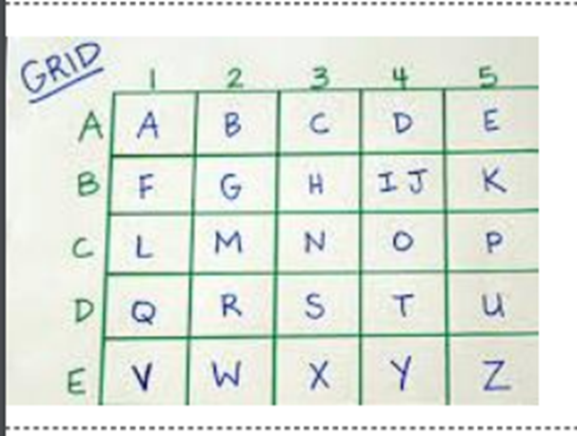
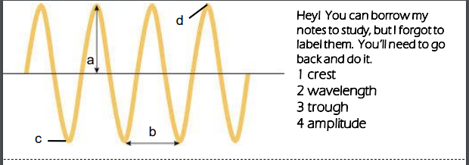
Activity 6

Activity 7

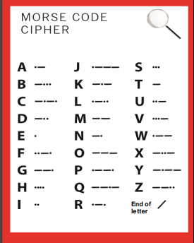

Activity 8
Scrambled Joke:

Light traVels fasTer than souNd, that’S why moSt pEople sEem bRight until you heaR them speAk.

