Wilson Library Video Lessons
5th Grade: First Chapters for 5th Grade
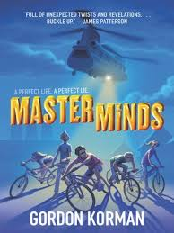
https://www.youtube.com/watch?v=7dUZi-0DWRQ&t=34s Masterminds Part 1
https://www.youtube.com/watch?v=dIQFtX7o5jk&t=25s Masterminds Part 2
https://www.youtube.com/watch?v=tio9a4qXd8g&t=43s Ungifted 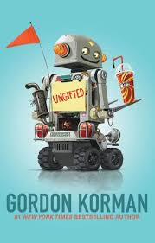
https://www.youtube.com/watch?v=8pBkt2-Nhzk New Kid 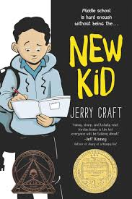

3rd and 4th Grade: Night of the Twisters
Chapter 8 Part 1 https://www.youtube.com/watch?v=-DizZnseZFg&t=3s
Chapter 8 Part 2 https://www.youtube.com/watch?v=tGRwtxBqpPo&t=49s
Chapter 9 https://www.youtube.com/watch?v=mBDRSg9KBHg&t=50s
Chapter 10 Part 1 https://www.youtube.com/watch?v=22S-P6u2Sn4
Chapter 10 Part 2 https://www.youtube.com/watch?v=471hmMi2Wic
Chapter 11 https://www.youtube.com/watch?v=EvLc3XYksFs
Chapter 12 https://www.youtube.com/watch?v=YiSl5XCfdTg

2nd Grade : Secret of the Silver Key 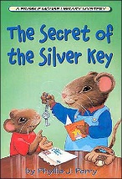
Chapter 8 https://www.youtube.com/watch?v=nFixVGnvFlA&t=26s
Chapter 9 https://www.youtube.com/watch?v=gTVVLeK-O9I
Chapter 10 https://www.youtube.com/watch?v=5LLSYqFRs8E

1st Grade : Stuart’s Cape 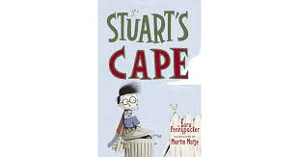
Chapter 3 https://www.youtube.com/watch?v=3gCwYyvt-EM
Chapter 4 https://www.youtube.com/watch?v=wxt7sEClln8
Chapter 5 https://www.youtube.com/watch?v=rjVDUY1l5OY
Chapter 6 https://www.youtube.com/watch?v=kMOk90Jf4l8

Kindergarten : Caldecott Award Winning Books
A Sick Day For Amos McGee https://www.youtube.com/watch?v=7lmsWPtBgmc&t=23s 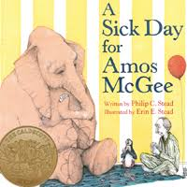
My Friend Rabbit
https://www.youtube.com/watch?v=lkRVPJSYx5U&t=2s 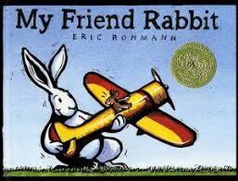
The Three Pigs
https://www.youtube.com/watch?v=1ualKvmGfs8

