Area: Social Development
Goal: is to teach the students the true meaning of wisdom and how to use it to shape their lives positively.
Standard: Students will understand self and respect others
Objective/Competency: Students should be able to:
- Identify the meaning of wisdom
- How to apply the word wisdom in their daily activities

Strategy: Through Virtual Classroom Guidance Lesson
Key Material and Resources:
- Youtube Video “Wise Old Owl”
- Wise Old Owl Coloring Sheet
- Wise Old Owl Template
Evaluation Method:
- Complete Wise Old Owl Template
- Parents are to ask the student or students questions about the youtube video

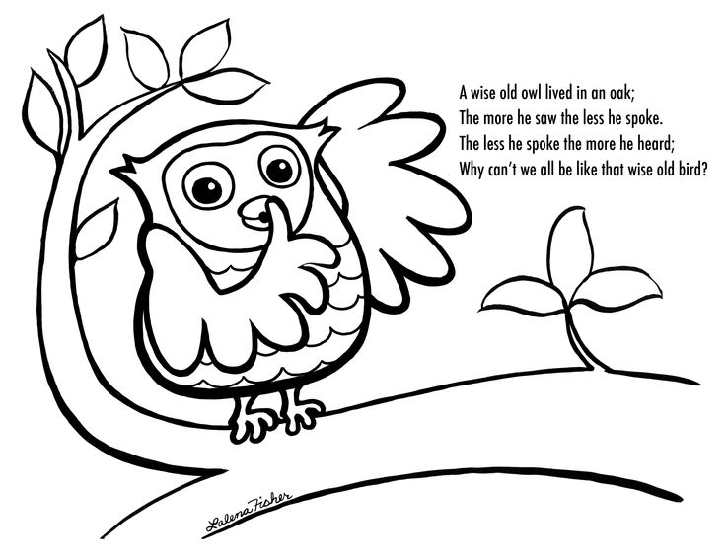
Name:_______________________________________ Date:______________________
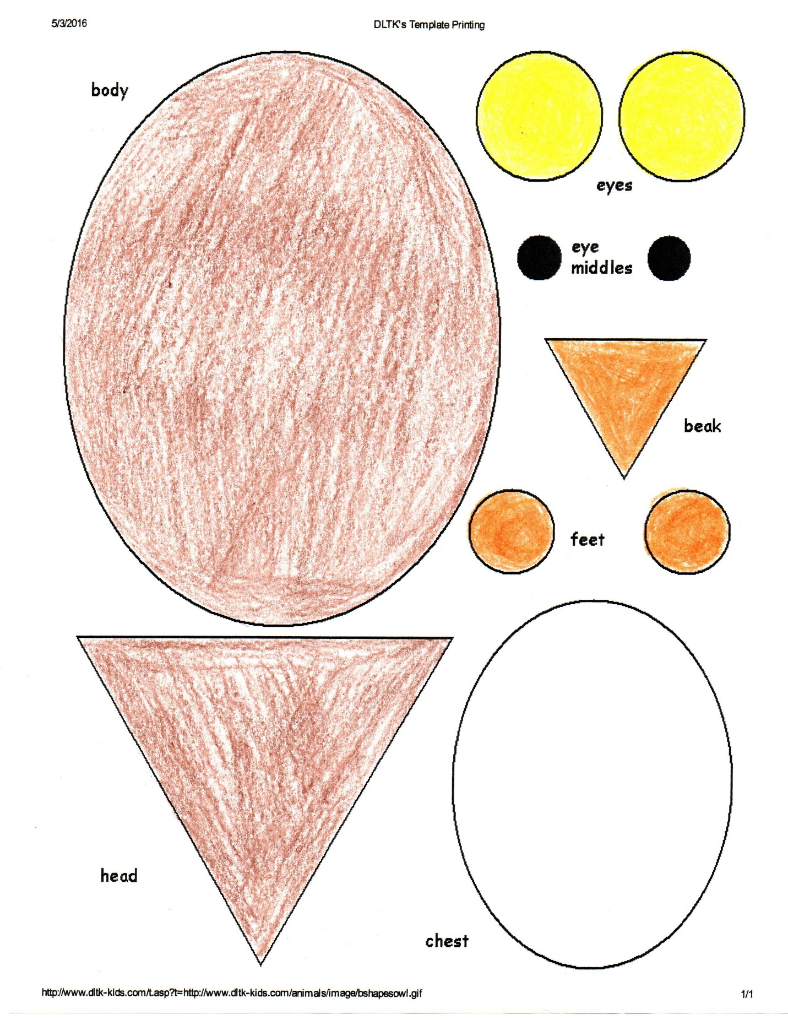
Wise Old Owl template- students are to cut out each piece of the owl and paste together…..see next page for finish view of the Wise old Owl…….
