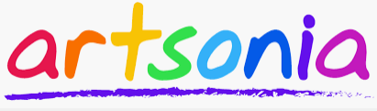
Hiawatha Middle School Class Portal

PARENTS – Our school is offering a way for students to submit their artwork to their Artsonia portfolio from home.
Your child can use iPads or similar devices (or even a browser) to photograph their own artwork, make edits and enter artist statements - all on their own! The artwork will be reviewed by the art teacher prior to being published.
Access Code:
Download the Artsonia 6.0 app in the Apple or Android app store, select the "Students" option, then scan the Access Code on the right (or manually type in the code). You can also go to www.artsonia.com/class on a browser if you don't have a compatible device.
MWYH-FYDZ
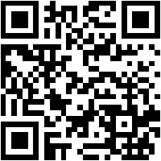

You can view a short tutorial video by going to: www.artsonia.com/videos/student-app
If you have any questions, please contact:
Mrs. Covert: call the school or e-mail at kcovert@usd415.org
Or Artsonia at 800-869-9974 or info@artsonia.com

