SMARTs Parent Resources
Take a look below at some resources for parents to help their students plan and prioritize their work. Adapted from the SMARTS Executive Function curriculum, these activities are perfect for helping students develop strategic approaches to planning their day.

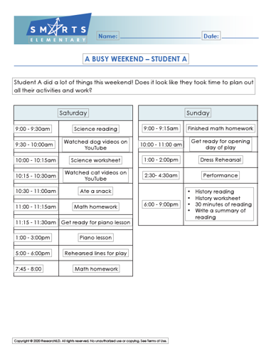 | 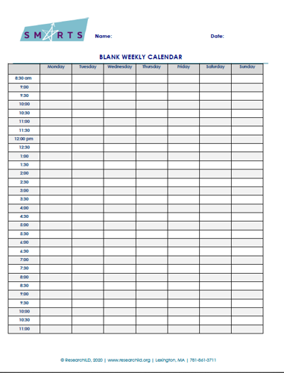 | 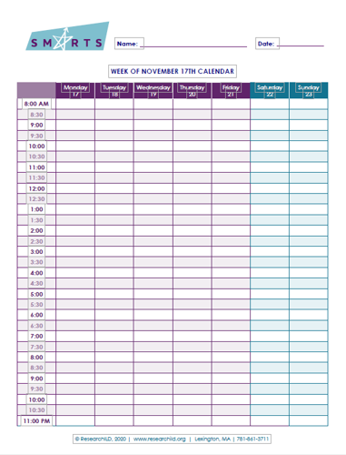
Elementary Version | Middle School Version | High School Version
Want the full lesson plan? Download the elementary lesson plan or the secondary school lesson plan now!

