Supporting Your Mental Well-being

Tips to Reduce Anxiety

Focus on what you can control – including thoughts and behaviors

Remember that you are resilient, and so is humankind. We will get through this.

Do what you can to reduce your risk; take comfort that you are caring for yourself and others.

Use technology to connect with others frequently.

Look for the good stuff: the helpers, time with family, and opportunities to pull together. Write down three things you are grateful for each day.

Limit exposure to news or social media updates.

Be gentle with yourself and others.

Maintain or create a routine.

Maintain a healthy diet and exercise routines to help your immune system and mental health.

Spend time in nature.

Reflect on your reactions. Many who have experienced trauma may be triggered by feelings of powerlessness. Understanding what you are feeling can help you consider how you want to respond to the triggers.

Practice meditation, yoga, or other mind-body techniques.

Reach out if you need to talk. There are local and national hotlines.

[](https://www.google.com/url?sa=i&url=https%3A%2F%2Fwww.pinclipart.com%2Fmaxpin%2FiRboJhw%2F&psig=AOvVaw2X3tZ2HMOdKIq44gQwLtYx&ust=1586374193923000&source=images&cd=vfe&ved=0CAIQjRxqFwoTCMDH18qG1-gCFQAAAAAdAAAAABAc)

[Equipping Students With Resilience To Withstand Any - Strength ...](https://www.google.com/url?sa=i&url=https%3A%2F%2Fwww.pinclipart.com%2Fmaxpin%2FxJbbmR%2F&psig=AOvVaw136eba6ZlUq5c1md3JQ3_R&ust=1586374321064000&source=images&cd=vfe&ved=0CAIQjRxqFwoTCKjl8oSH1-gCFQAAAAAdAAAAABAN)

[](https://www.google.com/url?sa=i&url=http%3A%2F%2Fclipart-library.com%2Fgreenhouse-cliparts.html&psig=AOvVaw3ZDBqtbJzHm-tNqFSZ-K7Z&ust=1586374489324000&source=images&cd=vfe&ved=0CAIQjRxqFwoTCKDi8NSH1-gCFQAAAAAdAAAAABAD)

[](https://www.google.com/url?sa=i&url=https%3A%2F%2Fwebstockreview.net%2Fexplore%2Flaptop-clipart-computer-symbol%2F&psig=AOvVaw1S1AET0WsZ48PIw8wcmZJM&ust=1586374587584000&source=images&cd=vfe&ved=0CAIQjRxqFwoTCLih84OI1-gCFQAAAAAdAAAAABAD)

[](https://www.google.com/url?sa=i&url=https%3A%2F%2Fwww.iconsdb.com%2Fguacamole-green-icons%2Fpencil-icon.html&psig=AOvVaw1G43zfbIKdiXS688QGUJoA&ust=1586374663181000&source=images&cd=vfe&ved=0CAIQjRxqFwoTCKCnrIqJ1-gCFQAAAAAdAAAAABAJ)

[](https://www.google.com/url?sa=i&url=https%3A%2F%2Fwww.vectorstock.com%2Froyalty-free-vector%2Fmodern-phone-icon-image-vector-12781328&psig=AOvVaw2il72OqKRKCJiuetMiPg4E&ust=1586375012107000&source=images&cd=vfe&ved=0CAIQjRxqFwoTCLDrjc2J1-gCFQAAAAAdAAAAABAJ)

[](https://www.google.com/url?sa=i&url=http%3A%2F%2Fwww.clker.com%2Fclipart-awesome-clock-green.html&psig=AOvVaw12t--f62DCl_OtqTJa8E_f&ust=1586375381042000&source=images&cd=vfe&ved=0CAIQjRxqFwoTCKjT7_uK1-gCFQAAAAAdAAAAABAI)

[](https://www.google.com/url?sa=i&url=https%3A%2F%2Fwww.shutterstock.com%2Fsearch%2Fapple%2Boutline&psig=AOvVaw3kP6wUlNuqvuVFFS4KYZeX&ust=1586375441314000&source=images&cd=vfe&ved=0CAIQjRxqFwoTCLi556WL1-gCFQAAAAAdAAAAABAD)

[](https://www.google.com/url?sa=i&url=https%3A%2F%2Fwww.pngkit.com%2Fbigpic%2Fu2w7e6e6o0o0u2y3%2F&psig=AOvVaw1f_Jq5SsZwcbqZkTUGHLpb&ust=1586375532112000&source=images&cd=vfe&ved=0CAIQjRxqFwoTCMj6nc2L1-gCFQAAAAAdAAAAABAD)

[](https://www.google.com/url?sa=i&url=https%3A%2F%2Fwww.pinterest.com%2Fpin%2F552253973038541512%2F&psig=AOvVaw2jKUu163THbIPgoDLI9Rwx&ust=1586375616039000&source=images&cd=vfe&ved=0CAIQjRxqFwoTCNj2-e-L1-gCFQAAAAAdAAAAABAP)

[](https://www.google.com/url?sa=i&url=https%3A%2F%2Fwebstockreview.net%2Fexplore%2Fmeditation-clipart-senior-yoga%2F&psig=AOvVaw2l7_ISgSFoWnSuqDVm0pJj&ust=1586375793766000&source=images&cd=vfe&ved=0CAIQjRxqFwoTCNjo0sOM1-gCFQAAAAAdAAAAABAD)

[](https://www.google.com/url?sa=i&url=https%3A%2F%2Fya-webdesign.com%2Fimage%2Ftelephone-transparent-green%2F1495197.html&psig=AOvVaw2vax7xYxB-DLi-yhiWMZQt&ust=1586375871177000&source=images&cd=vfe&ved=0CAIQjRxqFwoTCLjrseaM1-gCFQAAAAAdAAAAABAD)

Source: www.health.state.mn.us

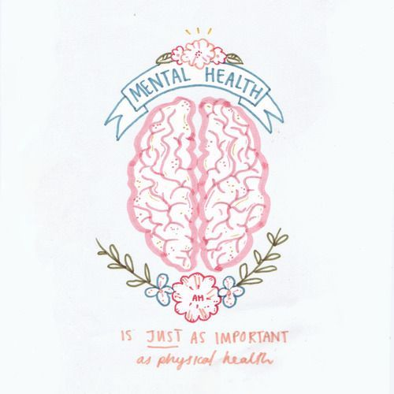

Helpful Resources

**Your School Counselor**

* David.schill@k12.nd.us
* Taylor.hintgen@hillsborok12.com

**Help Lines**

National Suicide Prevention Lifeline: 1.800.273.8255

24/7 support. Chat online https://suicidepreventionlifeline.org

FirstLink: 211 or text your zipcode to “txt-211” (898-211)

24/7 support.

ADAMHS: 216.623.6888 or text “FLS” to 741741

24/7 support. Chat online www.adamhscc.org

National Alliance on Mental Illness (NAMI): 800.950.NAMI or text “NAMI” to 741741

M-F 10am – 6pm est.

Crisis Text Line: text CONNECT to 741741

24/7 support.

SAMHSA’s Disaster Distress Helpline: 1.800.985.5990 or text TalkWithUs to 66746 (espanol: “Hablanos” al 66746)

**Websites**

https://afsp.org/campagins/covid-19/