German Choice Board
Please choose 2 of the following activities to practice your German. To prove you did them send me a screenshot or photo to my email. If you have any questions or need any help, my office hours are 12-1 and you can reach me by phone, text, or email!
Activity # 1  Learn one of the following songs! Either send me a screen shot of your progress or send me a clip of you singing the chorus!  'Bye Bye' Cro  https://lyricstraining.com/de/play/cro/bye-bye-unplugged/HI4VxsixKI#b7c  194 Länder' Mark Forster  https://lyricstraining.com/de/play/mark-forster/194-lander/H5ofqYNcd5#b7c  Namika ‘Alles was zählt’  https://lyricstraining.com/de/play/namika/alles-was-zahlt/HjK5ofqDyj | Activity # 2  Spend 30 minutes on Duolingo! But instead of doing traditional lessons either go to stories or podcasts! (You won’t need to send me anything for this one. Just login using your school account!)
Activity # 3  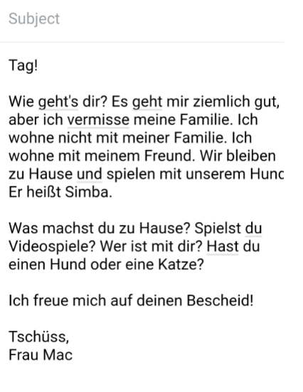  Answer my email auf Deutsch! | Activity #4  Watch this video and answer the questions below. You can send me your answers via a short video or email me!  Easy German- Coronavirus in Deutschland  https://www.youtube.com/watch?v=PS5dJR66swA  - This video was made two weeks ago, do you think anything has changed? If so, how and what?  - How is Janusz spending his time and how does he feel?  - What are some things that are different in Germany than the US?  - RESEARCH TIME! Look up the statistics in the US versus Germany. Which country has been more affected? Why do you think?

