1. You can make up a dance to your favorite song. If you have a way to video and email it to me, I would love to see it. If not, you parent/guardian/family member an sign off for you that you completed it.
2. You can create a dance class for your friends/family members. Start with a warm-up of some sort. You can use the stretches that I have taught you in class. Then teach your class and 8 count of one of the styles that I taught you in class. After you are done with the choreography then do a cool down and stretch. This can just be lying down and slowly stretching all of your limbs and breathing.
3. Take the time to interview someone or several people in your house about dance. Ask them if they like to dance? Why or why not? Ask them what types of dancing was popular when they were younger? You can ask them what types of dances are their favorite? Also if they could learn any style of dance which one would they choose and why?
4. You can pick a song that you like and then draw a costume for that song. Then explain in a short paragraph why the costume looks that way. If you cannot draw then you can cut out pictures from magazines to make a costume. You can always do more than one if you would like.
5. Come up with five professions other than professional dancers that would use the skills of dancing. How can the skills help this profession and why?
6. Using these stretches below, you can stretch every day for 10-15 minutes. This is a good way to continue to work on your flexibility.
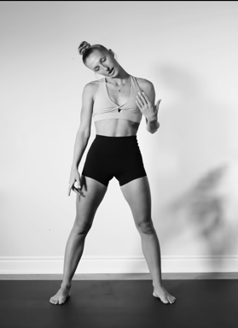
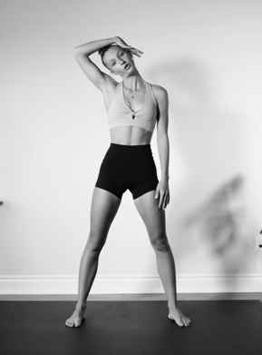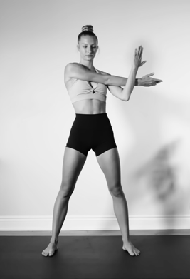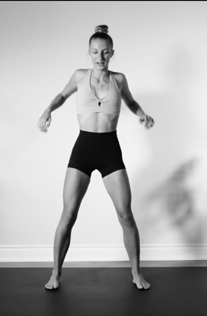
Roll your shoulders front and back for two 8 counts each.
Put your arm behind your back and stretch for two 8 counts. Repeat on other side.
Pull your arm in front of you and stretch for two eight counts. Repeat on other side.
Turn your neck to the right grab and stretch for two eight counts. Repeat on the left.
Roll your neck to the right four times and then to the left four times.

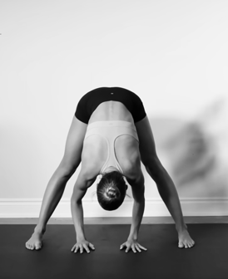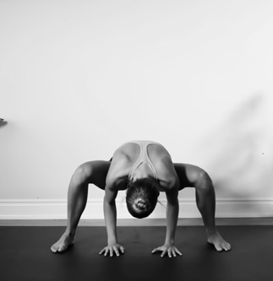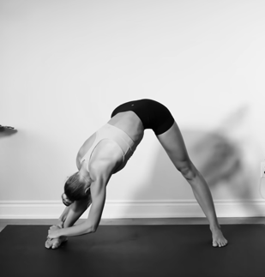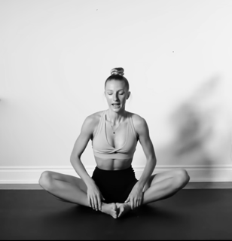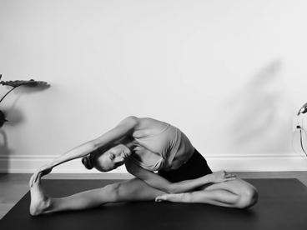
Bend one leg in and stretch one out. Lean over for two 8 counts and repeat. Lean to the right for two 8 counts then repeat on the left.
Sit in butterfly. Lean over for two 8 counts and repeat. Lean to the right for two 8 counts then repeat on the left.
Lean to the right for three 8 counts. Then repeat on the left.
Plie and straighten at least 5 times.
Lean over and stretch your back for three 8 counts.

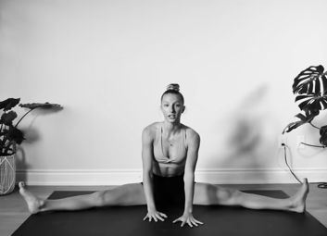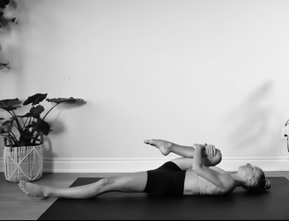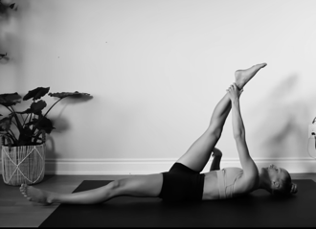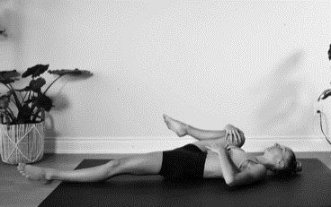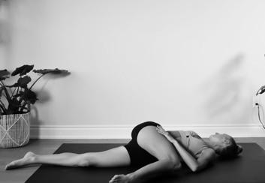
Pull your leg over your body and stretch for three 8 counts. Make sure you are balanced. Repeat on the left.
Pull your leg close to you and stretch to the right for three 8 counts. Repeat on the left.
Stretch leg out and hold for three 8 counts. Pull it as close to you then slowly pull your leg down.
Lay on your back. Pull right knee to your chest and stretch for three 8 counts. Repeat on the left.
Lean over for two 8 counts and repeat. Lean to the right for two 8 counts then repeat on the left.

