Nyssa School District SSA/SIA Application

Applicant
School District or Eligible Charter School Name: NYSSA SCHOOL DISTRICT
Institution ID: 2110
Webpage (where SIA Plan will be posted): www.nyssa.k12.or.us

Contact Person
First Name: Darren
Last Name: Johnson
Email: djohnson@nyssasd.org
Phone Number: (541) 372-2275

Plan Summary

Nyssa School District includes the small, rural town of Nyssa in eastern Oregon as well as the surrounding community. Nyssa lies adjacent to the Snake River which, at the eastern city limits, forms the boundary between Oregon and Idaho. The town of Nyssa is situated approximately eleven miles south of Interstate 84 and the city of Ontario.
Nyssa schools serve an agricultural community. Located at the western end of the Treasure Valley, Nyssa exists because of the huge irrigation projects constructed during the Depression. Reservoirs built in the surrounding mountains and hills send water through a massive canal system to the valley, supplying area farms with surface irrigation. Major Nyssa area crops are sugar beets, potatoes, corn, and onions. Until recently, Amalgamated Sugar operated a large sugar beet processing factory located in the town of Nyssa, which has been an economic challenge for our schools and community. Extensive onion and potato storage and sorting sheds are some of the largest employers in the community.
The Nyssa School District serves 1,185 students in grades K-12, with one K-5 elementary school (enrollment 563); one 6-8 Middle School (enrollment 282); and one 9-12 High School (enrollment 340). Demographic characteristics of our students:
Student Demographics:
Hispanic/Latino 66%
White: 32%
Mutliracial 2%
English Language Learners: 46%
Students with disabilities: 16%
Free/Reduced Lunch: 100%
Strengths and Challenges:
The Nyssa School District has a strong and caring staff of certified, classified, and confidential personnel who are all very dedicated to the success of students of our district. The Nyssa School District's vision is: "All students are thriving citizens realizing their potential." To realize this vision, we empower our school community through the belief that all students can achieve at high levels given the necessary supports, rigorous curriculum, strong educator collaboration, positive culture and climate, and individualized pathways to success. We have created many pathways to success for our students, namely: Career/Technical Education (CTE) offerings such as computer networking, welding certifications, Nursing, Business education, Construction trades, Agricultural Education, Culinary Arts, and we are recently began an e-sports league to include students who feel a strong identification and purpose in that field. Students also have the option to earn an Associate’s degree by enrolling in dual credit course through the local Treasure Valley Community College. Additionally, our incoming freshman class is showing an increase in their “on-track to graduation” readiness.
Some of our challenges include: socioeconomic factors, homelessness/mobility, low attendance in school, a graduation rate that has been on the decline, math and reading achievement below the state averages in grades 3 and 8, and a need for student counseling for mental health concerns as well as about future plans. We also have some infrastructure that is aging and has required some investments from our general fund, which hasn’t left enough there to replace aging playground structures that are not repairable.
Student Success Act/Student Investment Account funds will address all of the issues named in our “Challenges”. The requests we are making for extra teachers, extra instructional assistants, a school nurse, mental health professionals, playground structures, etc. will allow us to meet the needs we have identified in our Continuous Improvement Plan (CIP), meeting students’ mental and behavioral health, and increasing academic achievement for all students, but especially students who have traditional disparities in education achievement. We are requesting funds for a well-rounded education, reducing class size in our K-3 grades, and in Health and Safety of our students.

Overview of Community Engagement

We were able to engage our stakeholders in a variety of meetings throughout the year and also asking their input on surveys we sent out.

- On October 4, 2019, we had surveys available for all patrons of our district who attended the Elementary School Carnival.

- On October 23-24, 2019, we had surveys available for parents to fill out at Parent-Teacher Conferences.

- All staff received a survey asking for their input in October. Responses were tallied and used in meetings with district leadership, which included certified, classified, and confidential personnel to discuss responses and possible expenditures of funds from the SSA.

- All students at Nyssa High School took a “Climate Survey” in October and responses were tallied. Responses from this survey were discussed in district leadership meetings, which included certified, confidential, and classified personnel to discuss responses and possible expenditures of funds from the SSA.

- On December 3, 2019, Superintendent Darren Johnson met with the Nyssa Chamber of Commerce to discuss the Student Success Act. We discussed ways which those community leaders felt we should spend the extra money that would come to the schools, and the conversation centered around a school nurse and hopefully healthier school lunches.

- On February 13, 2020, an informational meeting was held in the district office for all community members who wanted to gather more information about the Student Success Act. Surveys were given to all attendees and collected.

- On March 9, 2020, the proposed budget was presented to the Nyssa School Board, and was made available to the public for viewing and input at both the board meeting and on the school’s website: www.nyssa.k12.or.us . During this meeting and public posting, further input was sought from constituents regarding the SSA/SIA plan and proposed budget. It was proposed that the School Board would vote to approve the plan and budget at the April 13, 2020 meeting and the plan would be submitted to the Oregon Department of Education on April 14, 2020.

Self-Assessment of Community Engagement

We made many different efforts, over many months, in many different ways, to engage all members of the school community by asking for input. In some of these efforts, we were able to get a higher percentage of people participating than others. While we hoped that more people would give input, we know that each constituent had multiple opportunities to voice their opinions. Here is the breakdown of those who participated in giving feedback for us to write this budget and plan:

250 Students
39 Teachers and staff
401 Community Members/Parents

We wanted to hear from all constituents, to know what their thoughts were for improving our schools and how we can best serve students. In future engagement efforts, we will be better informed on how to solicit that from our public. Our surveys will be prefaced with information for the public/staff/students/parents so they know why we are seeking their input, why it is valuable, and when and in what form the questions will come.

One of the things we have done to improve our communication with the public is to use a new website platform that allows us to not only post things on our school website, but also has an “app” that can “push out” information to people’s cell phones for immediate notification. This modification alone will allow us to involve people more effectively in seeking public input.

What relationships and/or partnerships will you cultivate to improve future engagement? (150 words or less)

We will continue to work with our local Chamber of Commerce to keep a strong alliance between the schools and our business partners. We will continue to advertise and publish the “goings on” at our school in the local newspaper so the community is informed about all the good things happening in our district with students and teachers.

What resources would enhance your engagement efforts? How can ODE support your continuous improvement? (150 words or less)

One of the resources that would enhance our efforts to continue to engage the community is the website with the App that people can download to their smartphones. We were able to purchase this service for implementation in January 2020, and have requested that the ongoing support of this will be in our new Student Success Act budget.

Who was Engaged? Select all of the community members / groups you engaged for this process:
- Students of color: 63% of those who responded
- Students with disabilities: Yes, we received their input
- Students who are emerging bilinguals—a large percentage of our bilingual students gave input.
- Students navigating poverty, homelessness, and foster care—yes, we these students give input in order to consider their thoughts
- Families of students of color—Yes
- Families of students with disabilities—Yes
- Families of students who are emerging bilinguals—Yes
- Families of students navigating poverty, homelessness, and foster care—Yes
- Licensed staff (administrators, teachers, counselors, etc.)—Yes
- Classified staff (paraprofessionals, bus drivers, office support, etc.)—Yes
- Community Based Organizations (non-profit organizations, civil rights organizations, community service groups, culturally specific organizations, etc.)—Yes, we held a community meeting where all were invited to participate. Additionally, the Superintendent attended the Chamber of Commerce meeting to invite them to advertise for us and to participate in giving input.
- Tribal members (adults and youth)—Not applicable
- School volunteers (school board members, budget committee members, PTA/PTO members, booster club members, parent advisory group members, classroom volunteers, etc.)—Yes
- Business community—Yes
- Community leaders—Yes

How did you engage your community? Select all of the strategies / activities you deployed to engage your community:
- Survey(s)—Yes
- Other engagement applications (i.e. Thought Exchange)—Yes, attended public meetings to inform business groups that we wanted their input
- In-person forum(s)—Yes
- Focus group(s)—Yes
- Roundtable discussion—No
- Community group meeting—Yes
- Website—Yes
- Email messages—Yes
- Newsletters—No
- Social media—Yes
- School board meeting—Yes
- Partnering with unions—Yes
- Partnering with community based partners—No
- Partnering with faith based organizations—No
- Partnering with business—Yes

Evidence of Engagement

Upload top five artifacts of engagement.

School Board SSA update (ppt)

February community meeting and flyer

October 2019 community meeting and announcement

Chamber of Commerce minutes

Parent/Community Survey Results

Tell us why you selected the artifacts you did. How do they show evidence of engaging focal student populations, their families and the community? (250 words)
We chose these artifacts in order to document the efforts we made as a district to engage our community, solicit their input, inform our school board, and write a plan that addresses the input received. Not only was this a new process for all districts across the state, but I am also a first-year Superintendent, and spent the last six years outside the state of Oregon. As you can imagine, I have had a learning curve in getting up to speed with all aspects of my new position, as well as the addition of the Student Success Act requirements.
Additionally, we are in a small district so we don’t have lots of personnel to assign to carry out the aspects of this plan. With that background, it is important for me to state that this has been a very productive and helpful process to engage our community and hear their voices. Therefore, the artifacts selected emphasize the engagement that we did to fulfill the requirements of the law and make sure our community understands what it is and how it will affect our schools.
Strategies and Activities for Engaging Focal Student Populations and their Families

Describe the strategies (at least two) that you executed to engage each of the focal student groups and their families present within your district and community. Your response should include why the strategies were used. (500 words).

-During Parent-Teacher Conferences in October, we had school personnel sitting at tables near the offices in each building and they asked parents to take a survey regarding the new Student Success Act.
-We held a community/parent forum on February 13, 2020 to inform community members who are taxpayers about the SSA and how it will benefit our schools. We received support from Kelsi Skinner, the Student Success Act liaison who was hired through Malheur county’s Education Service District (ESD). Our ESD superintendent was also there to make sure our community had additional voices to support the presentation.
Describe the activities (at least two) that you executed to engage each of the focal student groups and their families present within your district and community. Your response should include why the activities were used. (500 words)

- On October 4, 2019, we had surveys available for all patrons of our district who attended the Elementary School Carnival.

- On October 23-24, 2019, we had surveys available for parents to fill out at Parent-Teacher Conferences.

- All staff received a survey asking for their input in October. Responses were tallied and used in meetings with district leadership, which included certified, classified, and confidential personnel to discuss responses and possible expenditures of funds from the SSA.

- All students at Nyssa High School took a “Climate Survey” in October and responses were tallied. Responses from this survey were discusses in district leadership meetings, which included certified, confidential, and classified personnel to discuss responses and possible expenditures of funds from the SSA.

- On December 3, 2019, Superintendent Darren Johnson met with the Nyssa Chamber of Commerce to discuss the Student Success Act. We discussed ways which those community leaders felt we should spend the extra money that would come to the schools, and the conversation centered around a school nurse and hopefully healthier school lunches.

- On February 13, 2020, an informational meeting was held in the district office for all community members who wanted to gather more information about the Student Success Act. Surveys were given to all attendees and collected.

- On March 9, 2020, the proposed budget was presented to the Nyssa School Board, and was made available to the public for viewing and input at both the board meeting and on the school’s website: www.nyssa.k12.or.us . During this meeting and public posting, further input was sought from constituents regarding the SSA/SIA plan and proposed budget. It was proposed that the School Board would vote to approve the plan and budget at the April 13, 2020 meeting and the plan would be submitted to the Oregon Department of Education on April 14, 2020.

Strategies and Activities for Engaging Staff

Describe the strategies (at least two) that you executed to engage staff. Your response should include why the strategies were used. (500 words) Please note: your strategies for staff may be the same or different for the focal engagement with student populations and their families.

- All staff received a survey asking for their input in October. Responses were tallied and used in meetings with district leadership, which included certified, classified, and confidential personnel to discuss responses and possible expenditures of funds from the SSA.
- We also encouraged staff to attend informational meetings that were being held throughout the year. Additionally, we posted information on our district website and sent emails requesting staff to give their input.

Collecting and Using Input

Describe and distill what you learned from your community and staff. Ensure your response includes: What you learned or are actively learning How you applied the input to inform your planning (250-500 words)
We learned from staff, parents, and community, we found that they wanted:
- Increased number of teachers to help reduce class sizes;
- Time to collaborate and professional development;
- Better communication and ability to communicate with community/parents;
- Instructional Assistants to support learning;
- Nursing care;
- Mental health more easily available to students;
- Tracking personnel and system to make sure students are on-track to graduate.
From students, we learned that they want:
- Counselor;
- Nurse;
- Safe play spaces;
- More interesting and challenging courses,
- Help to stay on track to graduate.

Data Sources

Describe the data sources used and how the data informs equity-based decision-making. (150 words or less)
We had all constituents take surveys. Sometimes the surveys were filled out by computer and other times they were filled out by paper, which required us to manually enter their entries. Surveys were given to parents, students, staff, and community, and in some cases, surveys were given after a meeting was held where attendees were able to discuss ideas in groups before filling out the survey.

SIA Plan

Your SIA plan must be for three years. It names the strategies, activities and actions that you believe will cause changes to occur and meet the two primary purposes of the SIA fund. It also reflects the choices you’ve made after pulling all the input and planning pieces together for consideration. Your SIA Plan serves as an essential snapshot of your expected use of SIA funds. In this section, you’ll be required to upload and share how you applied an equity lens or tool in your engagement, planning and decision-making. We are not setting a firm limit on plan page size or word count for the SIA Plan. We suggest your written plan be between five and 20 pages. Along with your written plan, you’ll be asked to complete and submit an SIA Integrated Planning Tool (optional, see below) and SIA Budget (template to be released in January 2020).

Nyssa Student Investment Account (SIA) Plan
Nyssa School District SIA Budget
Nyssa School District Integrated Planning Tool

Equity Lens or Tool

Upload the equity lens or tool you used to inform and/or clarify your plan. Describe how you used the uploaded equity lens or tool. (250 words or less)

We used the Oregon Education Equity Lens in our planning and consideration for this plan.
https://www.oregon.gov/ode/students-and-family/equity/equityinitiatives/Documents/OregonEquityLens.pdf
This lens requires us to engage the groups who are named in the law, who will be most affected by the law, specifically race and ethnicity. Of the 320 students at our high school, we had 250 responses, which means 74% of students took the survey. Since 66% of our high school students are Hispanic, we know that most of them were represented in taking this survey. We have 46% English Language Learners in our school district, so most of these students were able to give us their input on the survey. We have a large percentage (more than 80%) of our students who qualify as students of poverty, so they were also highly represented in our survey.
We have over 400 community members, staff, and parents respond to the survey, so we know a large percentage of those respondents are of ethnic and racial minorities.
Draft Longitudinal Performance Growth Targets – FOR PREVIEW ONLY

For a complete preview of the SIA application, we are including this section where we will ask SIA applicants to provide their DRAFT Longitudinal Performance Growth Targets. They will later be co-developed with ODE post submission.

Nyssa School District will use the 5 “common metrics” identified by legislation to measure success of Student Investment Account funds. Each of these common metrics are research-based indicators of the effectiveness and health of our educational system. The 5 “common metrics” to be used are: four-year graduation, five-year completion, third grade reading, ninth grade on track, and regular attenders.

Nyssa Longitudinal Growth Targets

Allowable Uses

Which of the following allowable use categories is your plan designed to fund within? Select any or all.
- Increasing instructi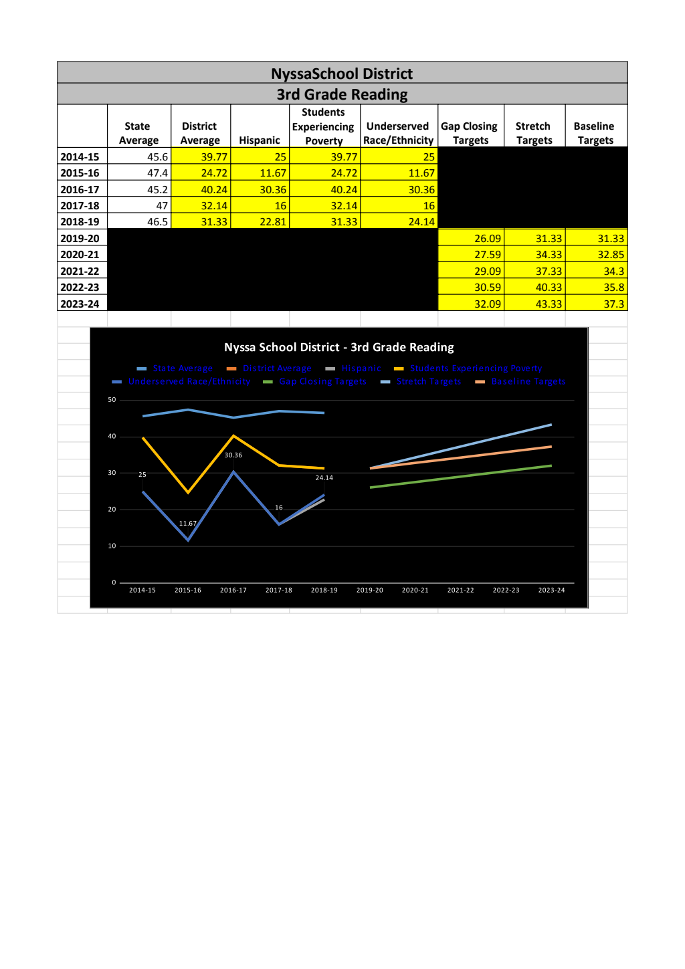onal time—YES
- Addressing students’ health and safety needs—YES
- Evidence-based strategies for reducing class size and caseloads—YES
- Expanding availability of and student participation in well-rounded learning experiences—YES
- Meeting Students’ Mental and Behavioral Health Needs—YES
- Identify which allowable use(s) will be designated to meet student mental and behavioral needs.
- Increasing instructional time—NO
- Addressing students’ health and safety needs—YES
- Evidence-based strategies for reducing class size and caseloads—YES
- Expanding availability of and student participation in well-rounded learning experience—NO

Describe how you will utilize SIA funds to: (500 words or less)
- Meet students’ mental and health needs; and
- Increase academic achievement and reduce academic disparities for the focal student groups called out in the law.
We are very excited to be able to finally provide consistent health resources in the form of a school nurse for our students. This will be a great help to students and families in taking care of children’s health. This is currently being done by Secretaries and Instructional Assistants, who are not able to meet the health needs of children in the time and expertise they have. We are also looking forward to having a permanent counselor in the elementary school and also a mental health professional for the entire district to help students and families receive some level of behavioral and mental health intervention, as well as assistance in making contact with community resources for ongoing and in-depth mental health services.
We will employ additional teachers in the elementary and secondary levels so that class sizes and class offerings will address areas where we feel our students need additional learning and support.
We have listed several other requests, all of which will lead to increased student mental and behavioral health, which in turn lead to increased academic achievement. Keeping kids in school by taking care of their health needs is one of the best ways to ensure that curriculum is presented, students receive instruction, and can progress in their learning.
Addressing the Needs and Impact on Focal Student Groups

Describe the potential academic impact for all students and the focal student groups based on your plan to use funds. (500 words or less)

Academic impact for all items and services we have requested in the Student Success Act plan is expected to be incremental but substantial. Some of our requests will yield immediate academic growth, while others will be more difficult to measure. For example, measuring the academic growth of students based on the hiring of a school nurse may not be easily accomplished, but it could definitely be linked to improved health and keeping children in school.

What barriers, risks, or choices are being made that could impact the potential for focal students to meet the longitudinal growth targets you’ve drafted or otherwise experience the supports or changes you hope your plan causes? (250 words)
We are expecting that smaller class sizes, additional instructional assistants to give more individual attention to students, and purchasing research-based reading intervention curriculum will increase student achievement over time. My main concern currently is that we will not have sufficient ongoing funding in order to support all the activities we have planned that will lead to student growth.
Evidence of Board Approval

Upload evidence of board approval in an open public meeting (meeting minutes, notes, etc.). Share link where the plan exists on a public website.

