1st Grade P.A.L.
Parkview At-Home Learning

Parkview At-Home Learning is as easy as 1, 2, 3! Thank you for your support at home as we work to retain and strengthen the skills learned in 1st Grade this year.

Week 6 | April 27- May 1 | Online Resources | Teacher Tips
Reading | Passage #41 | https://www.abcya.com/ | Time your child as he/she reads a sentence from the passage. Create a fun, no-pressure challenge by asking your child to reread the same sentence and try to “beat” their own time. Just for fun, no pressure!
 | Main Idea: School is Fun | https://www.teachyourmonstertoread.com/ | Make a general statement, such as “First graders learn a lot at home and at school.” Have your child state 2 or 3 details that could support your statement. (Example: First graders learn to read. They learn to add and subtract. First graders learn to sing new songs.)
 | Mixed Up Long Vowels | https://www.storylineonline.net/ | Read the words on the “Mixed Up Long Vowels” sheet using a silly voice - baby voice, cowboy voice, football player voice, cheerleader voice, slow motion voice, etc.
Math | Graphing Review Packet |  | Complete the review packet for graphing and tally marks.
 | Jelly Bean Graphing | https://drive.google.com/file/d/1_o5IHW96xRrCOrzVQDibBxaiG-KnJ5ye/view?usp=sharing | This can be done with any type of candy with different colors. Ask random questions, such as which is greater, how many ___ and ___are all together, how many more ____ are there than ____.
 | Lego (or toys) graphing |  | Find your legos or toys and graph the different types of toys or colors of legos.
Writing | Use the ORC Writing format to answer this question: “What is your favorite thing to learn at school?” |  | Have your child write about the best pet using the ORC format:  Opinion: I like ____.  Reason 1:  Reason 2:  Reason 3:  Conclusion: I think ______ is the best _________.
 | Is it a Pronoun? Set 2 | https://www.pinterest.com/pin/231442868337656165  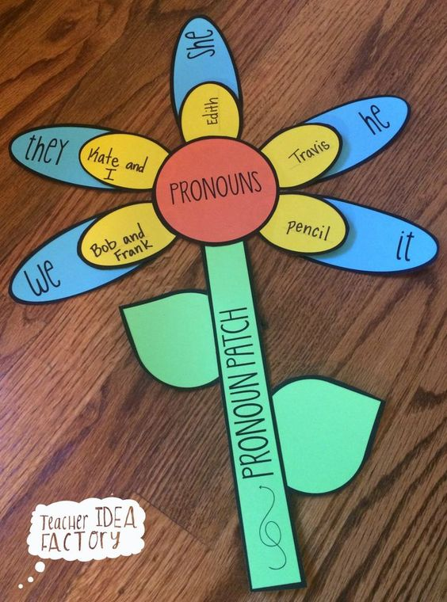 | Create a pronoun flower with construction paper (if available) or just draw a flower. Write the word ‘pronouns’ in the center circle. Write a pronoun, such as ‘pencil’ on a smaller petal. Write ‘i’ on a larger petal behind it. (Refer to the example.)
 | Editing: Capitalization and Punctuation Set 4 |  | Look over your opinion writing piece and check for capitalization and punctuation.

