

**The Knightly News**

**April 3, 2020**

**What’s Important Now**  
Congratulations! You have survived another week of this crazy way of life that we are currently in. Each week has been an opportunity for learning, growth, and continued adaptation. Please know that myself and the staff here have you all in our thoughts each day as we try to tackle each challenge. There are priorities and we all have different elements in our lives at this time that are priority.

**Student health**

We all want the students and their families to be healthy. Which is why we are not able to have school. The experts in this pandemic have made it very clear that keep everyone safe we have to keep ourselves distanced. This is not easy. We are creatures of social gatherings and whether that is in an environment at school or wherever, we thrive on social interaction with others.

As a community we want to make sure that everyone is getting their nutritional needs met. If your family needs your nutritional needs met, we continue to have food at both the Elmwood and Murdock buildings from 9-10am on Monday and Thursday mornings. There are also various churches in the community and the Food Bank is another great resource. If you would like more information on these resources, please feel free to call or email me.

Students mental health is another concern. This is a tough time. We want to make sure that students are doing okay with their mental health as well. If you, as parents, feel like your child is struggling please reach out to their teacher or to Ms. Sigler, our school guidance counselor.

**Student Academics**

Our school motto is to empower all students to achieve academic success. Our first goal in this pandemic is to ensure all students are safe and healthy. If those needs are met, we want to empower them to be ready for their grade level next year. This is why the teachers are working to try to provide as many opportunities and resources for students to learn and grow to their highest potential. Teachers would prefer to have your children here where they can work with them in a more personal setting. However, they are thankful for technology and the opportunities to connect with students and try to help them grow through various lessons.

We understand the strain this is putting on parents and we want to be resources to you to try to do what we can to help you. Please reach out to myself or your child’s teacher if you or your child needs help with anything.

The latest update is that school will be closed for the remainder of the school year. We are working to plan a day for students to come back at the end of the regularly scheduled school year and return any textbooks, devices, or anything else belonging to the school. Once that is determined we will be sure to let you know.

The school office building will be open from 10:00am to 2:00pm Monday through Friday. If you have any questions or concerns please call the school during those hours or email me at [tnichelson@emknights.org](mailto:tnichelson@emknights.org). I miss seeing your children each day.

Please stay safe and healthy,

Mrs. Nichelson

**Kindergarten**

If your son or daughter turns 5 on or before July 31, 2020, they are eligible to begin Kindergarten in August 2020. Please contact the Elementary office at 402-994-2125 to make sure you are on our list for the 2020-2021 school year. Kindergarten registration was postponed. We feel like this is an important event for parents, students, and teachers. We are hoping to try to have it sometime this summer. We will let you know as the date gets closer if this will be possible. If you know of any families that are new to the Elmwood-Murdock community, please share this information with them. Thank you!

**Library News**

Mrs. Paulsen will be going into the school every Monday from 9:00-11:00 to get books for kids.  If students need new materials.  They need to have their requests to her by Monday at 10:00.  This will be her schedule for the remainder of the school year. The books can be picked up or dropped off any day of the week between 10 and 2.  Requests can be emailed to [jpaulsen@emknights.org](mailto:jpaulsen@emknights.org)

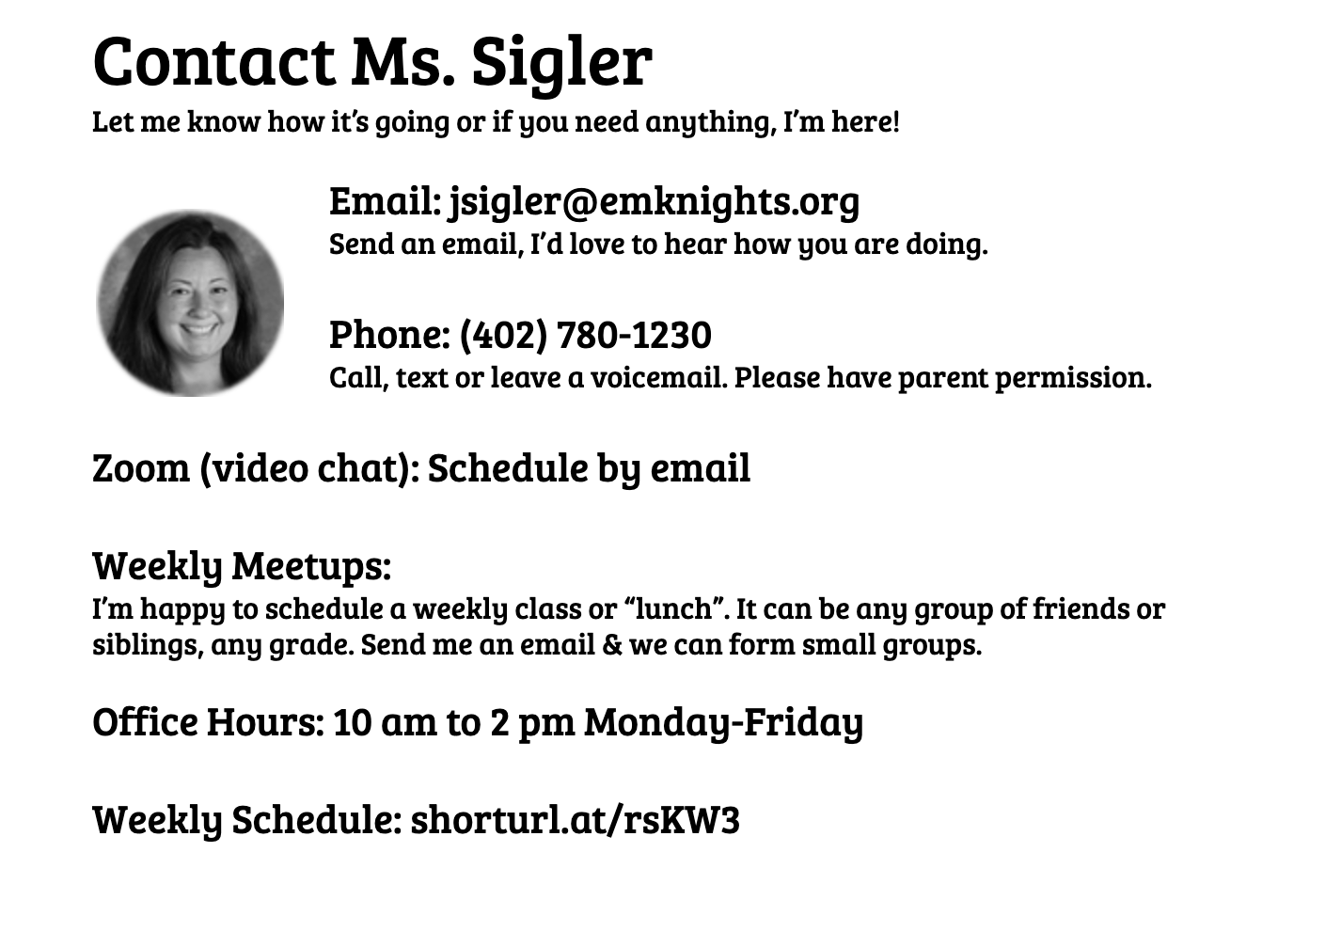



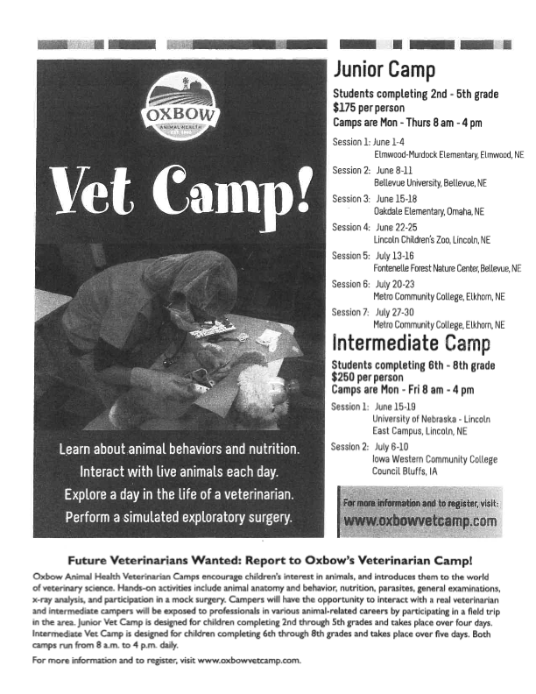

**Art News/Resources**

Objective:  To observe and reflect on the photography of a famous photographer!

For all ages - even mom and dad!!

I want to share with you one of my very favorite photographer/ artists.  His name is Tom Mangelsen.  He has an art gallery in Omaha as well as other locations.  It is one of my favorite places to go and just be amazed at the huge lifesize photos of some very cool wildlife and landscapes.  If you ever go to Omaha and the Old Market area,  you simply must check out his gallery there!

What makes him my favorite photographer is that every photo tells a story or captures a specific moment or feeling.  I admire the fact that he spends hours waiting to get that special shot!!

Look up his web page :

Mangelsen

Images of Nature Gallery

Go to the section : THE ART

scroll down to: collector favorites, mammals, image folders, or any others you like.  It is all good!

See if you can find my favorites:  Catch of the Day,  Bad Boys of the Arctic, Eyes of the Grizzly, and my absolute favorite - the video of the baby polar bears playing outside their den with their mama bear peeking out the den to keep an eye on them.  It absolutely makes me smile every time.

Which are your  3 favorites?  Why?

Do you like landscapes or animals best?

What skills do you think he has besides  the ability to use a big,  fancy, very expensive  camera very well?

How close do you think he gets to his subjects?

How does he keep safe when photographing wild animals like lions and bears?

How many photos do you think he has to take to get one perfect shot?

What things does he have to consider and think about when he is trying to take a great photo?

How does the light and time of day make a difference in his photos?

You can also look up his You Tube videos about how he takes his photos.  I like the one where he tells the people with him how to take photos of a moose.

Have you ever taken a photo of a moose?  I have . Where we camp in Wyoming  there are moose - but it is dangerous to get too close to moose and my camera is not as fancy as his,  so even with my zoom the photos are not all that close.

 Except the one time when we were hiking and came around the corner of the mountain path  and were face to face with a mama moose and a papa moose and their baby moose. Yup we could see their breath.  That time I was so scared that I  was shaking so much the photo was blurry.  Ha.  For real. My friends said what are you doing taking a picture?   I said,  "After they trample us maybe someone will find the camera and know what happened to us.  Ha.  Besides, what is the chance of ever getting this close again? "  Luckily the moose family  stared at us and we stared back,  and then they  just melted away into the willows and brush.  Whew.

I would be interested to know your thoughts if you want to email me at [ltrundle@emknights.org](mailto:ltrundle@emknights.org)

Have a great day!! Mrs Trundle