Art Lesson Plans
Week of 4/6/20

The following lessons are for the 6th and 7th grade classes. The lessons are going to be building blocks for other lessons to follow. All of the lessons will be conducted using materials that should be available at home. If there are any questions on how to complete the lessons, feel free to email me at satterwhite.andrew@marion.k12.ga.us or text me at 229-429-9014.

Thanks.
Coach Satterwhite

6th and 7th Grade:
Still Life Drawing:
Materials: Pencil, copy paper (notebook paper is ok)
Lesson 1: Practice drawing several shapes filling up the paper. Shade in several shapes with different shades. For example, some shapes should have little shade, some can have a lot.
Lesson 2: Practice drawing a group of 3 forms. Forms are three dimensional shapes (cube, cylinder, sphere). The three forms should be drawn together as a group where they are overlapping each other.
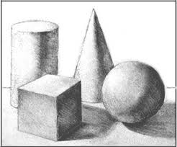
Lesson 3: Create a value scale to practice shading. Begin by drawing a rectangle 2”x 5”. Then divide the rectangle into five equal sections. Each section should be shaded from a very light value to a very dark value. Make sure the sections are smooth with a solid shade (also known as value).

Light Dark
Lesson 4: Still Life Drawing
Find five small, hand held objects (soda can, bottle, bowl, shoe, etc.) and arrange them on a table. Using observation skills, draw the arrangement of objects just how you see them. Do not draw them as individual objects but as a whole group.

Example:
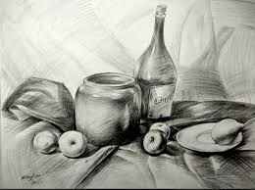
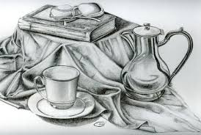

Draw the outline of the objects first. Draw them big enough to fill up the whole paper. Once the objects are drawn, shade the objects and add the details.

