Crossett Seniors



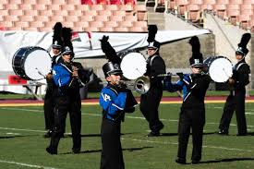 vzv

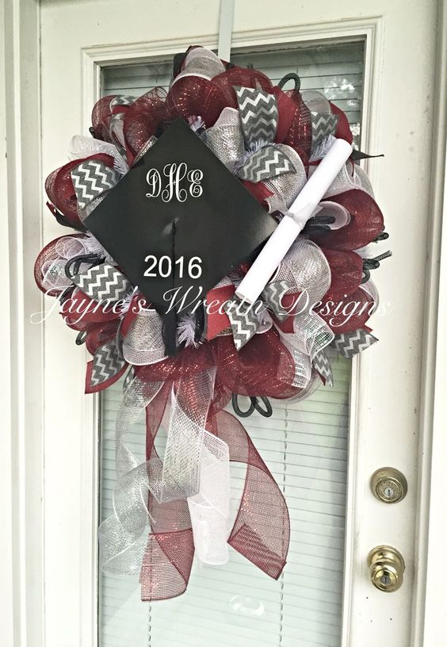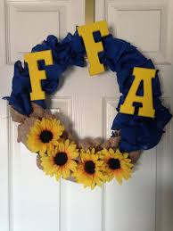

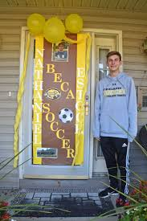 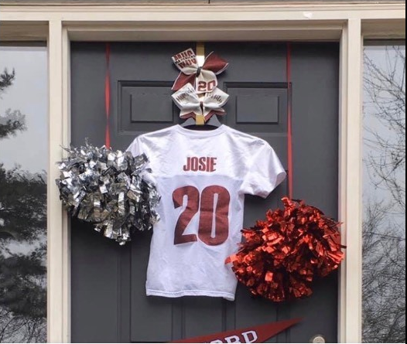

We want you to celebrate your senior year with the community! Decorate your front door with accomplishments from your high school career, so the community can congratulate you. Design your door with different organizations, teams, clubs, or career explorations that you did during your high school career. Once you finish your door, snap a picture and send it to us so we can feature it on the school’s Facebook page. We look forward to applauding your success!

Submit photos to:

Ms. Melissa: [mbutler@hsdlions.org](mailto:mbutler@hsdlions.org)

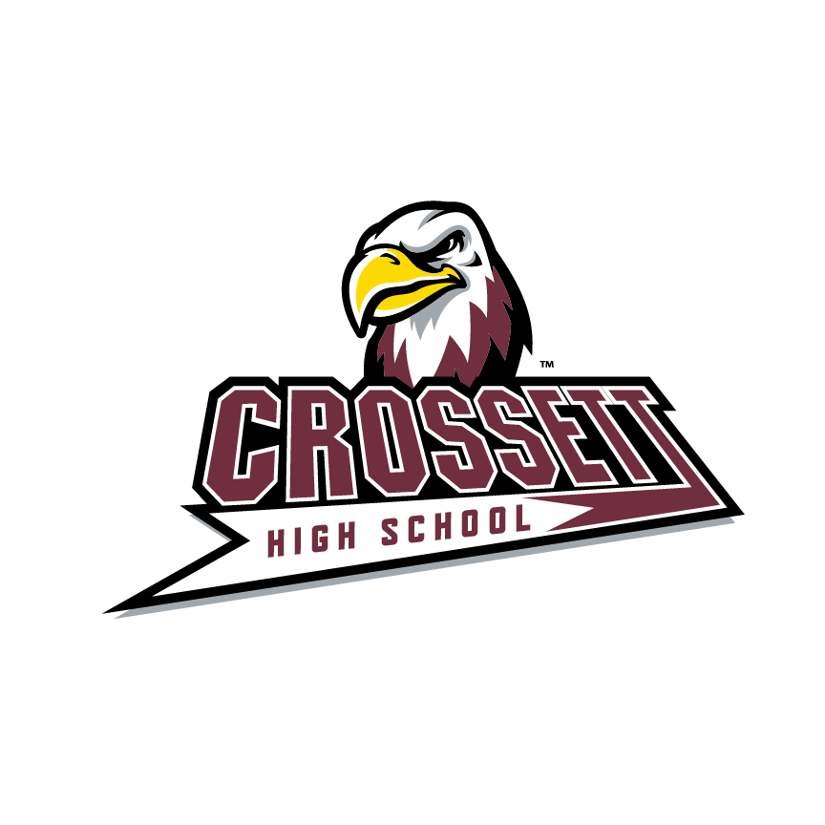

Celebrate Your Senior Year!