Physical Education Fitness Calendar
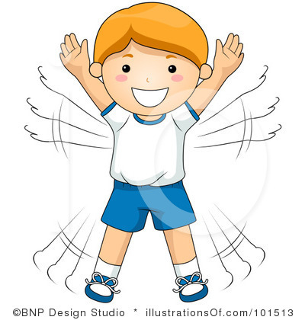
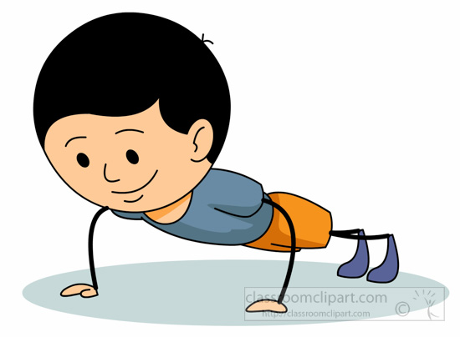
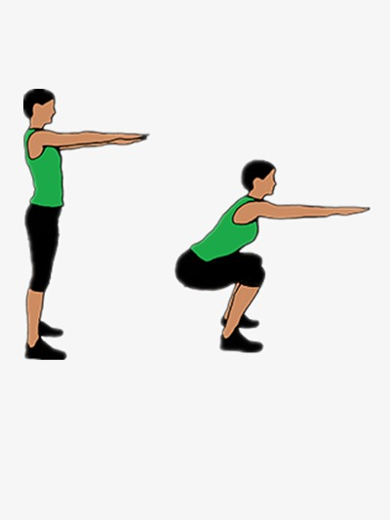
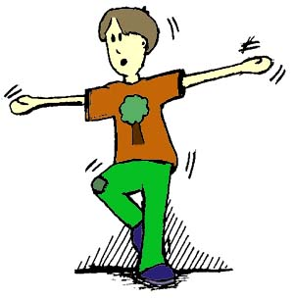
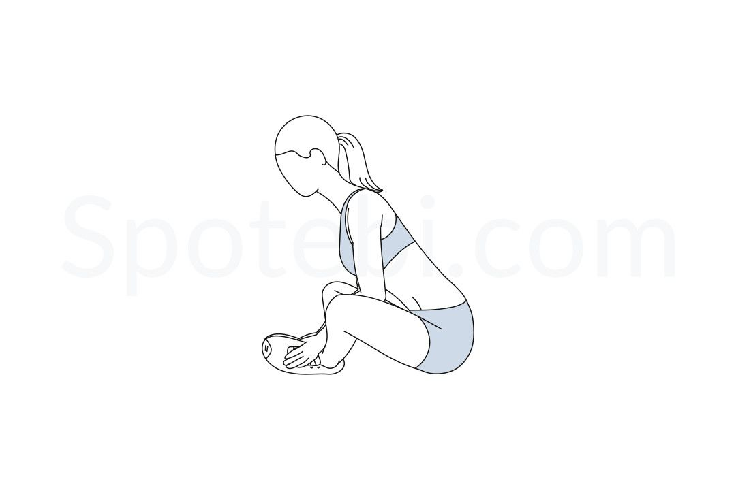
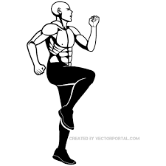
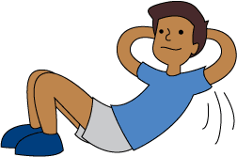
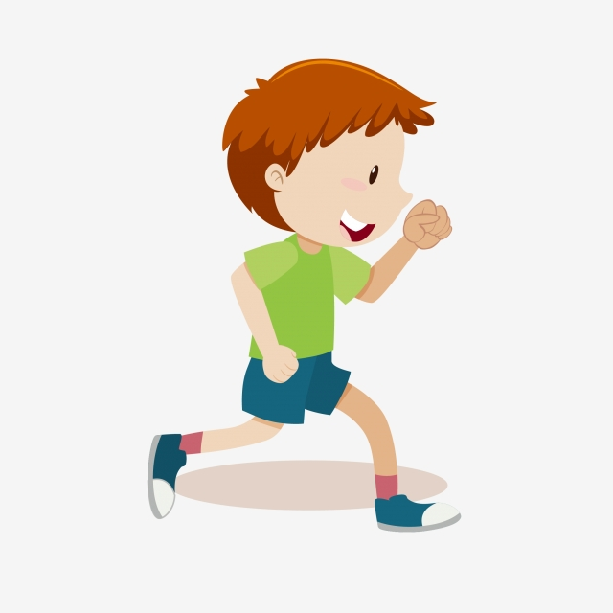
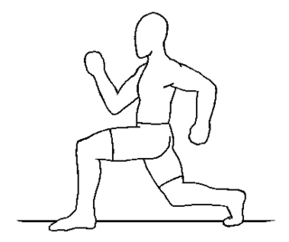
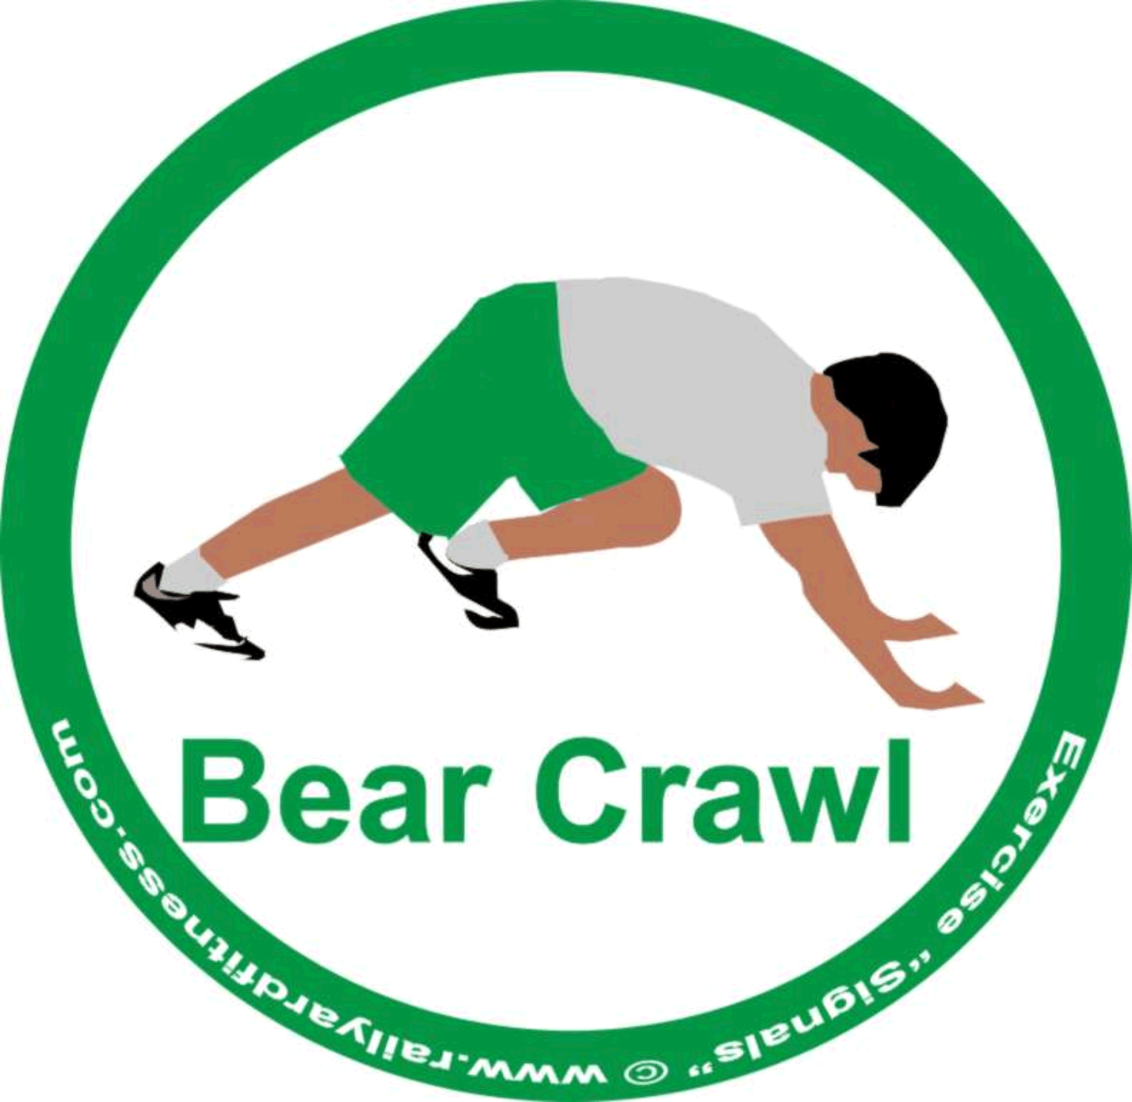
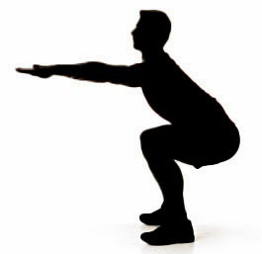
Directions: Complete each fitness challenge for each day of the month. When you are finished pass it in to your Physical Education Teacher.
April 2020
Note: If you miss a day. That’s alright just make up that day on the next day. The idea is to do something active everyday!!!
Sunday | Monday | Tuesday | Wednesday | Thursday | Friday | Saturday
 |  |  | 1 Hold a push-up position while saying your ABC’s 3 times. | 2 10 Sit-ups  Hold a Crab Walk Position for 30 seconds. | 3 Do High Knees in place for 30 seconds then switch to butt kickers for 30 seconds repeat (2x) | 4  Rest Day
5 Shoulder touches (3x) of 10 | 6 Skip around your home 3 times | 7 Keep your legs strait while you bend relaxed at the waist breath in and out slowly making your hands reach for your toes. | 8 Do the butterfly stretch while saying the words out loud that start with the letter “B “ | 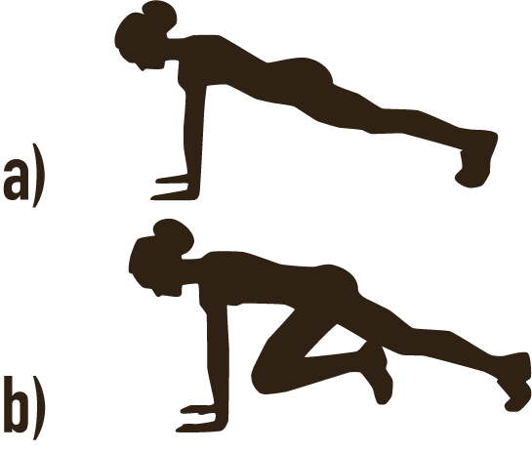  9 Do 100 mountain climbers throughout the day. | 10  Rest Day | 11 Balance on one foot while you say the months of the year 3 times, then switch feet and repeat.
12 Do 100 Jumping Jacks throughout the day. | 13 Do 50 lunges throughout the day | 14 Dance to your favorite songs. | 15 Do squats while watching 3 commercials on T.V. | 16  Rest Day | 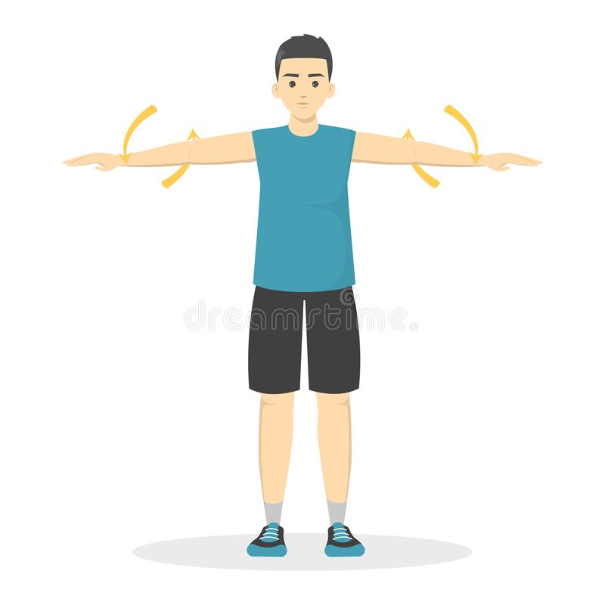  17 60 seconds of arm circles repeat it 3 times | 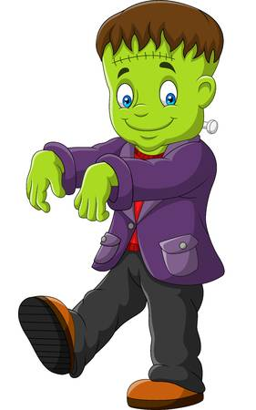  18 Frankenstein walk around your home 3 times.
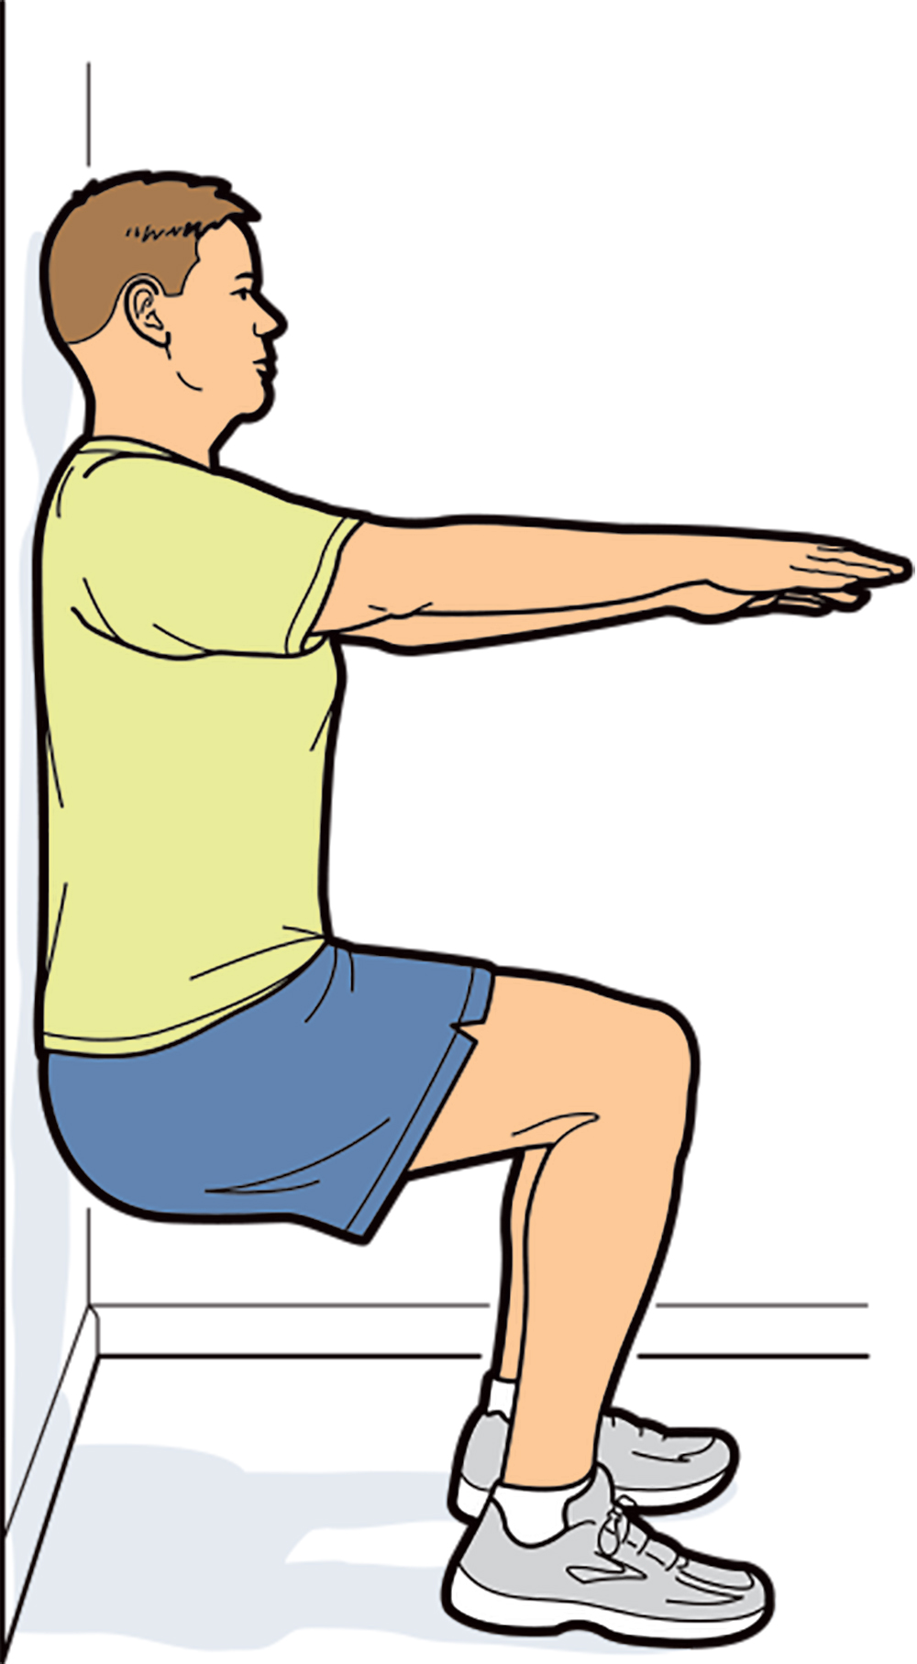  19 With your back against the wall do the wall sit for 60 seconds. | 20 Spell your full name while you jump as high as you can in the air for each letter. | 21 Hold a push-up position while giving a high five to a family member or friend 25 times. | 22  Rest day | 23 Do 50 push-ups throughout the day | 24 Reach and touch your toes while counting to 30. Go slow and do it 3 times. | 25 Challenge a family member or a friend to a “jumping jack race to 60” Contest.
26 Bear crawl from the kitchen to your bedroom (even if it’s up or down the stairs) | 27 Do 50 squats throughout the day. | 28  Rest day | 29 Make up your own fitness challenge and draw it on the back of this paper. | 30 Pick one of your favorite Days and Do it again. |  | Check off  When you finish each day

