Crisis hotlines:
http://www.1istoomany.org/pages/contact
https://www.crisistextline.org/
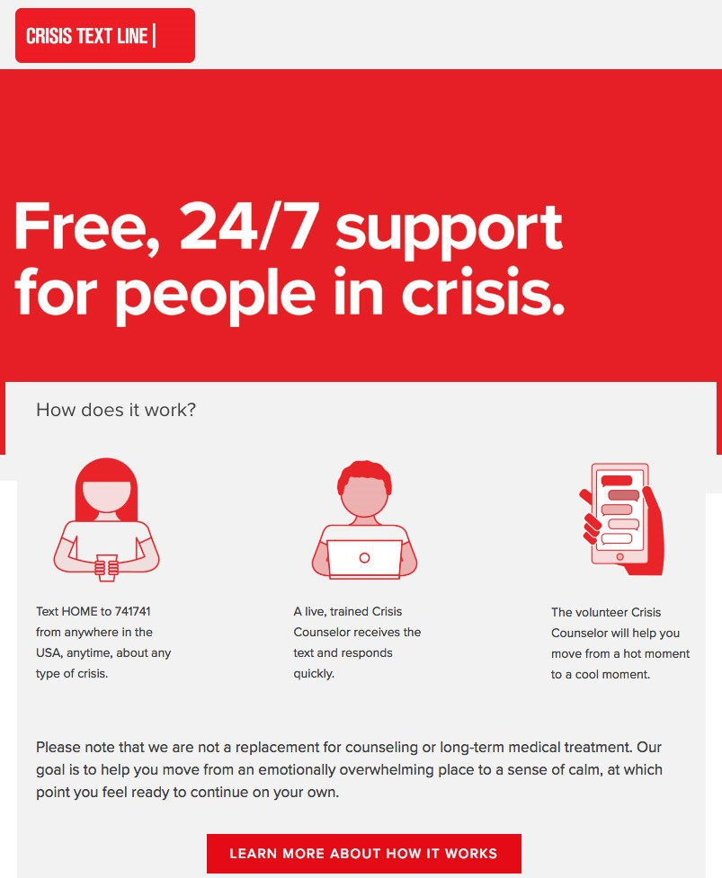
COVID-19 Resources:
https://www.commonsensemedia.org/resources-for-families-during-the-coronavirus-pandemic

