The Lead-Deadwood School District Physical Education and Wellness Committee has put together some ideas relating to activities for your children and family during the school closure. We know you all have a lot on your minds during the current situation, so hopefully this will help you and your family enjoy some quality time out from all that is going on.

Here are a few options:

OPEN PE Website: https://openphysed.org/activeschools/activehome

Options on Youtube
- STRONG by Zumba offers a variety of workouts for free
- Planet Fitness will live stream workouts and others can be accessed for free
- YMCA 360 - Your Virtual YMCA
Other online options:
- Core Power Yoga - corepoweryogaondemand.com offers various yoga workouts from 30 minutes to an hour each
- Team Beachbody - 2 weeks for free
- Les Mills - https://watch.lesmillsondemand.com/at-home-workouts
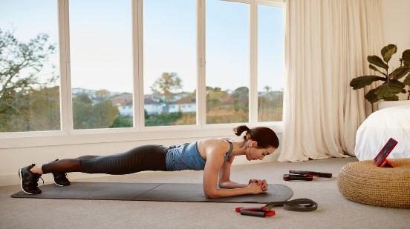 | AT HOME WORKOUTS - LES MILLS ON DEMAND  Workout at home with LES MILLS. Click on the drop-down below to select from our extensive variety of workout categories. There is something for everyone from high intensity interval training designed to improve strength and fitness fast, dance fitness workouts, the martial arts inspired BODYCOMBAT Invincible program through to mindfulness practices to slow the stream of thoughts that can cause ...  watch.lesmillsondemand.com
- offers over 100 different workouts ranging from general strength workouts to body combat.
- Fitness Blender - https://www.fitnessblender.com/videos offers video based workouts focused on strength, core and HIIT workouts.

